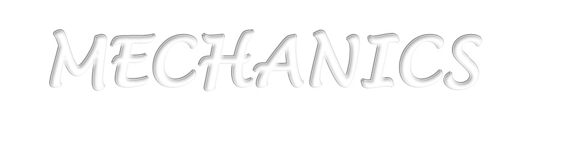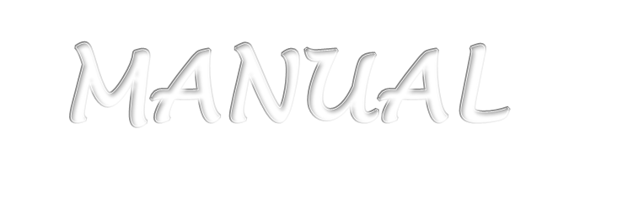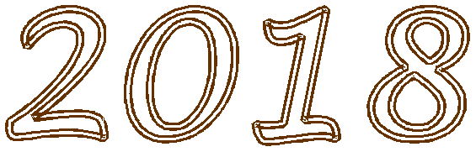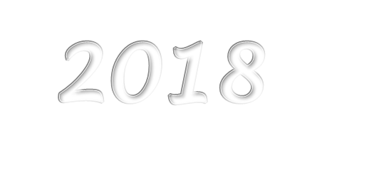

CALIFORNIA FOOTBALL OFFICIALS ASSOCIATION

OFFICIALS MECHANICS MANUAL

Purpose of Manual

This manual was developed after reviewing several other football mechanics prepared by various local, regional, state and national officiating associations. Compromises were made in several areas to generate a system of mechanics that are relatively simple and can provide the best field coverage for games worked by the CFOA high school officials.

The manual provides descriptions of officiating excellence, uniform requirements, general mechanics, and signals as well as specific mechanics for a crew of five and four officials. Officials should concentrate on mastering the mechanics for a crew of five officials and then learn the differences and adjustments required to work with crews of four.

The National Federation of State High Schools Associations (NFHS) Football Rules
Book is the official rule book for the CFOA.

Acknowledgements 14
INTRODUCTION 14
GOALS AND PREPAREDNESS 15
SECTION 1: GENERAL PRINCIPLES 17
I. Knowledge of the Rules: 17
II. Physical Condition: 17
III. Mental Reactions: 17
IV. Duties and Responsibilities: 17
V. An Official Must: 17
VI. Signals: 18
VII. Enforcement: 18
VIII. Hustle: 18
IX. Boxing In: 19
X. Off-Ball Officiating: 19
XI. Cooperation: 19
SECTION 2: STANDARD UNIFORM 20
I. Traditional Uniform: 20
II. Summer Uniform: 20
III. RADIO PROTOCOL 20
SECTION 3: OFFICIATING PROCEDURES 22
BEFORE ENTERING THE FIELD 22
ALL OFFICIALS: 22
I. Back Judge 22
II. Back Judge 22
III. Referee 22
IV. Back Judge 22
V. Referee and Umpire 22
VI. All Officials 22
SECTION 4: PRE-GAME DUTIES ON THE FIELD PROCEDURES 23
I. All Officials 23
II. Referee 23
III. Umpire 23
IV. Head Linesman 23
V. Line Judge 24
VI. Back Judge 24
VII. Head Linesman and Line Judge 24
VIII. Back Judge and Line Judge 24
Coaches’ Conferences 24
PRE-GAME WARM-UPS 25
REFEREE 25
UMPIRE 25
FLANK OFFICIALS 26
BACK JUDGE 26
SECTION 5: COIN TOSS AND OVERTIME 27
COIN TOSS PROCEDURE 27
SECTION 6: GENERAL GAME DUTIES 28
SUBSTITUTIONS AND COUNTING PLAYERS 28
Free Kicks 28
All Officials 28
OTHER GENERAL GAME DUTIES – ALL OFFICIALS 28
PRE-SNAP ROUTINES 30
REFEREE 30
UMPIRE 30
HEAD LINESMAN 31
LINE JUDGE 32
BACK JUDGE 32
PRE-SNAP DUTIES 33
I. All Officials 33
II. Referee 33
III. Umpire 34
IV. Head Linesman 34
V. Line Judge 34
VI. Back Judge 34
SECTION 7: TIMING PROCEDURE 36
GAME TIMING 36
I. Referee 36
II. Line Judge 36
III. Back Judge 36
TIMER INSTRUCTIONS 36
SECTION 8: USE OF BEAN BAGS 38
PROCEDURE 38
SITUATIONS IN WHICH THE BEANBAG SHOULD BE USED 38
Fumbles 38
First Touching 38
End of a Scrimmage Kick 38
Momentum Exception 39
Out of bounds 39
Inadvertent Whistles 39
SECTION 9: USE OF WHISTLE 40
ALL OFFICIALS 40
DECLARING THE BALL READY FOR PLAY 41
SECTION 10: BALL HANDLING 42
SCRIMMAGE PLAYS 42
I. Back Judge, Head Linesman, and Line Judge 42
GENERAL BALL HANDLING 42
I. Relaying Ball 42
II. Tossing Ball 42
III. Start of Each Half or Extra Period 42
IV. Spotting Ball 42
WHEN THE BALL IS DEAD AND BETWEEN THE NINE-YARD MARKS: 43
Umpire 43
Referee 43
Back Judge 43
Flanks 43
WHEN THE BALL IS DEAD OUTSIDE THE NINE-YARD MARKS, OR OUT OF BOUNDS: 43
I. Referee 43
II. Umpire 43
III. Back Judge 43
IV. Flanks 43
WHEN A FORWARD PASS IS INCOMPLETE: 43
I. Flanks 44
II. Umpire 44
III. Back Judge 44
IV. Referee 44
FOLLOWING PUNT OR MISSED FIELD GOAL: 44
I. Back Judge 44
II. Flanks 44
III. Referee 44
IV. Umpire 44
SECTION 11: FREE KICKS 45
I. Referee 45
II. Umpire 45
III. Line Judge 46
IV. Linesman 46
V. Back Judge 47
POINTS OF EMPHASIS 47
REFEREE and UMPIRE 47
BACK JUDGE, LINE JUDGE, HEAD LINESMAN 48
FREE KICK COVERAGE MECHANICS 48
ALL OFFICIALS 48
RETURNS DOWN THE CENTER OF THE FIELD 48
RETURNS INTO THE REFEREE / HEAD LINESMAN SIDE ZONE 48
RETURNS INTO THE UMPIRE / LINE JUDGE SIDE ZONE 48
POINTS OF EMPHASIS 48
FREE KICK AFTER SAFETY 49
FREE KICK AFTER FAIR CATCH 49
SECTION 12: KEYS 50
I. Situational Keys 50
II. Positional Keys 50
III. Unbalanced Formation 52
IV. Balanced Formation 54
V. Three-Receiver (Trips) Formation 55
VI. Double Wing Formation 55
VII. Motion 56
SECTION 13: PLAYS FROM SCRIMMAGE 59
BASIC POSITIONS 59
I. All Officials 59
II. Referee 59
III. Umpire 59
IV. Head Linesman 59
V. Line Judge 60
VI. Back Judge 60
SECTION 14: RUNNING PLAYS 61
RUN MECHANICS 61
RESPONSIBILITIES AT THE SNAP 61
ALL OFFICIALS 61
REFEREE 61
UMPIRE 61
HEAD LINESMAN 61
LINE JUDGE 61
BACK JUDGE 61
RESPONSIBILITIES AFTER THE SNAP 61
ALL OFFICIALS 61
REFEREE 61
UMPIRE 62
LINE JUDGE and HEAD LINESMAN 62
BACK JUDGE 63
POINTS OF EMPHASIS 63
REFEREE 63
UMPIRE 63
LINE JUDGE and HEAD LINESMAN 64
RUN ZONE COVERAGE 64
RUN TOWARD THE REFEREE 64
REFEREE 64
UMPIRE 64
NEAR FLANK 65
AWAY FLANK 65
RUN AWAY FROM THE REFEREE 65
REFEREE 67
UMPIRE 67
FLANKS AND BJ 67
SECTION 15: FORWARD PASSESS 68
I. Referee 68
II. Umpire 68
III. Flank Officials 69
IV. Back Judge 69
V. All Officials 70
SECTION 16: GOAL LINE PLAYS 71
I. Referee 71
II. Umpire 71
III. Head Linesman and Line Judge 71
IV. Back Judge 71
V. Umpire, Head Linesman and Line Judge 71
VI. All Officials 71
Reverse Goal Line 71
I. Referee 71
II. Umpire 71
III. Head Linesman and Line Judge 71
IV. Back Judge 71
SECTION 17: FUMBLES 72
SIGNALS 72
DIGGING OUT FUMBLES 72
SECTION 18: SCRIMMAGE KICKS (PUNT PLAYS) 73
PRE-KICK MECHANICS 73
ALL OFFICIALS 73
REFEREE 73
UMPIRE 73
HEAD LINESMAN 73
LINE JUDGE 73
BACK JUDGE 75
KICK MECHANICS 75
ALL OFFICIALS 75
REFEREE 75
UMPIRE 75
HEAD LINESMAN 76
LINE JUDGE 76
BACK JUDGE 77
POINTS OF EMPHASIS 77
REFEREE 78
UMPIRE 78
HEAD LINESMAN and LINE JUDGE 78
BACK JUDGE 78
SECTION 19: TRY AND FIELD GOAL PLAYS 80
BASIC POSITIONS AND COVERAGE 80
I. Referee 80
II. Umpire 80
III. Flank Official Facing the Referee 80
IV. Flank Official on the Back Side of the Referee 80
V. Back Judge 80
VI. Back Judge and other official Under the Goal Post 80
SECTION 20: TIME OUTS 82
PROCEDURES 82
I. Referee 82
II. Flanks 82
III. All Officials 82
IV. Referee 82
V. All Official 82
VI. Flanks 82
VII. Umpire 82
VIII. Back Judge 82
IX. Officials Time Out 82
X. All Officials 83
XI. Injury Time Outs 83
SECTION 21: MEASUREMENTS 84
PROCEDURE 84
I. All Officials 84
II. Back Judge 84
III. Referee 84
IV. Head Linesman 84
V. Line Judge 84
VI. Umpire 84
VII. All Officials 84
VIII. Head Linesman 85
IX. Referee and Umpire 85
SECTION 22: CALLING FOULS AND ENFORCEMENT 86
PROCEDURE 86
PENALTY CODES / DOCUMENTING 87
SECTION 23: END OF A PERIOD 89
PROCEDURES 89
I. All Officials 89
II. Referee and Umpire 89
SECTION 24: ONE-MINUTE INTERMISSIONS 90
PROCEDURES 90
I. All Officials 90
II. Back Judge and Line Judge 90
III. Back Judge 90
IV. Referee 90
V. Umpire, Head Linesman, Line Judge and Back Judge 90
VI. Head Linesman 90
VII. All Officials 90
VIII. Back Judge 90
IX. Referee 90
SECTION 25: HALFTIME INTERMISSION 91
END OF SECOND PERIOD 91
I.Back Judge 91
PRIOR TO KICKOFF 91
I. Line Judge or Head Linesman 91
II. Referee and Umpire 91
III. Back Judge and Line Judge 91
IV. Head Linesman 91
V. All Officials 91
SECTION 26: OVERTIME PROCEDURE (RESOLVING TIED GAMES) 92
END OF REGULATION PLAY 92
I. Referee 92
II. All Officials 92
III. Back Judge 92
I. Referee and Umpire 92
II. Head Linesman, Line Judge, and Back Judge 92
COIN TOSS 92
I. Referee 92
II. All Officials 92
ADDITIONAL EXTRA PERIOD 92
OVERTIME PROCEDURE 92
SECTION 27: OCFOA PHILOSOPHIES 93
QUALITIES OF AN EXCELLENT CREW MATE 93
The following philosophies have been adopted for OCFOA games. 94
I. Ball Spotting 94
II. Line Of Scrimmage 94
III. Bean Bags 94
IV. Defensive Pass Interference 94
III. Not Defensive Pass Interference 95
VI. Offensive Pass Interference 95
VII. Not Offensive Pass Interference 95
1) Other Passing Situations 96
IX. Backward Pass 96
X. Catch/No Catch (taken from the SDCFOA Manual) 96
XI. Blocking and Holding 98
XII. Free Blocking Zone 98
XIII. Kicking 100
XIV. Plays At The Sideline 100
XV. When In Doubt 100
XVI. End Of Game 100
XVII. Miscellaneous 100
SECTION 28 Crew-of-Seven Mechanics 101
Pregame Duties and Responsibilities 101
Referee 101
Umpire 101
Head Linesman 101
Line Judge 101
Back Judge 101
Field Judge 101
Side Judge 101
Coin Toss Procedures and Responsibilities 102
Referee 102
Umpire 102
Head Linesman 102
Line Judge 102
Back Judge 102
Field Judge 102
Side Judge 102
Free Kicks-Deep (click here to go to diagram) 102
Referee 102
Umpire 103
Head Linesman 103
Line Judge 103
Back Judge 103
Field Judge 104
Side Judge 104
Free Kicks-Onside (click here to go to diagram) 104
Referee 104
Umpire 104
Head Linesman 104
Line Judge 105
Back Judge 105
Field Judge 105
Side Judge 105
Plays from Scrimmage (click here to go to diagram) 105
Referee 105
Umpire 105
Back Judge 106
Field Judge 106
Side Judge 106
Running Plays 106
Referee 106
Umpire 107
Head Linesman 107
Line Judge 107
Back Judge 107
Field Judge 107
Side Judge 107
Passing Plays 108
Referee 108
Umpire 108
Head Linesman 108
Line Judge 108
Back Judge 109
Field Judge 110
Side Judge 110
Punts (click here to go to diagram) 111
Referee 111
Umpire 111
Head Linesman 112
Line Judge 112
Back Judge 112
Field Judge 112
Side Judge 113
Field Goals and Trys (click here to go to diagram) 114
Referee 114
Umpire 114
Head Linesman 114
Line Judge 114
Back Judge 114
Field Judge 115
Side Judge 115
Goal Line Plays 115
Referee 115
Umpire 115
Head Linesman 116
Line Judge 116
Back Judge 116
Field Judge 116
Side Judge 116
Penalty Enforcement 117
Umpire 117
Head Linesman 117
Line Judge 117
Back Judge 117
Field Judge 117
Side Judge 117
General Game Duties 117
Referee 117
Umpire 117
Head Linesman 117
Line Judge 118
Back Judge 118
Field Judge 118
Side Judge 118
Measurements 118
Referee 118
Umpire 118
Head Linesman 118
Line Judge 118
Back Judge 118
Field Judge 119
Side Judge 119
7 Man Diagrams 120
Free Kick Position and Coverage 120
Short Free Kick Position 120
Basic Scrimmage Position 122
Basic Scrimmage Kick Position (FG and Try) 123
Basic Scrimmage Kick Position (Punt) 124
SECTION 29 4 PERSON MECHANICS SUPPLEMENT MANUAL 125
SECTION 30 3-MAN MECHANICS 141
BELOW VARSITY PRE-GAME 141
COIN TOSS PROCEDURES 141
QUARTER 141
FREE KICK MECHANICS – 3-MAN 142
FREE KICK FOLLOWING A FAIR CATCH 143
DURING THE FREE-KICK MECHANICS 143
FREE KICK COVERAGE MECHANICS 144
SCRIMMAGE PLAY MECHANICS – 3-MAN 145
RUN MECHANICS – 3-MAN 146
RESPONSIBILITIES AT THE SNAP 146
RESPONSIBILITIES AFTER THE SNAP 146
PASS MECHANICS – 3-MAN 148
COVERAGE MECHANICS (In addition to Running Play) 148
PASS RECEIVER COVERAGE KEYS 149
SCRIMMAGE KICK MECHANICS – 3-MAN 149
PRE-KICK MECHANICS 149
DURING THE SCRIMMAGE KICK MECHANICS 150
FIELD GOAL & PAT MECHANICS – 3-MAN 152
PRE-SNAP MECHANICS 152

Acknowledgements
This mechanics manual is produced by the California Football Officials Association. Changes to CFOA mechanics that are specific to Orange County Football Officials Association will be highlighted in bold.
We are also including philosophy and direction provided by the San Diego County Football Officials Association. A big thank you to Steve Coover and the SDCFOA Board for granting us permission to use their outstanding mechanics manual. All entries that come from SDCFOA will be shown in italics.

INTRODUCTION
Consistency is critical in all we do as officials. And consistency of mechanics is the basis of our work (see pyramid below). Excellent mechanics places us in the right position with the very best view of the action. Conversely, poor mechanics leaves us without a good window to view the action and will ultimately lead to errors in judgment.
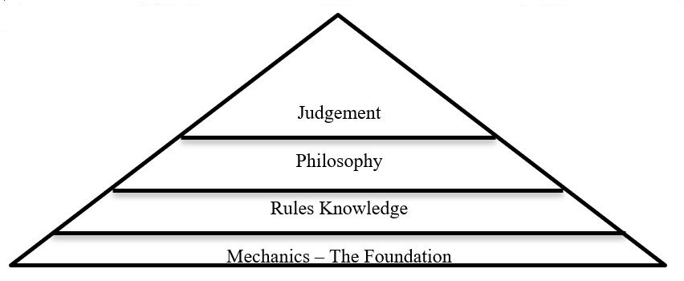
The Ratio of the Critical Elements of Great Officiating – Carl Cheffers NFL Referee
It is the expectation of the OCFOA that each member of a crew will thoroughly prepare themselves for each game assignment. That preparation will also include a thorough understanding of the differences between 5-man, 4-man and 3-man mechanics. All three are presented in this book for easy reference. Officials are expected to review and study the contents of this manual before the season begins, as well as selected sections of the manual each week of the season. As much as we study rules throughout the season, we must also re-visit our mechanics each week as well. For that reason, we’ve created this mechanics “book” so that you can easily carry it with you to all games and meetings.
Our mechanics describe for us all critical responsibilities we must consistently fulfill. If each crew member knows their responsibilities, plus how those responsibilities relate to the responsibilities of the other crew members, we establish the framework for outstanding crew communication, within each game, and throughout the season. Using approved, OCFOA mechanics allows for a new crew member to easily “fill in” on a game, or an entirely new group off officials to successfully work together for the first time with confidence.
It is the expectation of the OCFOA that you use these mechanics to prepare for each snap using the outline of our pre-snap routine. Just as a coaches and players prepare mentally prior to each play, officials must also prepare for each play using the pre-snap routine which serves as a checklist of critical elements relative to every play and/or that unique play! Proper pre-snap routines guide us to level of focus and vision during the play that allows us to expect or anticipate actions during the play. Proper mechanics guide our vision to the proper player responsibilities and purposeful body movements that provide us the very best view of the action in our area of responsibility. Lastly, these mechanics will train us to use the proper dead ball officiating sequence so players properly end all action and administrative duties are carried out perfectly (down, distance, clock/time, penalty, measurement, timeout, quarter change, etc.)
We must strive for perfection. There is no other option. So, each week we will work diligently to prepare ourselves to be 100% consistent with the contents of this book. It then follows that each crew will then be 100% consistent with its contents and, consequently, each crew within the entire SDCFOA will demonstrate consistent mechanics as a level that maintains our earned status as one of the finest associations in the country!
With that goal in mind, we must reflect on our performance each week and conduct an open and totally honest self-evaluation. Only then, can we develop personal goals for self-improvement. We expect that individuals and crews will then share and discuss these goals between officials and within the entire crew. Game observers should also be made aware of the individual and crew “stretch goals” which will form the basis for that game’s observation.

GOALS AND PREPAREDNESS
Our responsibilities as a football official do not start when we walk onto the field, they start when we decide we are going to put on the stripes for the first time. Before we start to think of "how good of a game will this be", we need to consider how prepared are we. How can I give the players, coaches, and fans the best that I can every games... every down.
Our responsibility to manage aspects of fair play and ensure the integrity of the game is best accomplished when we are ready, when our we are focused and prepared. The goals that we set for ourselves help drive us to improve. As officials, when the game grows more intense and the competition heats up, how well we have prepared ourselves will show. The best officials are the ones that remain consistent in the calls they make and in their demeanor on the field, and who can focus their involvement and control of the game.
The following list of topics and sub-topics can help you as you develop your personal and crew goals. Write your personal goals down and refer to them throughout the year, modifying or adding as needed. Crew goals may also develop from this list but should be a "team" effort and will be modified each week.
Character Goals
“First off, you’ve got to be a good person!” - David Coleman, Supervisor PAC 12
- Balance your life – faith family work and football – compartmentalize and be present in each phase of your life.
- Be responsible – Work hard to prepare yourself for the season and for each week’s games
- Believe that every game is a “super bowl” for those two teams
- Value your opportunity to excel, but let your work flow naturally
- Always present a positive attitude
- Constantly demonstrate your character to others

Relationship Goals
“Trust starts when you leave your ego at the door. Candor and friction are good for the team if the intentions of the individual are good.” - Chris Peterson, Head Coach University of Washington
- Be present for others – don’t be distracted
- Leave your ego at the door – No excuses
- Contribute to the crew as an equal member – don’t big time your crewmates
- Feedback must be used to get better
- Appreciate your crewmates: there is no better feeling than to be around football officials
Presence Goals
The goal is to be viewed as an athlete who has played the game. We want coaches, players and fans to trust us and our control of the game. What can we do to improve our presence?
- Find those that are rated #1 and study them, in great detail.
- You are your “brand”, does your brand resonate with coaches and the crowd?
- Do you demonstrate a passion for the game?
- How will I handle an angry coach?
- Can the coach trust you enough with the game?

Mechanics Goals
It is critical that each member of the crew master the mechanics of their position.
Our pre-season meeting is well organized and all of the crew is actively involved.
- The crew’s mechanics are well-integrated and practiced.
- The crew has identified situations where we must increase our energy to keep the tempo of the game high.
- I have mastered a thorough dead ball and pre-snap routine?
- Our video review focuses on our mechanics as well as our judgments.

Rules Goals
It is the expectations of coaches, players and fans that the officials know all of the rules – no excuses!
- My pre-season rules study is strong and I participate with study groups.
- I work on a portion of the rules each week.
- I study all rules study guide questions provided by our association.
- The crew is clear on how to accurately report fouls to the referee.
- The crew works to enforce penalties quickly and accurately.
- Every member of the crew is actively involved in the penalty enforcement.

Philosophy Goals
It is critical that we’ve internalized the association’s philosophy statements which will help us properly apply the rules of football to the level of play that we are officiating.
- Make it Big! Fouls should be obvious to the skilled observer causing a reaction that might best be characterized by – “Oh my God, what just happened!”
- It is impossible to build a successful officiating career by calling fouls that result in debates over whether they are quality calls or not.
- I pass on fouls where I did not see the entire action.
- If I am correct in all of my line-of-scrimmage and game administration fouls, plus correct in penalizing all safety and major unsportsmanlike fouls, and then correct in the few fouls where there was a material restriction which created advantage/disadvantage, then I had an outstanding game!

Judgement Goals
“Do no harm! It is better to miss a call than to invent one.” – Karl Richins, Supervisor Big Sky Conference

“Go slow, slower, and slower again. Then, when you are moving and thinking slowly and clearly…slow down some more!” – Andy Castagnola, CFO Replay Official
- See the entire action and then pause to consider advantage/disadvantage and material restriction
- Do No Harm! Refuse to insert yourself into the game unless it is demanded.
- I review the action in my mind (pause and take a breath) and accurately report all of the necessary information in the manner requested by the referee
- Each major call is honestly reviewed in Hudl. The action captured on video is compared to your foul report of the action from the game. Leave your ego at the door!

Each game will present to us opportunities to increase our energy, focus and activity so we present ourselves as a professional that is in total control at all times. Here are a few of those times when we consciously increase our energy, not decrease it!
- Pregame
- Dead ball between PATs, free kicks, and change of possession
- PATs
- Penalty enforcements
- Time outs
- Measurements
- Change of quarters, beginning and end of halftime

Officiating at all levels of football requires constant vigilance, concentration, and preparedness. Trouble can break out at any time. Good officials are prepared for situations that may lead to a breakdown in concentration. – Vern Sparling, Supervisor SCIAC

SECTION 1: GENERAL PRINCIPLES

Knowledge of the Rules:
  - Rule mastery will be perfected over time and must be supplemented by the ability to learn and interpret rules and editorial changes correctly. These abilities are acquired through devotion of time and study.

Physical Condition:
  - a. Football officiating is a difficult and exhausting endeavor which requires 100 percent efficiency of mind and body. An annual physical examination should be a personal requisite to ensure your health, thus allowing you to assess your ability to officiate.

Mental Reactions:
  - Decisions must be instantaneous, and rulings made without delay. To ensure improved instinctive reaction during play situations, continue to review the different game situations and play scenarios which may occur.

Duties and Responsibilities:
  - Each official must have a thorough knowledge of the duties of his own position as well as a general working knowledge of the duties of each of the other officials. They must be prepared to assume any one of the other positions whenever circumstances require rearrangement of assignments.

An Official Must:
  - Know the down and yardage prior to each snap
  - Be ready to assist any official that is temporarily out of position or had an obstructed view of a play
  - Observe erroneous procedures or ruling by other officials and attempt to prevent and correct in an expeditious and diplomatic manner, whenever possible and under no circumstances should an argument develop on the field between officials
  - Know the correct signals and their proper use
  - Secure a new ball when appropriate, after all action has ceased, and to handle and pass the ball properly
  - Be alert to action away from the ball when play has left their immediate area
  - Call time-out for any player who is obviously injured or disabled. Never rush the treatment of an injured player. Recognition of injured players is the concern of all game officials. The Game Clock can be started if a time-out is not necessary.

Signals:
  - All signals should be given promptly, distinctly and conspicuously as they are the non- verbal communication tools we use to inform

Enforcement:
  - All rules should be strictly and fairly enforced. There shall be no deviation from the NFHS Football Rules.

Hustle:
  - Keep the game moving smoothly from start to finish. Do not permit haste to interfere with duties or correct determinations.

Boxing In:
  - Smart officiating requires keeping the players “boxed in” and avoidance of officials being “boxed in”. “Outside looking in” is essential for sideline and end line coverage. The ultimate goal is to have each play viewed from more than one direction.

Off-Ball Officiating:
  - Officials should not be ball watchers. The official nearest the action should take the primary responsibility for the ball but should also be alert to action around the ball. The official that is the farthest away should take the widest “big Picture” view of the action, looking for unsportsmanlike acts and threats to player safety. The officials in between should work in “rings”. The closer you are to the ball, the smaller your “ring” is.

Cooperation:
  - Team work is essential amongst a crew of officials. If a ruling is puzzling, relay explanation to press box. Never issue direct or indirect newspaper interviews, statements, or stories concerning games in which you are an official. Continuous verbal and non-verbal communication between all officials during the game is essential for effective game administration. Officials should not post anything on Social Media regarding games, teams, coaches, players or other Officials.

SECTION 2: STANDARD UNIFORM

Traditional Uniform:
It is essential that all CFOA football officials dress in a consistent manner. All members of a crew must be similarly dressed. For all varsity games the uniform worn by all officials shall include the following:
- SHIRT – Standard black and white knit, long tail, 2¼ inch vertically striped officials’ long or short sleeve shirts with pocket on the left breast and complete with knit black “Byron” collar and black cuffs.
- PANTS - The pants shall be full length black pants. The pants must include a 1¼ inch white strip on the seam of the leg, must not be cuffed, and must continue to the shoe without a break.
- SOCKS – When wearing approved pants, officials will wear black socks.
- SHOES AND BELT – Predominantly black shoes with black laces and appropriate soles or cleats. A black belt, a minimum of 1¼ inches and a maximum of 2 inches in width shall be worn.
- CAP – Brooklyn style solid black cap with traditional narrow white piping (without emblem or numbers, other than small manufacturer’s logo) shall be worn by all but the Referee, who shall wear a Brooklyn style solid all-white cap (without emblem or numbers, other than small manufacturer’s logo). The cap shall be oriented with the bill facing forward and squarely covering the forehead of the official.
- FOUL MARKER – All officials shall be equipped with at least one light gold foul marker, 15” x 15” and weighted in the center with pebbles, sand or beans and worn INCONSPICUOUSLY.
- BEAN BAGS - All officials will be equipped with one or more white, blue, or black bean bags for marking spots. Bags shall be filled with pebbles, sand or beans. The entire crew must use the same color of bean bag.
- JACKETS - Jackets are not considered part of the official uniform. EXCEPTION: Alternate Officials before entering the game.
- UNDERSHIRTS – All undershirts which show should be black.
- GLOVES – Gloves when worn shall be black.
- EMBLEMS – A 2” x 3⅜” American Flag will be worn on the left chest ¼” above the pocket.
- HELMETS – A protective helmet may be worn by the Umpire. When worn, helmets will be black, without a bill and must be fitted and secured with a black chin strap which must be secured when the ball is in play.

Summer Uniform:
a. A “summer uniform” is approved for wearing in scrimmages and sub-varsity, in accord, but all in the crew must wear the same uniform. A “summer uniform” is a traditional uniform with black shorts with crew socks that meet the bottom of the calf.

RADIO PROTOCOL
The use of official-to-official (020) radios is now encouraged but not mandatory. The following guidelines are recommended if used. These guidelines have been developed by the crew chiefs in the OCFOA with guidance from officials at the NCAA and NFL levels.
The use of radios provides our crews with the opportunity to improve crew communication, both within the crew and with our respective sidelines, coaches, game timers, foul recorders, etc. But the overuse of the radios can lead to a serious decrease in the proper signaling by officials. This protocol has been established to guide our officials and crews in the proper use of the radios, and to prevent their overuse. The use of O2O’s in a game does NOT replace the proper use of hand signals of the crew.
Note: These radios are NOT SECURE and can be monitored by others, therefore, there should be NO opinions of teams, unprofessional language, ‘chatter’ or ‘banter’ used at any time.
Pre-Game
Use of the radios is encouraged as you share or access information from other crew members and to test the proper working condition of the radios

Dead Ball
- Communication with opposite flanks to inform opposite coach of challenging players, issues with formations, and answer other questions from opposite coach
- Request assistance from referee, umpire or opposite flank in regard to improving legal formations or assisting with challenging players
- Very helpful in communicating directly with the play clock operator when you need to reset the game clock (if you have enough radios)
- BACK JUDGE / LINE JUDGE may instruct the referee to wind or hack the play/game clock whenever necessary (does not take the place of hand signals to the referee as well)
- BACK JUDGE / LINE JUDGE will use the radio and his whistle to signal officials and teams of the end of time out periods

Pre-Snap
Absolutely no radio use at this time

Penalty Enforcement
- Absolutely no use of the radio to report the foul to the referee
- After signaling or verbally communicating the foul to the referee, the radio may be used to communicate the number of the offending player to the referee
- Communication of all foul information to the opposite flank to share with the head coach is encouraged

Recommended Models
Midland – Model BR200
Midland – Model LXT600VP3
Midland – Model LXT500VP3
Midland – Model LX118
Motorola – Model MH23OR
Midland – Model GXT1000VP4

SECTION 3: OFFICIATING PROCEDURES

BEFORE ENTERING THE FIELD

ALL OFFICIALS:
All members of the officiating crew shall arrive no later than 1½ hours prior to the scheduled Kick-Off Time, to have time to dress, prepare for the game, and to participate in the Pre-Game Conference. The only acceptable excuse for being late for this Pre-Game Conference is in the case of an Emergency, provided the official has given notice to the Referee/Crew Chief.

I. Back Judge
a. In the absence of the Referee, you are responsible to ensure that a pre-game conference is conducted.

II. Back Judge
a. Make certain you have the correct time. Other officials will coordinate their watches with yours. The Play Clock should be kept along with a game clock, which may be either a field clock, or a wrist watch or stopwatch operated by the Back Jude. Assure you have an accurate timing device for timing the 25 second count.

III. Referee
a. Conduct a thorough Pre-Game Conference outlining individual and crew duties. The purpose of a Pre-Game Conference is to prepare the crew mentally. It is important to solidify the thinking of officials in regard to procedures, rules, interpretations, philosophy and enforcements.

IV. Back Judge
a. Instruct clock operators.

V. Referee and Umpire
a. Visit each team 1¼ hours prior to kickoff. Umpire inspects player equipment, braces, bandages, tape, and act. Remind head coach of equipment rule requirements and his certification that all layers are legally equipped according to the rule. Additionally, the Referee may ask the head coach any unusual game situations. This may also take place on the field during your On-Field Pre-Game duties.

VI. All Officials
a. Be on the field at least 30 minutes before kickoff

SECTION 4: PRE-GAME DUTIES ON THE FIELD PROCEDURES
Know that you are representing the OCFOA when you are traveling to and from a game. Always be on your best behavior, especially when you near the school or game location. And always arrive on time!

It is expected that you will dress in business casual attire for a varsity game, and will not dress in shorts, flip/flops, t-shirt, etc. Officials are asked to arrive in uniform (excluding shirt, hat, and auxiliary equipment) to the game site when assigned a game below the varsity level. It is appropriate for the official to complete dressing in the parking lot, not one the field.

Our professional actions and communication begin in the parking lot and continue as we encounter any and all school employees, volunteers, fans, players, coaches and game administrators. We get one chance at making a great first impression and we must earn everyone’s trust as much as is possible, even before the game starts.

I. All Officials
- Arrive on the field as a crew at least 30 minutes before kickoff, or as soon as the crew is able.
- Inspect the field for possible hazards and for correct markings. Notify game management of hazards and incorrect field markings. Hazardous situations must be resolved to the referee’s satisfaction before kickoff.
- Once you have completed your assigned responsibilities, visually prepare yourself during team warm-ups by watching player actions similar to those you will see during the game.
- Look for any illegal equipment and bring it to the attention of the umpire so it can be corrected before the game.

II. Referee
- With the umpire or another official, locate and meet each head coach separately. This may also be done one hour and fifteen minutes prior to game time.
- Give the Head Coach the correct time-of-day and discuss the game timeline (toss, kickoff, half time). If there is any question about warm up time due to the previous game extending into the traditional warm up time, the referee will seek out both head coaches and negotiate the correct(ed) time for the kick off
- Obtain information on captains and verify that all players are properly equipped. Ask about unusual plays or formations.
- Explain the sideline policy and introduce the flank official that will be on his sideline. e. If required, check to see that the medical staff is present.
- Ask the home team coach or athletic director if overtime rules will be used in this game in the event of a tie.
- Communicate the response to the visiting coach.

III. Umpire
- With the referee, locate and meet each head coach separately.
- Check player equipment and bandaging to ensure compliance with the rules.
- Weather conditions may require a closer coordinated effort by you, the flank officials and the back judge in putting a new ball in play. Arrange it through the Line Judge. Ball persons are to remain off the field, except to retrieve the “old” ball on incomplete passes.
- Approve the game balls.

IV. Head Linesman
- Locate the members of the Chain Crew, chains and down box. Proceed with them to the sideline opposite the press box.
- Make sure that the chain has a tape mark halfway between the stakes to assist with measurements.
- Review responsibilities with chain crew and box man. Remind them they will be
- operating six feet back from the sideline at all times.
- Introduce yourself to your ball persons and reinforce the Line Judge’s instructions.
- Provide a spare beanbag to the box man for first and goal situations.

V. Line Judge

- Instruct ball boys and help inspect field.
- Four minutes before kickoff, get captains and team (team on press box side) from their locker room in time for the coin toss three minutes before kickoff.

VI. Back Judge
- Instruct the timer as to starting and stopping the clock. At the end of a quarter, no audible device may be used until the play is dead.
- Confirm with the timer as to how time will be added to or taken from the clock.
- Check for a phone or radio connection to the press box for communication with the time. Review if game management has a contingency plan for having a timer, or timing device. Review timeouts and be prepared to discuss media timeouts.

VII. Head Linesman and Line Judge
- Identify “get back” coach before game to avoid sideline problems and warning.
- Learn the names of ball persons.
- Instruct ball persons as to their responsibilities and positioning. Remind ball persons they are to remain off the field and supply a ball to the nearest official as requested. It is unnecessary to replace the ball after each play (exception: foul weather).

VIII. Back Judge and Line Judge
- Have captains and teams from their locker room in time for the coin toss. This should occur no later than four minutes prior to kick off. Personally escort teams on to the field to keep teams separated until they go to their sidelines. This procedure is to be repeated after halftime.

Coaches’ Conferences
The following is a suggested Coaches’ Conference. Each Referee will develop his own approach to the conference but at a minimum, these points should be covered during the conference.
The referee and Umpire (or any other game official) will then confer with the head coaches from both teams starting with the home team. The officials shall be businesslike and cordial but not overly friendly with the coaches. During the Pre-game meeting the referee shall confirm (but not be limited to) the following information in any order:
- Introductions – “My name is (your name) and I’ll be your referee tonight.” The other game official will also introduce himself to the head coach. The head coach will be presented with the Association Coach’s Card which contains the names of the entire crew. The name of the official on that coach’s sideline will be pointed out at this time.
- “Coach, is everyone legally equipped?”
- “Do you have any unusual plays or formations?”
- “My watch/the game clock has the correct time; we will need the captains for the coin toss 5 minutes before kickoff”
- “If you win do you want the ball? If you lose, which direction to you want to go?”
- “Is this a homecoming or anything special about the game tonight/today??”
- “Will you be going in before kickoff?”
- “Where will you go at halftime?”
- “As you know we will expect good sportsmanship tonight.”
- “Can we agree to conduct all meetings at the sideline tonight and that you and your coaches are not to be on the field during the game, especially to protest a judgment by the crew?”
- “In order to hear and see a signal from the sideline for a time out, you may enter the field to alert any/all officials to stop the clock.”
- “Can we see your game ball, please?”
- “Good luck, coach!”

PRE-GAME WARM-UPS
Game officials must complete their required “duties” as described in this manual, but also must prepare themselves for the physical and mental requirements of the game during the 30 minute warm up.

All officials should stretch, jog and simulate movements that they will be using during the game to warm up and properly stretch their body. Prevention of muscle pulls and other related injuries must be a high priority!
In addition, officials are expected to use a large portion of the 30 minute warm up to continue to prepare themselves mentally. Visualizing actions around the pylon or goal line, viewing blocking techniques or QB release point on passes, are just a few examples of how we can prepare our eyes and mind for the game.

REFEREE
- Evaluate talent of long-snapper and motion of kicker in preparation for high snaps, low snaps (knee down) or proper positioning and view on contact with kicker (same for PAT/FG including holder)
- Observe QB throwing motion (right or left handed?) and release point to prepare for incomplete pass/fumble judgments
- Get into pre-snap position to view formations presented during warm ups
- Practice your pre-snap routine
- Observe positioning of best player(s) in different formations
- Evaluate action of QB when calling cadence
- Practice transition to zone responsibilities on runs
- Practice “read vision” on passes

UMPIRE
- Interview coaches to note numbering exceptions for scrimmage kicks (especially center)
- Observe long-snappers and their pre-snap and snap movements.
- Contact starting centers, obtain their first name, and give instructions regarding ready-for-play whistle and “stop signal”.
- Find out who brings out the new ball to start a series.
- Observe line drills and locate best linemen
- Practice your pre-snap routine
- Practice transition to zone responsibilities on runs
- Practice “read vision” on passes
- Practice pivot on passes and visualize incomplete vs catch fumble

FLANK OFFICIALS
- Introduce yourself to both head coaches (provide card to coach on your sideline if asked to by your referee)
- Move all yard markers well away from the sideline where you will be working, and move the goal line marker back even farther back so you have ample room to be off the pylon at the goal line.
- Visualize all of the possible actions that may occur at the goal line and pylon involving airborne player, player with foot down inbounds, and the goal line extended.
- Practice “feet then ball” as players catch passes near any line on the field pretending it is the sideline.
- Practice your pre-snap routine
- Work 7-on-7 or 11-on-11 warm ups from your regular position and visualize dead ball spots, out-of-bounds mechanics, coverage and progress spots.
- Observe positioning of best player(s) in different formations
- Practice zone responsibilities on runs
- Practice observing passing keys/zone/ball immediately after snap, during routes, and after ball is thrown.
- Confirm passing routes
- Practice/visualize incomplete vs catch fumble

BACK JUDGE
- Introduce yourself to both head coaches and answer any questions about 25 second play clock and 5 second warning signal.
- Move all end line markers well away from the end line where you will be working
- Observe kickers and the flight of the ball (heavy spin and curving, directional kicker, above or below average kicker, average “air time”)
- Discuss legal fair catch signal with returners
- Visualize all of the possible actions that may occur at the goal line and pylon involving airborne player, player with foot down inbounds, and the goal line extended.
- Visualize all possible actions of punts including: catch, muff, fumble, down inside the 5-yard line, touchback, safety, or touchdown
- Practice “feet then ball” as players catch passes near any line on the field pretending it is the end line.
- Practice/visualize incomplete vs catch fumble
- Practice your pre-snap routine
- Work 7-on-7 or 11-on-11 warm ups from your regular position and visualize dead ball spots, out-of-bounds mechanics, coverage and progress spots.
- Observe positioning of best player(s) in different formations
- Practice zone responsibilities on runs
- Practice observing passing keys/zone/ball immediately after snap, during routes, and after ball is thrown.
- Confirm passing routes
- Practice/visualize incomplete vs catch fumble

SECTION 5: COIN TOSS AND OVERTIME

COIN TOSS PROCEDURE

The coin toss is normally conducted in the center of the field three minutes before the game.

The Referee escorts the home captains to the middle of the field. Most of the time, the home team will be on the press box side. If the teams are flipped, stay with the home team. The Umpire escorts the visiting captains. They proceed to the middle of the field with the Referee in position to face the scoreboard at the 50 yd line. The speaking captains (those who will give options for their teams) should be positioned so they are closest to the referee when the group meets in the center of the field.

The Head Linesman and Line Judge stand at the numbers on their sides of the field to keep players away from the toss. The back judge obtains the correct ball for the kickoff. The captains are asked to introduce themselves to each other.

The Referee should allow all captains to view both sides of the coin, identifying which side is heads and which is tails. The visiting captain is instructed to call heads or tails before the coin is flipped. The umpire repeats the choice loudly enough for all to hear. The coin will be caught by the Referee and turned or not turned over. If the coin is dropped, the toss should be repeated. The Referee may choose to have the coin hit the ground.

Once the winner is determined, the winner is offered his choice: defer, receive, and choose a goal to defend or kick. If the choice is to defer, the Referee immediately faces the press box, taps the shoulder of the deferring captain and signals the declination. The remaining choices are then presented to the other captain and the final selection is made by the deferring captain. If the winner of the coin toss does not defer, no signal is immediately given.

When the final selections are made, the captains are asked to put their backs to the goal line their team will defend and the referee gives the appropriate signal. If the choice is to kick or receive, only the first selection is signaled. If the choice is to defend a goal, two signals are given: pointing both arms toward the goal line being defended, followed by the appropriate signal for the other captain.

If at any time during the toss the referee errs or gives incorrect information (for instance, giving the wrong team an option), the umpire should speak up immediately.

When the toss is completed, the other officials join the Referee and Umpire in the center of the field and record the results of the toss. All officials simultaneously move to their kickoff positions.

Before the second half kickoff, the flank officials should ask the head coach for his second-half choice. That will be done when getting teams to the field at the end of halftime.

SECTION 6: GENERAL GAME DUTIES

SUBSTITUTIONS AND COUNTING PLAYERS

All Officials are responsible for the legality of substitutions. The Referee and Umpire are responsible for the correct number of players on the offensive team and the Back Judge is responsible for the correct number of players on the defensive team . Head Linesman and Line Judge are responsible for the correct number of players on the of players on the team that are on their respective sidelines.

Free Kicks
The Referee and Umpire and Head Linesman are responsible for the correct number of players on the receiving team and the Back Judge, and Line Judge is responsible for the correct number of players on the kicking team.

All Officials
The fist signal will be used when the team you are counting has 11 players on the field. The open palm signal will be used when the team you are counting has fewer than 11 players on the field.

OTHER GENERAL GAME DUTIES – ALL OFFICIALS

- Make written record of charged time-outs and fouls you call.
- The position of ball at end of first and third periods, including down and distance, is the responsibility of the Referee, Head Linesman and Umpire.
- Back Judge is responsible for recording elapsed time and making certain the status of the clock is correct.

- Convey any message you have for other officials promptly. Avoid any position that suggests a huddle of officials, unless necessary.
- Be alert for players being out of bounds before a snap or free kick.
Watch for fouls, being certain to know:
- Spot where run or scrimmage kick ended
- Spot of foul, position or number of offending player
- Whether, ball was loose, in possession or dead when the foul occurred
- If the clock is stopped

Be ready for any type of play or unusual development.
Always be prepared to rule on:
- Fumbles I
  - On recovered fumbles, the official nearest to the recovery must rule on possession and promptly award the ball to the recovering team with a signal.
- Illegal forward passes,
- Know which team possessed a fumble or backward pass before it went out of bounds between goal lines.
- Be alert to rule on a dead ball behind a goal line. Indicate ruling by prompt signal.

- Signal time-out (S3) when the rules provide for stopping the clock or when time-out is charged to a team or to the Referee. Repeat time-out signal of other officials.

- Covering officials may use the dead ball signal (S7) when the play ends and there is no other reason to stop the clock.
- A “winding” signal (S2) may be used when the ball becomes dead close to the sideline and the covering official rules that the ball remained inbounds. If a first down has been made by Team A, simply stop the clock with no wind and then signal to the referee that the ball was inbounds.

- Indicate, by touchdown signal (S5), when the ball is legally in possession of a player on or behind his opponent’s goal line. Referee check for any foul which might affect the ruling, if none, then relay the touchdown signal to the Press Box.

- Check for false starts and feints.

- Leave no doubt in the minds of players or other officials, as to any ruling you make.

- Be especially alert for acts of misconduct.

PRE-SNAP ROUTINES
Great officials understand the importance of and have developed their ability to concentrate and focus on every play... one play at a time. They let the last play go and prepare themselves mentally and physically for the next play. Your Pre-snap routine is a tool the will help you move past the last play and get you into the flow of the game and improve your ability to correctly officiate the next play. Here are examples of effective Pre-snap routines:

REFEREE
- Accordion in and determine next down by looking at LJ who will indicate the status of the ball relative to the line to gain (forward stake).
- Confirm the status of the clock
- confirm next down with HL and signal HL to move the box
- If 1st down, wind or hack as soon as box is near new spot and ball is in the process of being placed – push the pace.
- Confirm the status of the clock
- Change down indicator on hand
- Make note of the down and distance
- Move to new position while observing: chains, ball relay and ball spotting by Umpire
- Confirm status of clock with BJ and other officials to determine wind or no wind
- Observe substitutions and player equipment
- Count offense & signal umpire
- Observe readiness of the crew (HL-BJ-LJ-U or any order you prefer)
- Hold U (U prevents center from snapping) if offense wants to snap and crew not ready
- Signal U to move to pre-snap position (if he’s holding the offense)
- Signal ready for play (hack or wind) & change down indicator on hand – unless you’ve already done this due to 1st down
- Re-count offense (if possible) identifying formation and key players
- Anticipate type of play based upon down and distance, formation, and location of key players
- Observe the cadence of the QB looking for hard counts that simulate the snap
- Use read vision while determining run (and direction of run) or pass
- Other pre-snap possibilities based upon the situation and location of the ball include:
- Punt – LINE JUDGE off, kicker receiving ball with knee down, roughing/running into
- Punt – observe signaler’s cadence (may be the protector)
- End line going out of the end zone or punter in end zone
- Intentional grounding, incomplete pass/fumble, roughing passer
- Field Goal – live ball – observe holder’s cadence

UMPIRE
- Confirm the status of the clock
- Place ball at proper spot and lateral location (positions 1-5)
- If 1st down or after a penalty enforcement, signal or verbalize the status of clock to the referee so he can properly wind or hack
- Confirm the status of the clock
- Confirm new down and change down indicator and position indicators on hands
- If 1st down, anticipate quick wind and leave the ball and move to new position
- Make note of the down and distance
- Observe substitutions and player equipment
- Count offense, identify 5 players wearing #s 50-79, & signal referee
- Hold the center to prevent snap if offense in hurry up and wants to snap and referee has not released you
- Move to pre-snap position when referee releases you when offense is in hurry up
- Identifying formation looking for strength of formation, unbalanced, and/or key players
- Anticipate type of play based upon down and distance, formation, and location of key players
- Feet then ball
- Observe the legal snap and your initial keys (guard-center-guard)
- Use read vision while determining run (and direction of run) or pass
- Other pre-snap possibilities based upon the situation and location of the ball include:
- Punt – LINE JUDGE off, numbering exceptions, legal long snap, roughing the snapper
- Punt – loosen position wider and deeper
- Goal line – stay off the goal line
- Goal line – locate the ball relative to the goal line after the play and communicate “I have the ball” to flanks if the final resting spot of the ball is in the end zone.
- Passing/screening/Run-Pass-Option teams – ineligibles down field
- Field Goal – live ball – numbering exceptions and roughing the snapper

HEAD LINESMAN
- Confirm the status of the clock
- Accordion in and confirm next down with referee and signal the box to move and change down
- Assist in relaying the game ball if necessary.
- If 1st down, go to the sideline and, using the heal of your foot, indicate the exact spot for the rear stake and down box. Use appropriate signal to referee to wind the clock or hack.
- Make note of the down and distance.
- Know the line to gain.
- Change down indicator on hand appropriate to the status of the clock (back-stopped; front-live)
- Observe substitutions and player equipment
- Confirm GL responsibility with BJ
- Use your up-field foot to indicate the back of the ball to the receiver.
- Confirm eligible receivers, including backs, to your side of the formation
- Note the location of better player(s)
- Signal back to the opposite flank if widest receiver is off the line of scrimmage (various signals will be used depending on the formation and confirmation of opposite flanks signals)
- Release up-field foot indicating the back of the ball, and now straddle the LOS with best view of ball, near tackle, and receiver(s)
- Anticipate type of play based upon down and distance, formation, and location of key players
- Anticipate screen and know where the ball was caught relative to the LOS
- Anticipate ineligibles downfield on pass to other side
- Feet then ball
- Observe the legal snap with no false start, encroachment or illegal shift or motion (man going away from you)
- Use read vision while observing near tackle to determining run (and direction of run) or pass
- Other pre-snap possibilities based upon the situation and location of the ball include:
- Goal line mechanics – Stay wide at the pylon
- Anticipate pick play
- Punt – If the LINE JUDGE is off, you have entire LOS for FST or encroachment
- Punt – Does kick cross the line of scrimmage?
- Know location of eligible receivers and the ball for intentional grounding calls
- Field Goal – live ball

LINE JUDGE
- Confirm the status of the clock
- Accordion in and communicate and signal the status of the ball to the referee relative to the forward stake (1st down or next down).
- If 1st down, use appropriate signal to referee to wind the clock or hack.
- Make note of the down and distance.
- Know the line to gain.
- Change down indicator on hand appropriate to the status of the clock (back-stopped; front-live)
- Observe substitutions and player equipment
- Confirm GL responsibility with BJ
- Use your up-field foot to indicate the back of the ball to the receiver.
- Confirm eligible receivers, including backs, to your side of the formation
- Note the location of better player(s)
- Signal back to the opposite flank if widest receiver is off the line of scrimmage (various signals will be used depending on the formation and confirmation of opposite flanks signals)
- Release up-field foot indicating the back of the ball, and now straddle the LOS with best view of ball, near tackle, and receiver(s)
- Anticipate type of play based upon down and distance, formation, and location of key players
- Anticipate screen and know where the ball was caught relative to the LOS
- Anticipate ineligibles downfield on pass to other side
- Feet then ball
- Observe the legal snap with no false start, encroachment or illegal shift or motion (man going away from you)
- Use read vision while observing near tackle to determining run (and direction of run) or pass
- Other pre-snap possibilities based upon the situation and location of the ball include:
- Goal line mechanics – Stay wide at the pylon
- Anticipate pick play
- Punt – LINE JUDGE on the LOS, FST or encroachment
- Punt – LINE JUDGE off, you have progress on your side of the field and sideline ruling
- Punt – Fair Catch signal by other receivers
- Know location of eligible receivers and the ball for intentional grounding calls
- Field Goal – live ball

BACK JUDGE
- Confirm the status of the game clock
- Accordion in and communicate and signal the next down to the other officials.
- Move to a location visible to the referee
- If 1st down, be visible use the appropriate signal to direct him to wind the clock or hack.
- Start the 25 second play clock at hack or wind by referee
- Confirm the status of the game clock
- Make note of the down and distance.
- Know the line to gain.
- Change down indicator on hand appropriate to the status of the clock (back-stopped; front-live)
- Observe substitutions and player equipment
- Count defense and signal to LINE JUDGE
- Confirm GL responsibility with HEAD LINESMAN and LINE JUDGE
- Confirm eligible receivers, including backs, to your side of the formation
- Identify initial key
- Note the location of better player(s)
- Anticipate type of play based upon down and distance, formation, and location of key players
- Anticipate pick play
- Anticipate screen and observe blocking receiver(s)
- Feet then ball
- Help with vision of the ball on catches at the sideline
- Use read vision while observing initial key and determine run (and direction of run) or pass
- Other pre-snap possibilities based upon the situation and location of the ball include:
- Goal line mechanics – end line
- Know location of eligible receivers and the ball for intentional grounding calls
- Punt – between hash marks
- Punt – legal signal
- Punt – KCI
- Punt – color of receivers
- Punt – catch, muff, fumble (assume receiver will muff every time)
- Punt – Kickers may not advance muff
- Field Goal – live ball

When the dead ball period ends, do it again. Do it every play!

PRE-SNAP DUTIES

All Officials
- Before each play, each official should work through their individual pre-snap duties. These duties include knowing the down and distance and clock status on each and every play. Back into position, keeping a wide view of all players and dead ball action. Additionally, individual officials are responsible for specific pre-snap duties that include, but are not limited to:

Referee
      - Signal upcoming down to HEAD LINESMAN and then to rest of the crew
      - Make visual contact with all officials to determine if they are ready, verify the BACK JUDGE is ready to start the 25 second play clock
      - Indicate “Ready for Play” with short whistle and hack or long whistle with hack and wind (two times). Be sure to stay in view of the press box when giving the signal
      - Count offense, signaling U with 11 or less
      - Ensure the defense has the opportunity to adjust to a substitution by the offense
      - Identify tackle as initial key for blocking
      - Identify backs or receivers that are outside of the tackle box, thus they cannot block below the waist back toward the original position of the ball at the snap
      - Identify any numbering issues in the backfield, e.g. player in a 50-79 jersey that cannot be eligible for a pass
      - Establish a position 12 to 14 yards deep and 12 to 14 yards wide of the original position of the ball
      - Identify formation and observe initial keys: QB hard count and head bob and false starts

Umpire
      - Retrieve the ball from the runner or obtain a new ball from another official or ball boy. Hustle outside the inbounds marks as needed to assist in retrieving the ball and spotting it
      - Cover the ball to prevent a snap prior to the ball being ready for play
      - Count offense, signaling Referee with 11 or less
      - Ensure five lineman numbered 50-79 are present and on the LOS (exception for Scrimmage Kick Formation)
      - Identify formation and strengths, lining up in a position to see the snap
      - Take a position 7 to 8 yards from the ball, clear of Team B players and in position to see the ball at the snap
      - Identify and observe your initial keys, (a) snap, and (b) center and (c) guard(s).

Head Linesman
- Signal upcoming down and confirm with BACK JUDGE and LINE JUDGE.
- Move box/chains as necessary for the correct down and distance
- Ensure the correct down is on the down indicator
- Count the team on your sideline (offense or defense). If team on your sideline is on defense, signal Back Judge using the approved signal for the number of players on the field
- Take a position on the line of scrimmage out of bounds, off the sideline
- Be prepared to indicate team A line to team A wide receiver with your downfield foot
- Identify formation and signal status of eligible receivers on your side of snapper
- Identify the eligible receivers and keys on your side of the football
- Rule on the eligibility of the lineman on your side of the football
- Motion – if motion man is going away from you, have primary responsibility for knowing if motion is legal or illegal. If motion man is coming to your side and motion is forward, call it if you see it

Line Judge
- Signal upcoming down and confirm with BACK JUDGE and HEAD LINESMAN.
- Ensure the correct down is on the down indicator
- Count the team on your sideline (offense or defense). If team on your sideline is on defense, signal Back Judge using the approved signal for the number of players on the field
- Take a position on the line of scrimmage out of bounds, off the sideline. If directed by a signal from the REFEREE in a “Hail Mary” situation, 3rd or 4th and long, the LINE JUDGE may establish his position at the goal line or line to gain in anticipation of a long pass
- Be prepared to indicate team A line to team A wide receiver with your down. foot
- Identify formation and signal status of eligible receivers on your side of snapper
- Identify the eligible receivers and keys on your side of the football
- Rule on the eligibility of the lineman on your side of the football
- Motion – if motion man is going away from you, have primary responsibility for knowing if motion is legal or illegal. If motion man is coming to your side and motion is forward, call it if you see it

Back Judge
- Know clock status and ensure the play clock is started appropriately
- Count the defensive team and signal the H or L as appropriate
- Identify the receivers and strength of the formation based on your keys
- Take a position approximately 20-25 yards from the line of scrimmage

Before the ball is put in play, adjust position as necessary to ensure you can clearly see your key and area of responsibility. There can be no excuse for failing to be in a good officiating position before the ball is put in play.

REFEREE

The Referee should move to the appropriate position where he can observe the offensive huddle. He should then check the down and distance with the Head Linesman and announce and indicate the new down. If play clock is to be started on the Referees’ signal, Referee should then declare the ball ready for play by sounding his whistle and giving ready signal (or wind the clock). Referee should only go to the line of scrimmage for non-routine events, close measurement, etc. Under unusual circumstances this pace of the game may vary and require discretionary slowing or speeding up action by the Referee. If, by rule, the clock should be started after Team A is awarded a first down, Referee will declare the ball ready for play by starting the game clock with a whistle when the point of the new series of downs has been established by Head Linesman and other officials are ready to resume play.

SECTION 7: TIMING PROCEDURE

GAME TIMING

Correct timing of the game is the responsibility of every official. Its importance cannot be overstated. Each official has their responsibilities for stopping the clock as well as keeping it running. These responsibilities must remain consistent.

Referee
  - Must always be on the same page with the Back Judge. The Back Judge will signal the Referee with 15 seconds remaining on team timeouts
  - Resetting the 25 second clock is your job. Use the raised and lowered open palm pumping motion to indicate to the Back Judge that a reset is necessary
  - Should you be facing the clock at the end of a quarter or half, do not allow a play to begin if time expires before the ball is live

Line Judge
- Know the time on the clock; even though the clock is stopped, it may be incorrect and may require adjustment. Ensure the referee is aware of that and that you are prepared to correct it. Always correct the clock when it was not running and started in error. Any timing error more than five seconds outside of five minutes of each half shall be corrected and any timing error inside the five-minute mark shall be corrected. After enforcement of a penalty, ensure that the clock remains stopped or is started according to rule.

Back Judge
- You must have a watch or timing device capable of properly timing the entire game. All timing of the game is your responsibility. Should the game clock malfunction, you are to keep the time on the field. You may use the clock operator along the sideline to assist you. When 5 seconds remain in the 25-second count, raise one arm overhead and silently count down the last 5 seconds. (That mechanic will be used at the varsity level. If it is to be used in lower level games with crews of five, the referee must inform both coaches.)
- Should you be facing the clock at the end of a quarter or half, do not allow a play to begin if time expires before the ball is live.
- On all timeouts, notify the crew when 15 seconds remain. The Flank Officials will notify their teams that the 25 second clock is about to start. The referee will signal the ball ready for play 15 seconds later.
- Know the time on the clock; even though the clock is stopped, it may be incorrect and may require adjustment. Ensure the referee is aware of that and that you are prepared to correct it.
- Always correct the clock when it was not running or started in error. Any timing error more than five seconds outside of five minutes of each half shall be corrected and any timing error inside the five-minute mark shall be corrected. After enforcement of a penalty, ensure that the clock remains stopped or is started according to rule.

TIMER INSTRUCTIONS

- The official in charge of timing (Back Judge in a crew of five) should:

- Meet the timer, record his name on his game card and synchronize watches

- Determine timer’s location and discuss proper communication accordingly

- Discuss coordination of starting and stopping clock

- Determine how the clock will be reset, and if it can be reset to an exact time

- Set and begin pregame countdown, with the clock to hit 0:00 at game time

- Discuss length of halftime and let the clock operator know that you will signal when to begin

- Remind him that at the end of any quarter, no audible device may be used until the play clearly becomes dead. He should reset the clock only after the referee holds up the ball at the end of a quarter. If the period is extended for an untimed down, keep the clock at 0:00

- Remind the timer any official may stop the clock and that it doesn’t run on Point-After tries

- On plays near the boundary line the clock will continue to run, unless the official signals incomplete or stop the clock (out of bounds, first down, runners helmet came off, etc.).

- After a play in which the clock has been stopped, the referee may start it again by winding his arm. If no signal is given, the clock will start on the subsequent snap.

- The clock stops following a score or touchback after the appropriate signal has been made.

- For overtime, there will be no game clock, so please keep the clock at 0:00.

SECTION 8: USE OF BEAN BAGS

PROCEDURE

- The bean bag is used to mark spots, other than the spot of a foul, which may later be needed as a reference point.

- Bean bags are not to be thrown, they are to be dropped or tossed (seldom more than three yards).

- On free kicks, all officials should have their beanbags in hand if needed to indicate a spot of first touching.

- On scrimmage kicks, the linesman, line judge and back judge should have beanbags in hand if needed to indicate a spot of first touching and the end of the kick.

- Under no circumstances should the beanbag be used as a substitute for hustle. One common example of lazy officials using the beanbag instead of proper mechanics involves a play in which the runner is downed near or past a sideline. Some flank officials approach the players, throw their beanbag toward the spot and retrieve the ball from the runner.

- It is not necessary to drop a beanbag at the spot a player intercepts a pass. Unlike the spot of a fumble, that spot has no bearing on penalty enforcement.

SITUATIONS IN WHICH THE BEANBAG SHOULD BE USED

Fumbles
  - The spot of the fumble must be marked in the event a penalty occurs and that spot is needed to determine where the run ended. Technically, the spot is required only for fumbles beyond the neutral zone, but many officials bag all fumbles out of habit.

First Touching
- During both free and scrimmage kicks, there are times when it is improper for Team K to touch a ball that has been kicked. That is known as “first touching” and it applies only when Team K touches the ball when it is not entitled to possession.
- On free kicks, if Team K touches the ball before the ball crosses Team R’s free-kick line and before it is touched there by any Team R player, the spot must be marked with the beanbag. For a scrimmage kick, the spot must be marked if Team K touches the ball in the field of play beyond the line before Team R touches it.
- The spot must be marked because Team R may have the right to take the ball at that spot.

End of a Scrimmage Kick
- If a scrimmage kick ends between the goal lines, the covering official must mark the spot with a beanbag. That is in case post-scrimmage kick enforcement (PSK) is needed on a foul.

Momentum Exception
- The momentum exception allows a defender or kick receiver to make a play without fear of giving up a safety.
- When a defensive player intercepts an opponent’s forward pass; intercepts or recovers an opponent’s fumble or backward pass; or a Team R player catches or recovers a scrimmage kick or free kick between his five yard line and the goal line, and his original momentum carries him into the end zone where the ball is declared dead in his team’s possession or it goes out of bounds in the end zone, the ball belongs to the team in possession at the spot where the pass or fumble was intercepted or recovered or the kick was caught or recovered.
- The bean bagged spot might also be used to enforce a penalty that occurs after possession was obtained.

Out of bounds
- The beanbag can also be used to mark the out of bounds spot on punts. On free kicks, if the ball is kicked out of bounds untouched, it is a foul and the spot can be marked with the flag. The beanbag is useful when certain players go out of bounds during a play. If a player is pushed or blocked off the field, he may legally return and participate as long as he immediately re-enters; that spot does not need to be marked. However, if a player of Team A or Team K goes out of bounds before a change of possession, the spot should be marked. It is not a foul unless he returns and the return spot should then be marked with a flag. The beanbag will demonstrate the covering official was on top of the play.

Inadvertent Whistles
  - When an official inadvertently blows his whistle, causing the ball to become dead, the covering official must drop his beanbag at the spot of the ball when the whistle was blown. The down may be replayed or the team in possession at the time the whistle was blown may choose to accept the result of the play.

SECTION 9: USE OF WHISTLE

ALL OFFICIALS

- Each official will carry a whistle as part of required game equipment. A whistle on a lanyard is preferred. The lanyard should be black. Finger whistles are allowed as an alternative.

- Whichever type of whistle is used, having a spare whistle in a pocket is recommended.

- The Referee, Umpire, Head Linesman and Line Judge should strongly consider having the whistle in their mouths prior to the snap in case a dead-ball foul occurs or a team’s timeout request is granted. Once the snap occurs, it is strongly recommended that no official have a whistle in the mouth until the ball becomes dead.

- Remember that, by rule, the whistle rarely causes the ball to become dead. Blowing the whistle only confirms that something has happened to cause the ball to become dead.

- When, at the end of a down, any official sees that a flag has been thrown, he should alert the crew by giving three short blasts of the whistle. That helps ensure the box is not moved or the chains moved until the penalty is sorted out.

- The Referee used the whistle to indicate the ball is ready for play, there is a timeout (charged or official), there is a player injury and to prevent the ball from becoming live due to a dead-ball foul before the snap.

- Rarely will the Referee use the whistle to confirm that the ball is dead after a play. It should take no more than three seconds to spot the ball and make it ready for play.

- The Umpire whistles to indicate a timeout, dead-ball foul that prevents the snap and player injury. It is strongly recommended the Umpire refrain from using the whistle to confirm the ball is dead at the end of the play outside the hash marks. The Umpire may blow his whistle if he sees an incomplete pass in his coverage area, however.

- If a play ends in front of the Umpire, inside the hash marks, flank officials should not blow their whistles to mark the end of the play, unless they see something unusual, such as a runner down but continues downfield, forward progress is stopped, first down, turnover, and penalty, player losing their helmet, injury or a team calling a timeout.

- The Back Judge uses the whistle to indicate timeouts, injuries; the end of a quarter, touchback, the ball is dead in his coverage area and touchdowns when he is the covering official.

DECLARING THE BALL READY FOR PLAY

- Communication with the quarterback regarding the status of the game clock at the ready-for-play is important during many intervals of the game. It is up to the referee to use good judgment in keeping the quarterback informed in the regard and over-communicate if there is any doubt.

- The Umpire should see that the ball if playable. If a towel is needed, carry one with you. In wet conditions you may hold the ball and not place it down until Team A comes to the line. If you request a new ball, it will be relayed to you by a Flank Official and/or the Back Judge, keeping the ball persons off the field.

- In a hurry-up offense, the officials need to hustle but not to allow it to take over the pace. The Referee should not give the ready-for-play signal until the officials are ready. Let the quarterback know the status of the clock (starting on the ready or the snap). Be in position and signal the Umpire to go to his position before giving the ready. The Umpire straddles the ball, instructing the snapper not to touch the ball until the Referee blows his whistle. The Umpire backs out to his position when signaled by the Referee.

SECTION 10: BALL HANDLING

SCRIMMAGE PLAYS

Back Judge, Head Linesman, and Line Judge
  - Meet and instruct Ball Person during on-field pre-game period. Ball Persons are to remain outside field of play at all times and be at least six feet off sideline unless relaying replacement ball or retrieving ball that has been replaced.
Note: Game officials are solely responsible for transferring replacement ball to Umpire for placement at the succeeding spot. Ball Persons are to remain off the field unless directed to retrieve a ball that has been replaced.
  - Ball Persons should be instructed to remain alert to relay a game ball in regardless of the situation.
  - Ball Persons should be instructed to pay attention to the official on his/her sideline. Ball Persons should be instructed to retain a towel for drying the ball.
  - Priority is always to get a replacement ball into the game; placing a ball at the foot of the official with forward progress must never delay getting the correct replacement ball into the game. For Field Goal attempts, Ball Persons are to be positioned at the Team B 10-yard line. For Tries, Ball Persons are to be positioned behind the end line. DO NOT PLACE REPLACEMENT BALL BY GOAL POST. Immediately following play, relay replacement ball to nearest official, then retrieve ball being replaced.

GENERAL BALL HANDLING

Relaying Ball
  - Relaying or transferring of ball should be done quickly and efficiently, with as few exchanges as possible.

Tossing Ball
  - All tosses shall be underhand, with a spiraling motion, and on a generally flat trajectory to chest level of person receiving ball. Do not toss ball over players. A crew proficient in ball handling will not allow ball to fall to ground while handling and transferring it.

Start of Each Half or Extra Period
  - Flank officials are responsible to get the correct ball to the Back Judge to begin the second half or subsequent extra periods.

Spotting Ball
  - Spotting the ball for the succeeding down should be done with one placement. The official that spots ball should do so as quickly as practical yet assuring ball if placed correctly when first spotted. However, any official that has positive knowledge that ball if not spotted correctly should take necessary measures, including stopping clock, to get ball located correctly.
  - An effective crew of CFOA officials will be expected to monitor the dead-ball action of the players while retrieving and placing the ball for the succeeding play. To provide better dead-ball coverage and better player safety, Referee, Back Judge and Flanks (when away from dead-ball spot) will focus more of their attention of the action of the players than on retrieving the dead-ball. While this represents a shift from traditional ball mechanics, the increased emphasis on player safety demand an approach based on effective coverage as well as efficiency.
  - The Umpire will retrieve and spot the ball in most situations. There will be situations when Umpire goes outside the hash marks to retrieve the ball. When conditions permit, the Referee should assist the Umpire by moving to the succeeding spot and spotting the ball. Fluid coordination and communication between the Referee and Umpire will ensure the most efficient spotting of the ball. When the Umpire relays the ball to Referee, the Umpire should move into position for the next play. The Umpire will not go to the succeeding spot unless Team A is in a “hurry up” or “no huddle” offense.

WHEN THE BALL IS DEAD AND BETWEEN THE NINE-YARD MARKS:
Generally, the Umpire will retrieve the ball used on the previous play and place the ball at the appropriate spot. Nearby officials may be in a position to assist if doing so does not take them away from marking the dead-ball actions of the players.

Umpire
  - When there is no further threat of foul, move to retrieve ball and place at the succeeding spot. The U must be prepared to retrieve and spot any ball that is between the nine-yard marks.

Referee
  - When there is no further threat of foul, and conditions permit, move to assist with retrieving the ball and delivering to Umpire to place at succeeding spot.

Back Judge
  - Maintain depth and monitor players away from the ball. Back Judge will only rarely be involved in retrieving the ball, except in situations where an incomplete pass is in his proximity.

Flanks
  - Indicate the dead-ball spot and mark with the downfield foot. Eyes should not be looking at the Dead-ball spot, rather, should be up and looking for illegal action by the players. Be prepared to assist Umpire in retrieving the ball. Observe the proper placement of the ball at the succeeding spot.

WHEN THE BALL IS DEAD OUTSIDE THE NINE-YARD MARKS, OR OUT OF BOUNDS:

  - Generally, a replacement ball will be used on plays that end outside the nine-yard marks on Team A’s sideline. When the ball becomes dead outside the nine-yard marks on Team B’s sideline, the ball from the previous play will be retrieved and placed at the succeeding spot.

  - Generally, Referee will retrieve the new ball and relay to Umpire who will place the ball at the inbounds spot. On long plays (more than 10-12 yards) Back Judge must be prepared to assist in relaying the ball to Umpire.

Referee
Move to an open area between the inbounds line and the nine-yard marks. When there is no further threat of foul, retrieve the replacement ball and relay to Umpire who will spot the replacement ball.

Umpire
When ball is dead following a play that ends outside the nine-yard marks, and there is no further threat of foul, move to the inbounds spot and receive the relay from Referee.

Back Judge
Maintain depth to observe dead-ball and off-ball action of players. Following plays that gain more than 10-12 yards, be prepared to assist in retrieving the ball and relay to Umpire.

Flanks
Indicate the dead-ball spot and mark with the downfield foot. Eyes should not be looking at the dead-ball spot, rather, should be up and looking for illegal action by the players. Be prepared to assist referee or Umpire in retrieving the ball or obtaining a ball from the Ball Person. Observe the proper placement of the ball at the succeeding spot.

WHEN A FORWARD PASS IS INCOMPLETE:

Flanks
If pass fails in such a manner that it can easily be re-used, when there is no further threat of a foul, retrieve the ball and relay to Umpire. If the pass fails in such a manner that is cannot easily be re-used, the Flank Official on Team A’s side will obtain a new ball from the Ball Person.

Umpire
If pass fails in such a manner that it can easily be re-used, when there is no further threat of a foul, retrieve the ball and either place at the succeeding spot or relay to Referee. If the pass fails in such a manner that is cannot easily be re-used the flank official on Team A’s side will obtain a new ball from the Ball Person and relay to Umpire.

Back Judge
Assist as necessary in getting replaced ball to appropriate Ball Person.

Referee
Be prepared to receive a relay from Umpire and place at succeeding spot.

FOLLOWING PUNT OR MISSED FIELD GOAL:

Back Judge
When there is no further threat of a foul, secure the ‘new offense’ ball from Ball Person on sideline of team now in possession and relay to Umpire. After relaying ball to Umpire, assist in getting replaced ball to appropriate Ball Person.

II. Flanks
If you have forward progress and conditions permit, secure ball being replaced or a‘spare’ ball from a Ball Person, and place at foot marking forward progress. This is to be done only if there is no threat of foul by any player, and if it does not distract any official from performing essential duties. Assist as necessary in getting replaced ball to appropriate Ball Person.

III. Referee
Assist as necessary in getting replaced ball to appropriate Ball Person.

IV. Umpire
Move to an open area between the inbounds line and the nine-yard marks to sideline of team now in possession; when there is no further threat of foul, permit replacement ball to be relayed to you. Spot the ‘new offense’ ball

SECTION 11: FREE KICKS

I. Referee
- Starting position is on the Head Linesman side of the field, on the bottom of the numbers on Team R’s goal line. Count the receiving team (use eyes not fingers). Signal accordingly for less than/greater than/equal to 11 players Once he sees a ready signal from each official, the referee blows his whistle and gives the ready for play signal. At his discretion, the R may move anywhere on the goal line between the hash and the pylon on the HL side of the field. On anticipated short free kicks, move to position in the middle of the field. May cheat-up if possible.
- On a free kick following a safety, take position five-yards deeper than the receiver(s) but not further from the goal line than the 20-yard line
- Identify your keys, the nearest receivers
- Consider your areas of protection; goal line and sideline
- Quickly check the direction of the ball (short, long, left, or right). If it is a short kick, move up and provide dead-ball support. On a kick out of bounds, move toward the out of bounds spot and throw your flag if in your zone. If kicked out of bounds in the air, look to the BACK JUDGE for spot
- When the ball is touched in your coverage area, start the clock (two winds)
- On a kick to your side, officiate from the goal line and assume coverage of the ball carrier to about the R15. You have progress if the runner is downed inside the R15.
- On a kick to the opposite side, move up 5 yards ahead of the receiver and watch for blocking around the receiver. On the return, watch blocking and look for illegal acts.
- When the kick breaks the goal line plane (touched or untouched), signal touchback.
- When the runner is downed in your coverage zone, stop the clock. Duplicate other official’s signals if play does not end in your coverage zone. Place the ball at your feet and wait for the HEAD LINESMAN to relieve you

II. Umpire
  - Starting position is on the Line Judge’s side of the field, on Team R’s Goal Line. Count the receiving team (use eyes not fingers). Signal accordingly for less than/greater than/equal to 11 players. On anticipated short free kicks, move to position on the receiving team’s restraining line on the sideline. Hold bean bag in hand. Anticipate first touching
  - On a free kick following a safety, take position five-yards deeper than the receiver(s) but not further from the goal line than the 20-yard line
  - When in position and ready for the kick, raise an arm as a ready signal for the referee. Position may be adjusted if kicker has demonstrated a stronger leg.
  - Identify your keys, the nearest receivers
  - Consider your areas of protection; goal line and sideline
  - Quickly check the direction of the ball (short, long, left, or right). If it is a short kick, move up and provide dead-ball support. On a kick out of bounds, move toward the out of bounds spot and throw your flag if in your zone. If kicked out of bounds in the air, look to the BACK JUDGE for spot
  - When the ball is touched in your coverage area, start the clock (two winds)
  - On a kick to your side, officiate from the goal line and assume coverage of the ball carrier to about the R30. You have progress if the runner is downed
  - On a kick to the opposite side, move up 5 yards ahead of the receiver and watch for blocking around the receiver. On the return, watch blocking and look for illegal acts. Mirror the REFEREE at the dead ball spot (R30 or less). Use cross-field mechanics where appropriate
  - When the kick breaks the goal line plane (touched or untouched), signal touchback
  - When the runner is downed in your coverage zone, stop the clock. Duplicate other official’s signals if play does not end in your coverage zone. Place the ball at your feet and wait for the LINE JUDGE to relieve you. Move to the succeeding spot and spot the incoming ball
  - On anticipated short free kicks (during onside kick), when the ball is kicked to your side of the field, you have primary responsibility for the ball. Be prepared to rule on whether the ball has advanced beyond R’s restraining line and possession at the end of the play
  - On anticipated short free kicks, when the ball is kicked away, take a wide view and prepare to assist on whether the ball has advanced beyond R’s restraining line. Be aware of backside blocks

III. Line Judge
- The Line Judge comes to the top of the numbers on his side of the field (typically the home team side) once the players are on the field. After identifying Team R’s free-kick line, the Line Judge reminds Team R that all blocks must be above the waist. The Back Judge and Line Judge turns towards each other, ensure that the other is ready, simultaneously jog off to their sidelines. Starting position is on the side opposite the chains, on Team R’s free-kick line. Count the kicking team (use eyes not fingers). Signal accordingly for less than/greater than/or equal to 11 players. Confirm with BACK JUDGE. When in position and ready for the kick, raise an arm as a ready signal for the Referee.
- Identify your keys, the nearest four players of the kicking team
- Watch the kicker’s restraining line for encroachment by the kicking team
- Quickly check the direction of the ball (short, long, left, or right). If it is a short kick, look for first touching by kicking team and use your bean bag as needed. On a kick out of bounds, throw flag to the out of bounds spot. If the team on your sideline is the offended team, get the enforcement choice from the coach and advise the REFEREE
- Drift to the R40 watching play in front of the runner. Assume coverage of the runner and determine progress after the runner reaches the R30. You have progress to the goal line
- On plays to the opposite side, mirror HEAD LINESMAN movement down field. With wide vision, watch blocking and look for illegal acts. Use cross-field mechanics where appropriate
- When the runner is down in your coverage zone, stop the clock. Place the ball at your feet until the incoming ball is spotted. Duplicate other official’s signals if play does not end in your coverage zone
- On anticipated short free kicks (during onside kick), when the ball is kicked to your side of the field, you are responsible for blocks around the ball. Be aware of blocks by K before the ball advances beyond R’s restraining line
- On anticipated short free kicks, when the ball is kicked away, take a wide view and prepare to assist on whether the ball has advanced beyond R’s restraining line. Be aware of backside blocks

IV. Linesman
      - Starting position is on the side of the field opposite the Line Judge, on Team R’s 30-yard line. Count the receiving team (use eyes not fingers). When in position and ready for the kick, raise an arm as a ready signal for the Referee.
      - Identify your keys, the widest four players of the kicking team on your side
      - Quickly check the direction of the ball (short, long, left, or right). On a kick out of bounds to your side, throw flag to the out of bounds spot. If the team on your sideline is the offended team, get the enforcement choice from the coach and advise the REFEREE
      - Watch play in front of the runner. Assume coverage of the runner and determine progress after the runner reaches the R20. You have progress to the goal line
      - On plays to the opposite side, mirror LINE JUDGE or UMPIRE movement downfield. With wide vision, watch blocking and look for illegal acts. Use cross-field mechanics where appropriate
      - When the runner is downed in your coverage zone, stop the clock. Place the ball at your feet until the incoming ball is spotted. Duplicate other official’s signals if play does not end in your coverage zone
      - On anticipated onside kick move to R’s restraining line. When the ball is kicked to your side of the field, you have primary responsibility for the ball. Be prepared to rule on whether the ball has advanced beyond R’s restraining line and possession at the end of the play
      - On anticipated onside kicks, when the ball is kicked away, take a wide view and assist with backside blocks

V. Back Judge
  - Time the one-minute intermission following a score. Alert LINE JUDGE and HEAD LINESMAN after 45 seconds. Make certain the ball is inflated properly, has “pebble grain” and white stripes. The Back Judge moves toward the center of the field once the players are on the field. Do not give the ball to the kicker until Team K has 11 players on the field. Remind the kicker not to kick the ball until the Referee has sounded his whistle. After identifying Team K’s free-kick line, turn toward the Line Judge. After ensuring that the other is ready, simultaneously jog off to their sidelines; the Back Judge is on Team K’s restraining line. When in position and ready for the kick, the back judge should raise an arm as a ready signal for the Referee. If the football falls or blows off the tee just prior to free kick, the Back Judge sounds whistle to prevent action and moves to kicker to give instructions.
- Identify your keys, the middle three players of the kicking team
- Watch the action of the kick. Was it kicked into the air or did it bounce off the ground?
- Quickly check the direction of the ball (short, long, left, or right). If it is a short kick, look for first touching by kicking team and use your bean bag as needed. Also, be aware of subsequent first touching spots. On kicks out of bounds in the air, line up sideline official at the out-of-bounds spot. If the ball will be re-kicked after a foul, you are responsible for signal and penalty enforcement
- Observe action on the kicker and watch the middle three players of the kicking team moving down the field. Cover blocking and other action on and by your keys. As the runner nears, assume coverage in front of the ball carrier. Be on the goal line before the runner. Maintain an inside-out view of the action around the ball carrier
- Flank officials have progress to the goal line
- On anticipated short free kicks (during onside kick), when the ball is kicked to your side of the field, you are responsible for blocks around the ball. Be aware of blocks by K before the ball advances beyond R’s restraining line
- On anticipated short free kicks, when the ball is kicked away, take a wide view and assist with backside blocks

POINTS OF EMPHASIS

REFEREE and UMPIRE
1) Touchback and kick out of bounds
2) Fair catch, including illegal signal
3) Knee on ground on catch
4) Forward handing during return
5) Batting
6) Blocking below the waist and clipping
7) Interlocked interference
8) Action on the wedge when coming towards you
9) Continuing action dead ball action out of bounds
10) Momentum exception
11) Short free kick support

BACK JUDGE, LINE JUDGE, HEAD LINESMAN
1) Short free kick
2) First touching (subsequent first touches) – USE BEAN BAG
3) Starting-stopping the clock
4) Blocking below the waist and clipping
5) Legal substitutions
6) Kick catch interference and fair catch interference
7) Knee on ground on catch
8) Forward handing, illegal forward pass
9) Batting
10) Interlocked interference and illegal blocking
11) Continuing action out of bounds
12) Players going out of bounds during kick

FREE KICK COVERAGE MECHANICS

ALL OFFICIALS
Keep play and runner boxed in and sidelines covered at all times.

RETURNS DOWN THE CENTER OF THE FIELD
- REFEREE and UMPIRE – Keep the runner boxed in between you. View the action immediately around the runner.
- HEAD LINESMAN and LINE JUDGE – Cover the secondary areas and view blocking and other illegal activity.
- BACK JUDGE – Responsible for goal line, action in front of the runner, inside-out coverage on runner to goal line.

RETURNS INTO THE REFEREE / HEAD LINESMAN SIDE ZONE
- UMPIRE will cover behind and to the side of the runner, keeping a distance to view activity by other players not around the play
- HEAD LINESMAN and REFEREE are responsible for the runner and action immediately surrounding the runner
- HEAD LINESMAN and BACK JUDGE will cover the action in front of the runner, viewing blocking and other illegal activity

RETURNS INTO THE UMPIRE / LINE JUDGE SIDE ZONE
- REFEREE will cover behind and to the side of the runner, keeping a distance to view activity by other players not around the play
- LINE JUDGE and UMPIRE are responsible for the runner and action immediately surrounding the runner
- LINE JUDGE and BACK JUDGE will cover the action in front of the runner, viewing blocking and other illegal activity

POINTS OF EMPHASIS
- Closest official to the runner has responsibility to declare the ball dead if and when the runner is tackled or downed
- There should always be three officials covering the secondary areas away from the ball carrier
- All officials should dead ball officiate after the play
- All officials will hustle and efficiently prepare for the start of the next series

FREE KICK AFTER SAFETY

All crew members take up the same positions and assume the same responsibilities as you would for a regular kickoff. The Referee’s and Umpire’s starting point will be determined by the type of kick used (punt or kickoff). Unless moved by penalty, the ball will be put in play at Team K’s 20 yard line.

FREE KICK AFTER FAIR CATCH

The Linesman sets the chains, which helps establish the 10 yards between team’s restraining lines. All crew members take up the same positions as on a regular kickoff, except the Back Judge and Umpire will position themselves under the goalpost uprights and will rule on the kick.

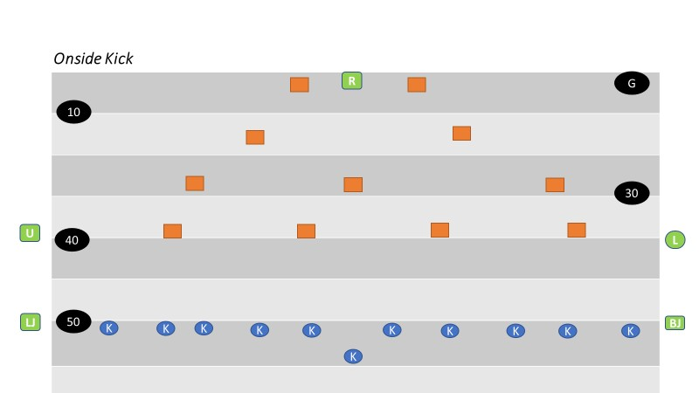

SECTION 12: KEYS

There are two basic types of keys: “Situational “and “Positional” keys

I. Situational Keys
  - Situational keys are based on the down, distance, score, time remaining, offensive and defensive formations and actions of players at the snap.
- In addition to down, distance and other fame factors, offensive and defensive formations provide hints as to what type of play an official can expect in a given situation. Most teams using the wishbone formation, for instance, are predominantly running teams. Teams using four-receiver sets and shotgun formations pass more times than not.
- Linemen provide situational keys.
- Pulling linemen indicate a sweep or trap block. Retreating linemen indicate a pass. Charging linemen indicate a running play. When offensive linemen provide only passive resistance, allowing defensive linemen to penetrate the neutral zone, a screen pass often follows.

II. Positional Keys
  - Positional keys are predetermined by the position you are working in the game.
  - Positional keys deal more with the Back Judge and Flank Officials.
  - The Back Judge’s main positional key is the inside-most eligible receiver on the strong side of the formation. At the snap, the Back Judge first observes the tackle to see if he’s run-blocking or pass-blocking, then observes the actions of his key receiver. If that player moves into another official’s coverage area, the Back Judge shifts his attention to players who have entered his coverage area.
  - Receivers, who are closely defended, always have priority coverage.
  - In order to determine positional keys, the officials must recognize the strength of the formation (strong side vs. weak side). The strong side is the side on which there are more eligible receivers outside of the tackle.
  - When determining keys, it doesn’t matter if a player is on or off the line of scrimmage. If players are stacked, the player nearest the line of scrimmage is considered to be the widest. For example, if a flanker is stacked directly behind the tight end, the tight end is considered the widest and is the Flank Official’s key.
  - A balanced formation is one in which there are the same number of eligible receivers outside the tackles on both sides of the formation.
  - An unbalanced formation is when one side has more eligible receivers on one side than the other.
  - The Back Judge has priority in determining keys, followed by the Flanks. Officials should not key the same player as the Back Judge.

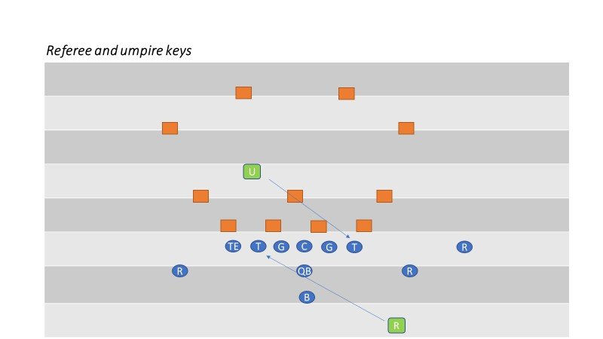

III. Unbalanced Formation
a. The Back Judge keys on the inside-most receiver on the strong side. The Flank Official on the strong side keys on the widest player of the formation, normally a split end. The Flank Official on the weak side keys the end nearest his side, normally a wide out.
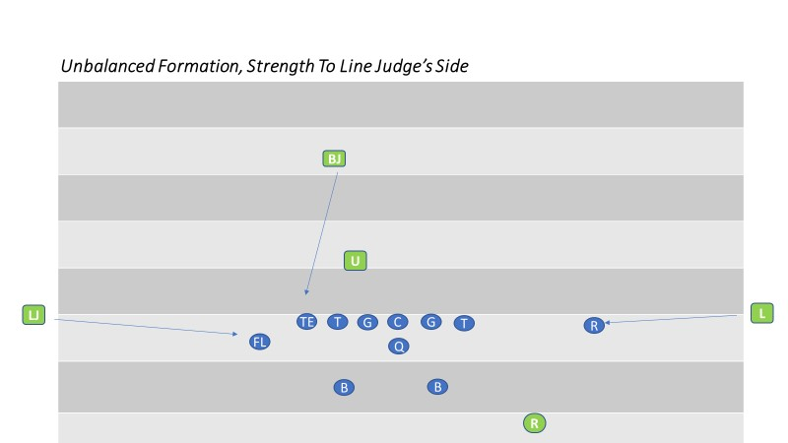
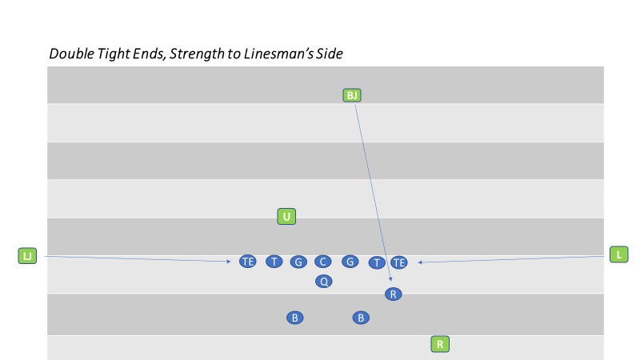

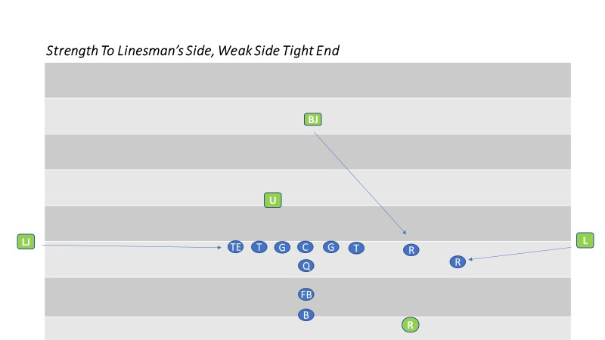

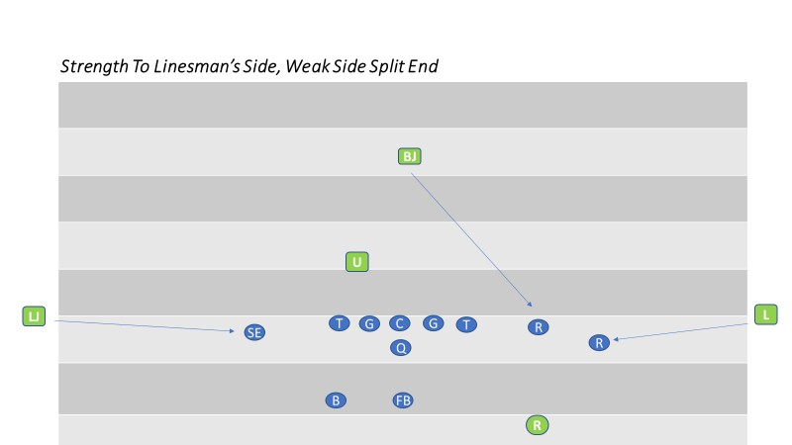

IV. Balanced Formation
a. In a balanced formation, strength is considered to be to the Lind Judge’s side of the field. The Back Judge keys on the inside receiver (usually a tight end). The Flank Officials key on receivers other than the Back Judge’s key and any backs who move toward them at the snap.
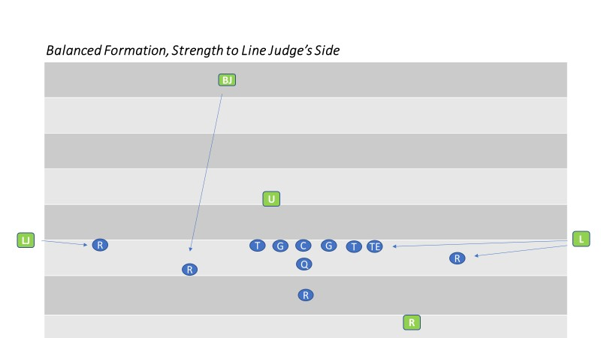

V. Three-Receiver (Trips) Formation
a. The Back Judge keys on the two inside receivers and the strong side Flank Official keys on the widest receiver. The weak side Flank Official keys on the end nearest him.
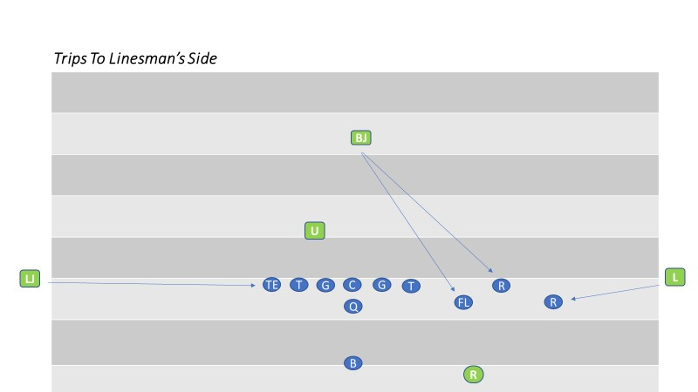

VI. Double Wing Formation
a. Strength is declared to the Line Judge’s side. The Back Judge keys the inside receiver on the Line Judge’s side. The Line Judge keys the widest receiver. The Linesman has both receivers on his side.
b. Flank Officials need to know that backs lined up between the tackle are the responsibility of the official whose side they come toward in route.
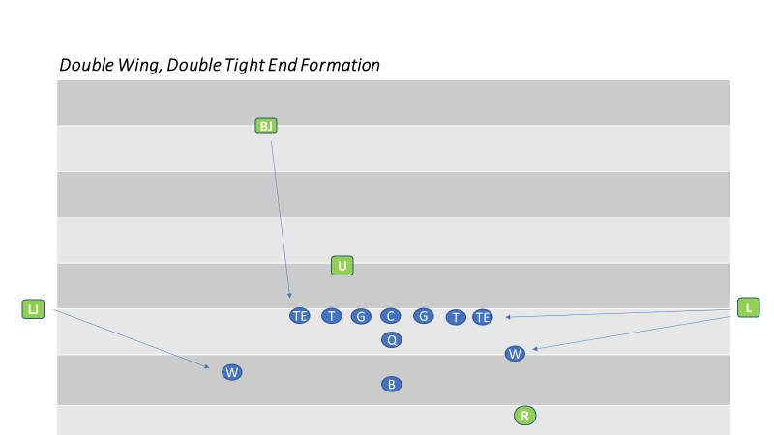

VII. Motion
a. An offensive player in motion can affect positional keys. It is crucial that the Back Judge and Flank Officials know where the motion man is at the snap because the strength of the formation (and therefore the keys) may change.
b. Team lines up strong to the Linesman’s side, but the Flanker on Linesman’s side goes in motion toward the Line Judge. If the motion man gets to the Line Judge’s side of the ball at the snap, the strength of the formation is now on the Line Judge’s side and the keys change. The Back Judge now has the motion man on the Line Judge’s side, the Line Judge has the widest receiver and the Linesman has the end on his side of the line. The Linesman is responsible for watching to ensure the motion man does not cut up field before the snap. Legality of motion is always the responsibility of the official away from whom the player is moving. If the player doubles back and goes in motion toward his original position, the official originally watching him continues to be responsible for determining legality of the motion.
c. If the motion man does not get to the opposite side of the formation and outside the
frame of the tackle before the snap, the keys do not change because the strength of the formation has not changed.

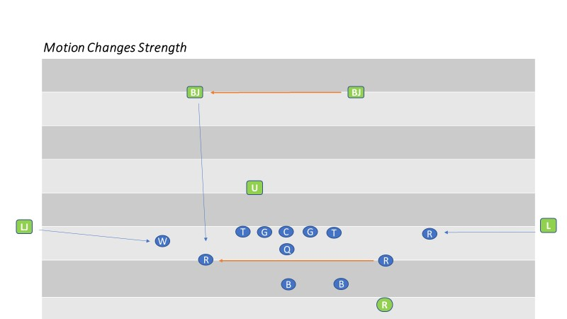
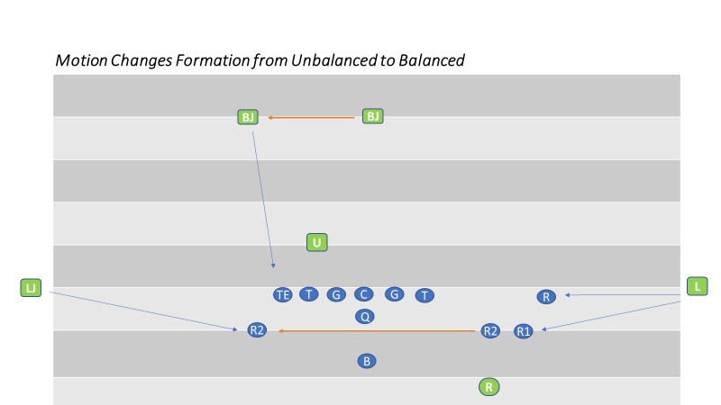

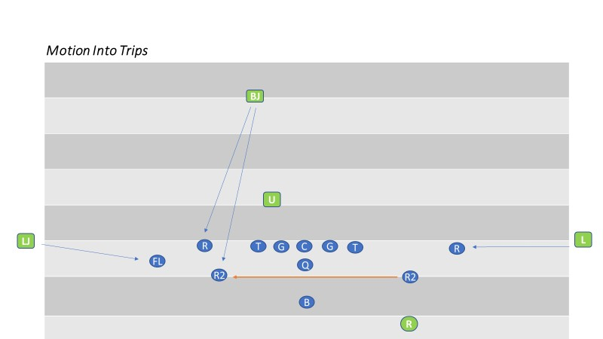

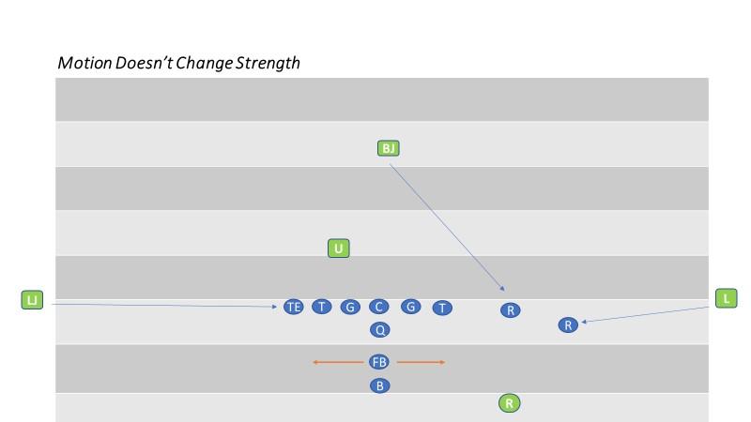

SECTION 13: PLAYS FROM SCRIMMAGE

BASIC POSITIONS

I. All Officials
a. Basic positions may vary, depending upon play situations, team formations, the field and weather conditions. Always box in the play. Avoid positions that may cause scrambling to avoid interference with plays.

II. Referee
a. Be in a position 12 to 14 yards deep and 12 to 14 yards wide of the original position of the ball, where you may comfortably see the ball and backs except Flankers, or a man in motion toward you. Usual position on the throwing arm side of the quarterback behind the deepest back, in position to see the snap. However the referee may work from either side of the quarterback’s passing arm. The position will be determined by the referee’s decision as to which side is the most efficient and effective.
b. Check the offensive formation and count the offensive players.
c. Check the back and quarterback for illegal motion, the ball at the snap, and assist the Umpire if there is movement of restricted Lineman.

III. Umpire
  - Alignment is variable according to formations of both teams avoiding position that may interfere with players. Adjust distance behind the defensive line according to width of Team A’s formation and, except on goal line or try situations, be at least seven yards deep.
  - Check the offensive formation and count the offensive players.
  - Whenever possible coordinate your position with that of the Referee for best coverage of interior line play. Read point of attack and your interior linemen. Know the ineligibles and where a forward pass first strikes anything.

IV. Head Linesman
- In the neutral zone extended and WIDE, out of bounds, off the sideline. Do not setup inside the 9-yard marks on your side. Adjust to the formation. Indicate offensive line of scrimmage by an extended foot, don’t exaggerate. Take final position astride the neutral zone.
- Check the offensive formation and count the players on your side. Confirm count with either the BJ or the R.
- Hand signals shall be used to indicate when the Team A player(s) closest to you, on your side, is off the line of scrimmage.
- Responsible for legality of motion man whenever he is on your side of the snapper (in any direction), until the snap. DOES NOT RELIEVE OPPOSITE OFFICIAL FROM MAKING OBVIOUS CALL!
- Be aware of the importance of assisting the Referee in making forward progress behind the neutral zone, particularly when the goal line is involved.
- Responsible for legality of motion man whenever he is on your side of the snapper (in any direction), until the snap. DOES NOT RELIEVE OPPOSITE OFFICIAL FROM MAKING OBVIOUS CALL!
- Be aware of the importance of assisting the Referee in making forward progress behind the neutral zone, particularly when the goal line is involved.

V. Line Judge
- In the neutral zone extended and WIDE, out of bounds, off the sideline. Do not setup inside the 9-yard marks on your side. Adjust to the formation. Indicate offensive line of scrimmage by an extended foot, don’t exaggerate. Take final position astride the neutral zone. On third down and 8 yards or more to go, move to line to gain. On all “HAIL MARY” plays, the Line Judge will move into “OFF” mechanics and go to the “goal line”
- Check the offensive formation and count the players on your side. Confirm count with either the BJ or the R.
- Hand signals shall be used to indicate when the Team A player closest to you, on your side, is off the line of scrimmage.
- Responsible for legality of motion man whenever he is on your side of the snapper (in any direction), until the snap. DOES NOT RELIEVE OPPOSITE OFFICIAL FROM MAKING OBVIOUS CALL!
- Be aware of the importance of assisting the Referee in making forward progress behind the neutral zone, particularly when the goal line is involved.
- Responsible for legality of motion man whenever he is on your side of the snapper (in any direction), until the snap. DOES NOT RELIEVE OPPOSITE OFFICIAL FROM MAKING OBVIOUS CALL!
- Be aware of the importance of assisting the Referee in making forward progress behind the neutral zone, particularly when the goal line is involved.

VI. Back Judge
a. Take position slightly behind deepest defensive back, approximately 20 to 25 yards beyond the scrimmage line. Favor the open side or middle of the field. Adjust to flankers and possible receivers. Be on the side of the tight end if only one. Count the defense, confirm count with flank.

SECTION 14: RUNNING PLAYS

RUN MECHANICS

RESPONSIBILITIES AT THE SNAP

ALL OFFICIALS
Concentrate on your area of responsibility. “Fish in your own pond.”
Verify no false starts or encroachment, legal snap (except BACK JUDGE)

REFEREE
- Observe the snap, then read the action of the Quarterback, Backs and Lineman to determine the type of play
- Allow your reads to help you identify the point of attack, while maintaining primary responsibility for action on and by the quarterback

UMPIRE
- Observe the snap then read run/pass by observing the block(s) by the guard(s) or center (block down, cross block, pass block, pulling, reach block, etc.)
- Allow your reads to help you identify the point of attack

HEAD LINESMAN
- Observe the snap then momentarily read run/pass by observing the block by the near tackle (block toward, pass block, pull, etc.)
- Locate the ball and the point of attack but do not focus on it
- On plays beginning at or within the five-yard line, going into the end zone, move to the goal line and officiate back to the line of scrimmage
- On plays beginning at or within the three-yard line, going out of the end zone, move back to the goal line and officiate forward to the line of scrimmage

LINE JUDGE
- Observe the snap then momentarily read run/pass by observing the block by the near tackle (block toward, pass block, pull, etc.)
- Locate the ball and the point of attack but do not focus on it
- On plays beginning at or within the five-yard line, going into the end zone, move to the goal line and officiate back to the line of scrimmage
- On plays beginning at or within the three-yard line, going out of the end zone, move back to the goal line and officiate forward to the line of scrimmage

BACK JUDGE
- Observe action on the tight end

RESPONSIBILITIES AFTER THE SNAP

ALL OFFICIALS
- Know when you have responsibility for the runner and progress and when you have responsibility for action away from the ball
- Maintain separation from the players and other officials and keep a wide view, even when you have responsibility for the runner and progress

REFEREE
- After determining the point of attack, shift your focus to appropriate run zone. Know where the runner is, but he should not be your focus once he is beyond the line of scrimmage
- If the point of attack is toward you, you have responsibility for the legality of blocks in Zone 2
- If the point of attack is away from you, you have responsibility for the legality of blocks in Zone 3
- If the point of attack is up the middle, you and the umpire both have responsibility for the legality of blocks in Zone 2
- If the point of attack is outside the inbounds marks, move to that side while maintaining your view of the action behind and around the runner
- If the point of attack is between the inbounds marks, box in from the rear, again focusing on blocks behind at the point of attack and around the runner
- After the runner is down, maintain a wide view of the dead ball action. If the play ends out of bounds, hustle to the sideline and ensure players separate and return inbounds. Assist with getting the ball to the UMPIRE
- If the ball is dead between the inbounds marks, hustle to that spot while keeping your head up to observe the action around the pile. Assist the UMPIRE

UMPIRE
- After determining that the initial blocks of the center and guards are legal and determining the point of attack, shift your focus to the appropriate Run Zone. Know where the runner is, but he should not be your focus
- If the point of attack is away from you, you have responsibility for judging the legality of blocks in Zone 3
- If the point of attack is toward you, you have responsibility for judging the legality of blocks in Zone 2
- If the point of attack is up the middle, you and the referee both have responsibility for judging the legality of blocks in Zone 2.
- If the ball is dead outside the inbounds marks, hustle to the dead ball spot while maintaining a wide view of the dead ball action. The umpire must go outside the inbounds marks to assist in retrieving the ball and spotting it
- If the ball is dead between the inbounds marks, hustle to that spot while keeping your head up to observe the action around the pile
- You are responsible for maintaining control around the pile. Talk to players as they un-pile, encouraging them to do so in a sportsmanlike manner
- Communicate to the flank officials with “I’VE GOT BALL” on a goal line play if the flank officials look for assistance and you are certain the ball is across the goal line and in possession

LINE JUDGE and HEAD LINESMAN
- After reading the block of the near tackle, momentarily locate the point of attack and the runner
- You always have the progress spot all the way until the runner crosses the goal line. This includes an accurate spot when the runner goes out of bounds Optional – The Back Judge will spot the ball when he/she believes it is the most efficient and effective way to have the ball spotted.
- On plays within the 10 yard line, if a play threatens the goal line, be prepared to be at the goal line to make the appropriate call
- If the point of attack is away from you, you have responsibility for judging the legality of blocks and action in Zone 4, maintain a wide view of the action while paralleling the progress spot, observing player conduct away from the play
- If the point of attack it toward you, you have responsibility for judging the legality of blocks in Zone 1, observe blocks in front of the runner until you take over responsibility for the runner at the line of scrimmage. If the runner is headed toward your sideline, allow the play to go past you (move into the offensive backfield, if necessary), then trail the play. If the runner crosses the sideline, hustle to the spot and mark progress. Signal timeout while observing the out of bounds dead ball action. Do not look at the ground. If the runner crosses the goal line and continues out of bounds, signal touchdown while observing all dead ball action
- After the ball is dead, close to the dead ball spot. You must move into the field on every play (unless safety prohibits) to show presence until the colors separate. Do not pass players and do not close beyond the near inbounds mark unless:
- The line to gain is threatened
- The goal line is threatened
- The ball is loose then recovered
- In these three cases, hustle to the dead ball spot

BACK JUDGE
- Read the play before moving, then, slowly backpedal while identifying the point of attack
- Observe blocks and other action in front of the runner at the second level. Look for holding, blocks below the waist, and clips
- Maintain a large cushion as the runner moves downfield all the way to the goal line
- Maintain your “inside out” view of the action
- After the runner is down, maintain a wide view of the dead ball action. If the play ends out of bounds, more than three yards downfield, hustle to the sideline and ensure players separate and return inbounds. Escort players back in bounds if in the opponent’s team area. Optional–The Back Judge will spot the ball when he/she believes it is the most efficient and effective way to have the ball spotted.
- Assist in getting the ball / a new ball to the umpire so it can be spotted

POINTS OF EMPHASIS

REFEREE
- False starts
- Illegal shifts
- Motion
- Blocking around runner and by team A backs
- Illegal acts around runner
- Reverses and trick plays
- Free blocking zone

UMPIRE
- False starts
- Illegal snaps
- Illegal use of hands and other illegal blocks
- Free blocking zone

LINE JUDGE and HEAD LINESMAN
- Encroachment
- False Starts
- Illegal motion, shifts, formations
- Clipping, blocks in back and use of hands

RUN ZONE COVERAGE
The following mechanics refer to “zones”. The zones are determined by the direction of the run and subsequent action.
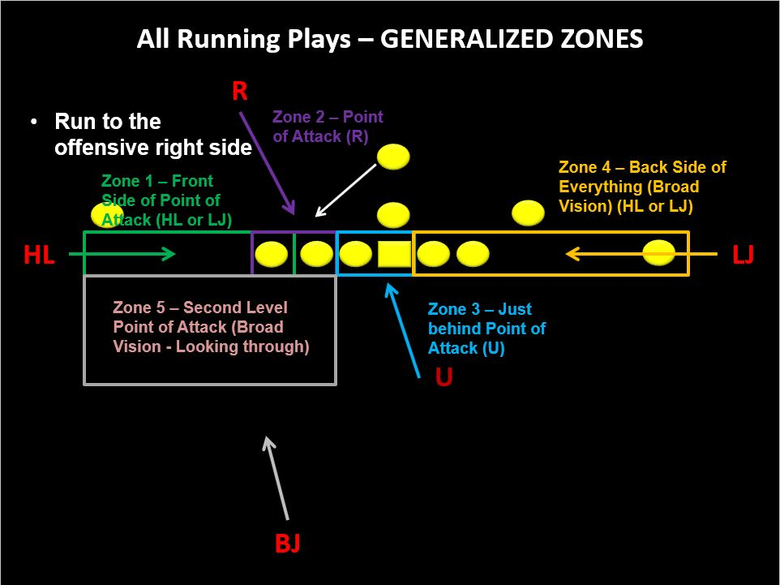

RUN TOWARD THE REFEREE

REFEREE
- Rule on legal cadence by QB
- Read run to your side
- Open-up facing more downfield and focusing on Zone 2 in front of you (most likely the “edge block”)
- Use read vision so as not to miss defensive penetration (bad color)
- View edge block of tackle or tight end or crack back
- As play gets beyond the edge block, triangulate action in Zone 1 with flank and BACK JUDGE

UMPIRE
  - Clear your initial keys
  - Read run away from your side
  - Step back 45 degrees with foot in direction of the run to open up your body
  - Continue to view action in Zone 3 (most likely your initial keys)
  - Move at a 60-degree angle toward the run action keeping your head and eyes on Zone 3
  - Your movement at 60-degree angle should maintain your relationship with Zone 3 as players are normally moving in the same direction
  - As the play progresses and you continue to move, include Zone 2 action in your read vision
  - As the play finishes observe the conclusion of the play and dead ball action from away

NEAR FLANK
- Read snap-tackle- run or pass
- If run, observe tackle and then pick up back with read vision.
- Observe action on runner if/when he’s threatened
- If runner is not threatened, keep read vision on blocks in front of the runner.
- Back Judge
- Clear your initial key TE/slot receiver (no chop block or low block)
- Read run and move your read vision to Zone 1 and view blocks in front of the runner
- Be aware of crack back blocks

AWAY FLANK
- Read snap-tackle- run or pass
- If run away from you, use read vision to observe action in Zone 4
- As the play progresses well away from you, close to hash marks acknowledging the growth in the size of zone 4 and the increase in the number of players in that Zone.

RUN AWAY FROM THE REFEREE
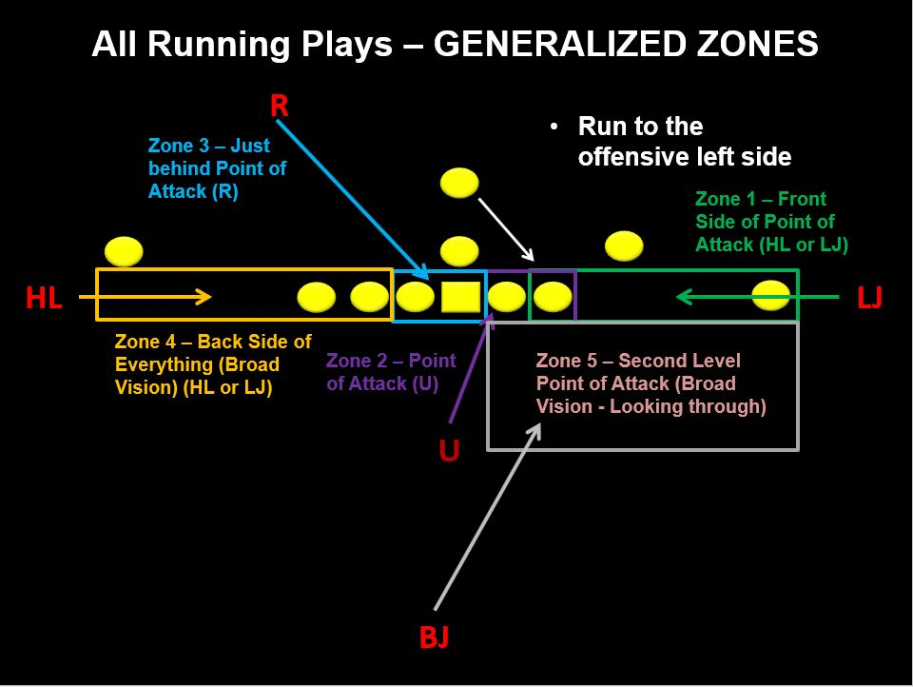

REFEREE
- Rule on legal cadence by QB
- Read run away from your side
- Move laterally toward the direction of the run but keep you head and focus on Zone 3 (most likely guard-center-guard)
- Use read vision so as not to miss defensive penetration (bad color)
- Continue to move laterally as you add zone 2 action with your read vision
- If the QB is the runner, you must observe him as a possible passer (abandon Zone 3)
- Continue to move into the team box area if the QB ends up there (or leave to BJ if he beats you there)

UMPIRE
- Clear your initial keys
- Read run toward your side
- Step back 45 degrees with foot in direction of the run to open up your body
- View action in Zone 2 (the edge block)
- View edge block of tackle or tight end or crack back
- Move at a 60-degree angle toward the run action keeping your head and eyes on Zone 2
- As play gets beyond the edge block, triangulate action in Zone 1 with flank and BJ
- As the play finishes observe the conclusion of the play and dead ball action before you close on the dead ball

FLANKS AND BJ
Same as listed above but the responsibilities of flank officials switch and BJ’s responsibilities go to the other side

SECTION 15: FORWARD PASSESS
BASIC POSITIONS AND AREA COVERAGE

I. Referee
- When the passer retreats, remain wide and deeper than the potential passer.
- If the passer is not threatened, observe legality of blocks in the offensive backfield and by line keys.
- The Referee is solely responsible for intentional grounding and should use a bean bag to mark the spot of the pass if need to confer with other officials.
- As QB is threatened and attempts to pass, determine if arm is moving forward
- Referee may consult with other officials on the positioning of eligible receivers.
- Remain behind the line to observe legality of the throw and action against the passer.
- After the passer throws the ball, continue to observe him until there is no threat of a foul. Ensure that the passer is not roughed or thrown roughly to the ground.
- Signal if the pass is tipped/touched
- Verbally alert the defenders when the passer has released the ball.
- Continue to observe the offensive and defensive players action behind the line before moving out of the area.
- Dead ball officiate
- Assist in relay / spotting ball on plays ending behind LOS
- ANTICIPATE
  - Forward or backward pass
  - Pass attempt vs. fumble
  - Roughing passer
  - Illegal pass (beyond LOS or intentional grounding)

II. Umpire
- Check legality of numbers of interior offensive linemen at the snap.
- Observe action of players in, and directly behind, the neutral zone, illegal advance downfield of ineligibles.
- When Umpire reads a forward pass play, he should step toward the line of scrimmage. This removes him as a target and opens up his area for shallow drag-pass patterns. This position permits Umpire to observe linemen moving illegally downfield.
- After observing play of linemen and their contact with up blocking backs, pivot to assist on low trajectory and short passes.
- Use tip ball signal if pass is touched in or behind neutral zone. Know if the pass crosses the neutral zone.
- Assist the Referee in determining legality of forward passer.
- Dead ball officiate
- Spot ball
- ANTICIPATE
  - Holding, Clipping, Illegal blocks
  - Ineligibles downfield
  - Assist in illegal pass determination
  - Touching of pass in or behind neutral zone

III. Flank Officials
- Assist the Umpire in checking the legality of numbers of offensive interior linemen.
- Check legality of positions for players with eligible numbers.
- Read through key receiver to nearest offensive lineman to read play
- After initial charge of linemen, move into position to check blocking and contact of eligible receivers and linebackers.
- Be ready to rule on the direction of a pass. The covering official, toward whom the ball is thrown, should signal, by extending one arm horizontally in the direction of the offensive backfield if the pass is ruled backward.
- Remain near LOS until pass is thrown unless all receivers are deep, stay underneath the shortest receiver (EXCEPTION: Goal line coverage when signaled by BACK JUDGE- responsible for goal line on snaps inside 15-yard line, snap from inside 5 yard line, move immediately to goal line)
- Drift downfield cautiously for the first 5-7 yards, approximately halfway between flat zone and deepest receiver. While pass is in flight, move to the most advantageous position to judge the play. If the receiver is driven backward after the catch, the opposite Flank Official should assist in marking the forward progress spot.
- Always be prepared to come back to rule on play near the neutral zone in addition to sideline action. Observing the wide initial position is helpful in covering any pass. If potential passer decides to run, you must cover him beyond the neutral zone. Entire sideline is your responsibility.
- On catch attempts near sideline, focus on feet then hands. Near end line, focus on hands, then feet
- On catch attempts near intersection of sideline and end line, make eye contact with BACK JUDGE before signaling
- If pass is caught in bounds and then player goes out of bounds, blow whistle, stop clock, mark spot, continue to officiate.
- After an incompletion, obtain a ball from the ball person and form a relay to return the ball to the official nearest the previous spot.
- If an airborne player receives a pass near the sideline and first returns to the ground out of bounds, after giving the incomplete signal, the covering official may, with both arms, give a sweeping motion towards the out of bounds.
- Off-ball officiate on plays away. Come into the numbers on plays into the opposite side zone
- Dead ball officiate
- ANTICIPATE
  - Holding
  - Pass interference
  - Catch/No-catch
  - Unnecessary contact / Personal fouls
  - Forward/backward pass
  - Illegal participation

IV. Back Judge
  - Cover plays from behind deepest receivers.
  - Initial focus on your key(s) as they leave the Line of Scrimmage.
  - Once receivers are no longer threatened at the Line of Scrimmage, you should transition quickly into zone coverage.
  - Bracket pass receivers between yourself and either Head Linesman or Line Judge, depending on location.
  - Be at goal-line if receiver crosses (EXCEPTION: if play starts inside 15-yard line, you are responsible for end line. Prior to play, signal to FLANKS by positioning on end line and pointing to corner pylons)
  - On catch attempts near sideline, focus on the hands. On catch attempts near end line, focus on feet then hands
  - Use appropriate signals for juggled or catches out of bounds
  - On catch attempts near intersection of sideline and end line, make eye contact with FLANK official before signaling, unless you know it is incomplete
  - If pass caught in bounds and then receiver goes out of bounds, stop clock and dead ball officiate. If multiple players go out of bounds, follow and escort opposing players back to field of play
  - Mark progress on long run or pass
  - Dead ball officiate
  - Assist with relay / spot ball on long completions

V. All Officials
- Be alert for an illegal pass, especially after a completion.
- Observe touching or catching by an ineligible player.
- Watch particularly for holding or illegally contacting eligible receivers and all contact beyond the neutral zone both before and after the pass is thrown.
- Observe action when opposing players contest for the pass.

SECTION 16: GOAL LINE PLAYS

I. Referee
a. Position and coverage are the same as for other scrimmage plays with the forward point of advancement is usually determine by the Flank Officials. Signal score only after you are positive that all requirements are met.

II. Umpire
a. Adjust your position to account for proximity to the goal line, but never directly on the goal line. Never signal score but assist the Head Linesman and Line Judge verbally or visually if necessary.

III. Head Linesman and Line Judge
a. Initial position must be wide, out of bounds and off the sideline. When the ball is snapped at or inside the 5-yard line, move toward the goal line at the snap and rule on the score or an accurate forward point when you see the ball.

IV. Back Judge
a. Start on the end line if the snap is on or inside the 12-yard line. The decision to move to the end line can be modified based on the type of play the offense is exhibiting. When the BJ is going to give up the goal line should be covered in the pregame discussion and needs to be communicated during the game to the flanks by voice or radio. Do not leave the goal line until the flanks have affirmed that they have assumed goal line coverage. Once you receive that confirmation, assume complete responsibility of the end line coverage.

V. Umpire, Head Linesman and Line Judge
a. If the balls forward progress stops short of the goal line, move in on the ball, mark and hold the dead ball spot until the ball is spotted for the next play.

VI. All Officials
a. Indicate the score with the touchdown signal only when in position to determine that all requirements are met with the exception of the umpire who will never signal.

Reverse Goal Line

I. Referee
a. Looks to appropriate Flank Official for progress spot or safety signal.

II. Umpire
a. Continues to observe blocking.

III. Head Linesman and Line Judge
a. If runner is clearly downed in end zone in coverage area, hustle in and signals safety. If runner is out of coverage area, hustle in for dead-ball officiating,

IV. Back Judge
a. Observes action of players away from pile.

SECTION 17: FUMBLES

SIGNALS

The closest official who actually sees the fumble, and who has recovered it, should point in the proper direction, no matter who recovers. If there is a change of possession, make sure to signal time out, “Stop the clock!” The Referee will then signal the next down when he makes the ball ready for play.

DIGGING OUT FUMBLES

Should it become necessary to “dig out” a fumble, the official nearest the ball should dig for the ball. The next official to the area should signal to stop the clock and look to the clock to ensure it is stopped. The stop the clock signal should be relayed by the remainder of the crew.

When the digging official determines possession he should verbally relay possession information to the nearest standing official, normally the Referee, who will then signal the proper direction. If possible, the signaling official will point to the recovering player to assist the press box. Only the Referee, if he is not the signaling official, should relay the direction signal.

SECTION 18: SCRIMMAGE KICKS (PUNT PLAYS)

Referee watches play on kicker, Head Linesman holds the line of scrimmage until ball crosses neutral zone, then moves slowly downfield covering on their sideline between line of scrimmage and deep receiver(s). Umpire takes initial position 10 to 12 yards deep and favoring the Line Judges side. Line Judge stays on line until it is apparent it is a kick, and then moves downfield covering their sideline between the line of scrimmage and the deep receiver(s). Head Linesman and Line Judge are alert for blocked or partially blocked kicks. Back Judge takes a position behind receiver(s). Head Linesman know if kick crosses neutral zone. Be alert for delay by kicking team designed to confuse opponents.

PRE-KICK MECHANICS

ALL OFFICIALS
HUSTLE TO POSITION!

REFEREE
- Count the kicking team and confirm with the UMPIRE and the HEAD LINESMAN
- View the lineman and know numbering exceptions
- Take a position at the side of the kicker, wide enough to see the ball from the snap to the kick.
- Be able to see blockers and kicker at the same time.
- Be in position three to five yards outside the tight end and two to three yards behind the kicker, on kicking leg side.
- Adjust to the situation; if punter is kicking from own end zone, warn kicker if they are on outside the end line prior to the snap

UMPIRE
- Position approximately seven (7-10) yards from the line of scrimmage and favor the LINE JUDGE side of the field Optional: The umpire may take a position in K’s backfield next to the kicker opposite the R
- Count the kicking team and confirm with the REFEREE
- View the lineman and know numbering exceptions
- Tell the receiving team lineman “DO NOT HIT THE SNAPPER”

HEAD LINESMAN
- Position on the line of scrimmage in front of the down marker
- Count your team and look for confirmation from REFEREE or BJ that he has eleven players
- View formation to see that they have at least seven (7) players on the line of scrimmage
- View the position of the outside kicking team players. Know who is eligible to catch a pass

LINE JUDGE
- Position on the line of scrimmage
- Count your team and look for confirmation from REFEREE or BJ that he has eleven players
- View formation to see that they have at least seven (7) players on the line of scrimmage
- View the position of the outside kicking team players. Know who is eligible to catch a pass

BACK JUDGE
- Position slightly behind and to the side of the deepest receiver on the same side of the field as the HEAD LINESMAN (approximately 7-10 yards to the side and 3-5 yards behind the receiver but always within the hash marks). If the position of the ball at the snap, and the position of the returner, places you outside the hash marks on the HEAD LINESMAN’S side of the field, adjust your starting position to the LINE JUDGE’S side of the field (approximately 7-10 yards to the side and 3-5 yards behind the receiver but always within the hash marks. If two receivers, field position may require you to take a position between the receivers. On kicks from inside the receiving team’s 40 yard line, take a position on the goal line at the sideline. When the ball is possessed, move to a position in the middle of the field keeping the runner between you and the sideline. You are responsible for coverage of runner from an inside-out view favoring the chains side of the field, if possible
- Count the receiving team and confirm with the LINE JUDGE
- Provide fair catch instructions to the receiver(s) if possible
- Hold a beanbag in your hand

KICK MECHANICS

ALL OFFICIALS
Strange things happen on kicks. Be mentally prepared for various scenarios based on your position. Be alert for blocked kick. Be alert for recovery and advance

REFEREE
- Normal Kick –Watch blocking by the A Team backs and protect the kicker. Stay with the kicker until all is clear. Be the last official down the field and box in all players from behind with wide vision. If the return breaks through defense, be prepared to take the runner all the way to the goal line
- Bad Snap - When there is a bad snap on a scrimmage kick and the play goes deep into the backfield, you will follow the ball back and bracket with HEAD LINESMAN
- Kick Out of Bounds – If the kick goes out of bounds in flight, move to the spot of the kick and then proceed to line up the out of bounds spot with covering official by signaling with a hack
- After the Play - Indicate to HEAD LINESMAN when to move chains, hustle to the new spot and indicate first down and direction of ball

UMPIRE
- Watch action on the SNAPPER
- Normal Kick – Initially view line play action and action on ground in front of ball. Pivot and release down the field watching the action of the players and blocking. On returns up middle and to other side, maintain wide inside-out vision
- Bad Snap – Lined up on the defensive side of the line- When there is a bad snap on a scrimmage kick and the play goes deep into the backfield, you will move up to the line of scrimmage and rule on whether the ball crossed the line of scrimmage
Bad Snap – Lined up in offensive backfield-– When there is a bad snap on a scrimmage kick and the play goes deep into the backfield, you will follow the ball back and bracket with REFEREE
- At the end of the play DEAD BALL OFFICIATE. Spot the incoming ball to be ready for play

HEAD LINESMAN
- Look to see that the ball has been kicked and quickly see where the ball is headed (i.e. short, long, right, left). DID THE BALL CROSS THE LINE OF SCRIMMAGE, HIT THE GROUND OR A PLAYER?
- Normal Kick – View the blocking and action around the kicking team’s eligible players (the widest players on your side) and view line action until the ball clears. After the ball has crossed the line of scrimmage, quickly release down the field and parallel the play from the outside with wide vision. Continue to watch the action as the players and ball move toward the receiver. Observe blocking down the field and in front of the runner. Mark first touching with a bean bag
- Bad Snap-Umpire-Lined up on the defensive side of the line and you are facing the Referee When there is a bad snap on a scrimmage kick and the play goes deep into the backfield, you will follow the ball back and bracket with REFEREE (the UMPIRE will then have kick crossing or not crossing line)
- Bad Snap Umpire-Lined up on the offensive side of the line, duties are the same as a normal kick
- Kick Out of Bounds – Medium to short kicks going out of bounds on the bounce, you are responsible for your side of the field
- If you are one of the covering officials, at the end of the play, spot progress and square-up with the LINE JUDGE, stop the clock and signal direction of the team in possession. DEAD-BALL OFFICIATE. If you are holding the spot, cover the ball until you are relieved by another official. Look to the REFEREE for confirmation to move the chains

LINE JUDGE
- Look to see that the ball has been kicked and quickly see where the ball is headed (i.e. short, long, right, left). DID THE BALL CROSS THE LINE OF SCRIMMAGE, HIT THE GROUND OR A PLAYER?
- Normal Kick View the blocking and action around the kicking team’s eligible players (the widest players on your side) and view line action until you read a good snap. Once you have determined a good snap, quickly release down the field and parallel the play from the outside with wide vision. Continue to watch the action as the players and ball move toward the receiver. Observe blocking down the field and in front of the runner. Mark first touching with a bean bag
- Bad Snap-Umpire-Lined up on the defensive side of the line and you are facing the Referee When there is a bad snap on a scrimmage kick and the play goes deep into the backfield, you will follow the ball back and bracket with REFEREE (the UMPIRE will then have kick crossing or not crossing line)
- Bad Snap Umpire-Lined up on the offensive side of the line, duties are the same as a normal kick
- Keep the runner between you and the BACK JUDGE. You are responsible for your sideline coverage and progress. Watch the action immediately around runner observe action on and by the ‘flyer’ (Team A players charging towards the receiver) and receivers positioned close to the line of scrimmage. When the ball is not in your area, take a position to observe action in your area ahead of the runner
- Fair Catch - View the action around the receiver and make certain the receiver catches the ball cleanly and it does not go through his hands. Stop the clock upon signal with the BACK JUDGE. Get the spot and hold it until the chains are set
- First Touch Violation – Use your beanbag if there is a first touching violation by the kicking team. Note: there may be more than one spot of the first touching violation
- If you are one of the covering officials, at the end of the play, spot progress and square-up with the HEAD LINESMAN, stop the clock and signal direction of the team in possession. DEAD-BALL OFFICIATE
- Kick Out of Bounds – On kicks out of bounds, you are responsible for your sideline. Blow your whistle and stop the clock. Line-up deeper than where the ball went out of bounds on the sideline (no deeper than the goal line) with outside arm straight above your head. Make eye contact with REFEREE and begin to walk toward the original line of scrimmage. The REFEREE will hack when you have reached the out of bounds spot

BACK JUDGE
- Look to see that the ball has been kicked and quickly look to see where the ball is headed (i.e. short, long, right, left)
- Normal Kick – View the receiver and run up to be even with the receiver as he prepares to catch the ball. Your only view is the receiver and stay to the side of him by 7-12 yards. Look to see that the receiver catches the ball cleanly and that there was no kick catch interference or to rule on fair catch
- Drop your beanbag where the kick ends. Remember that the kick ends when any player gains possession or when the ball becomes dead. If the kick crosses the goal line, blow your whistle and signal touchback
- Keep the runner between you and the LINE JUDGE. You are responsible for coverage of runner from an inside-out view favoring the chains side of the field. Your distance should be about 10-15 yards from the runner. You may have progress
- Fair Catch - View the receiver and run up to be even with the receiver as he prepares to catch the ball. View the fair catch signal (valid or invalid?). Make certain the receiver catches the ball cleanly and it does not go through his hands. With a confirmed catch, stop the clock and blow your whistle
- First Touch Violation – Use a beanbag if there is a first touching violation by the kicking team. Note: there may be more than one spot of the first touching violation
- You are one of the covering officials. At the end of the play, stop the clock and signal direction of the team in possession. DEAD-BALL OFFICIATE
- Kick Out of Bounds – On medium to long kicks out of bounds, you are responsible for the sideline opposite the LINE JUDGE. Blow your whistle and stop the clock. Line-up deeper than where the ball went out of bounds on the sideline (no deeper than the goal line) with outside arm straight above your head. Make eye contact with REFEREE and begin to walk toward the original line of scrimmage. The REFEREE will hack when you have reached the out of bounds spot
- Communicate possession and direction to the REFEREE

POINTS OF EMPHASIS

REFEREE
- Fake kicks
- Bad Snaps
- Blocked Punt
- Roughing or Running Into the Kicker; Incidental Contact
- Illegal Blocks
- Illegal Use of Hands
- Clock Status before and after the play

UMPIRE
- Snapper
- Blocking; legal or illegal, illegal use of hands
- Numbering exceptions
- Check first touches, forced touching, muffs, fumbles, blocked punts

HEAD LINESMAN and LINE JUDGE
- Blocking
- Touching of ball; beyond line of scrimmage
- Illegal Kicking
- Interference
- Muff and First Touching Violations
- Ineligible players downfield

BACK JUDGE
- Fair Catch Signals
- Blocking
- Goal Line
- Illegal Batting or Forward Handing
- Muff and First Touching Violations
- Fair Catch or Kick Catch Interference
- Ball Out of Bounds in Flight

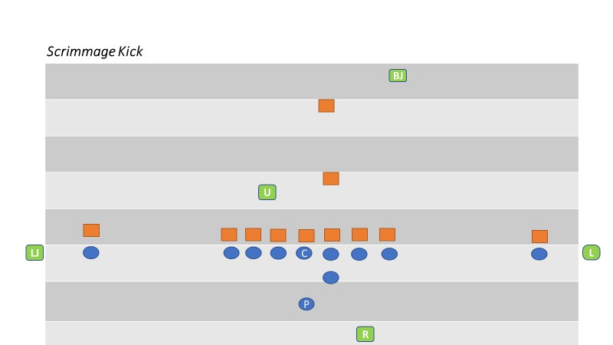

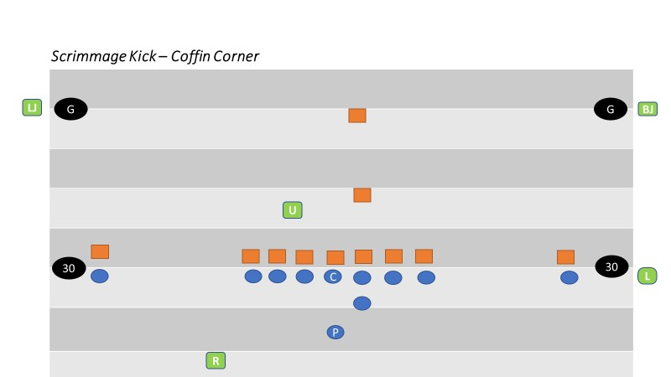

SECTION 19: TRY AND FIELD GOAL PLAYS
BASIC POSITIONS AND COVERAGE

I. Referee
- On a try or field goal, Referee’s position is a yard or so to the rear and several yards to the side of the potential kicker, facing the holder where you can see the ball when spotted for the kick.
- When it is obvious a kick will take place and a potential holder and potential kicker are not seven or more yards behind the neutral zone, the Referee will place an open hand on his chest, indicating to the U that Team A is not in a legal scrimmage kick formation.
- Covers as usual if a run or pass.
- Assist in sideline coverage if run develops to Flanks vacated side.
- Signal score after being positive that requirements are met.
- Rule on roughing or running into the kicker and/or holder.

II. Umpire
- Adjust to favor vacated Flanks side.
- Adjust depth based on length of kick.
- Look down the line at the initial charge, checking blocks of offense and action by defensive players.
- Observe defensive linemen over center to avoid roughing and serious injury to snapper. Shift observations to contact between offensive and defensive players.
- Assist in goal line coverage if run develops to flanks vacated side.

III. Flank Official Facing the Referee
- Responsible for legality of the snap and entire line of scrimmage.
- Quickly move to goal line if a run develops.
- After the kick, move onto the field to observe dead ball action by players on the line of scrimmage.
- If the kick is short or partially blocked, must know if it crossed the neutral zone.

IV. Flank Official on the Back Side of the Referee
- Responsible for your upright goal post.
- If run develops to your vacated side, quickly move along back line to back pylon to rule on the sideline. Next move is toward goal line to assist. If run situations develop to the other side, opposite Flank has primary sideline responsibility with Referee’s assistance.
- If attempt is short and ball remains alive, officiate as a scrimmage kick on field goals only.
- If the kicking team’s initial formation is the “Swinging Gate,” remain on the line of scrimmage until the team shifts into scrimmage kick formation with an obvious kicker and holder.
- If the kicking team originally lines up in scrimmage kick formation and then shifts to another formation, move to the end line corner of the end zone during the shift and then down the sideline toward your normal scrimmage play formation. Be ready to rule on the goal line.

V. Back Judge
- Responsible for your upright goal post and rule if ball hits or goes over, the cross bar on kick.
- If run develops, move to goal line to assist in ruling.
- If attempt is short and ball remains alive, officiate as a scrimmage kick.
- Sound whistle when ball becomes dead on attempted field goals and kick tries.

VI. Back Judge and other official Under the Goal Post
When the field goal or try attempt narrowly passes outside an upright, the official nearer the ball may give a sweeping motion with both arms away from the upright.

ALL OFFICIALS – SWINGING GATE and Optional PAT Mechanic
- All officials will be in their regular positions for a scrimmage down. If team A shifts to a formation normally used for a PAT or attempted field goal, the HEAD LINESMAN and LINE JUDGE will stay in their regular scrimmage down positions and the UMPIRE will move to the unoccupied goal post to rule on the kick success or failure. UMPIRE will still maintain responsibility for protecting the snapper
- The BACK JUDGE will retain primary responsibility for the whistle
- Prior to the snap, the UMPIRE and BACK JUDGE will establish eligible receivers on their respective sides of the offensive formation
- If the play is a fake kick, the UMPIRE will attempt to get to his normal scrimmage position while the remaining officials maintain their usual scrimmage play responsibilities
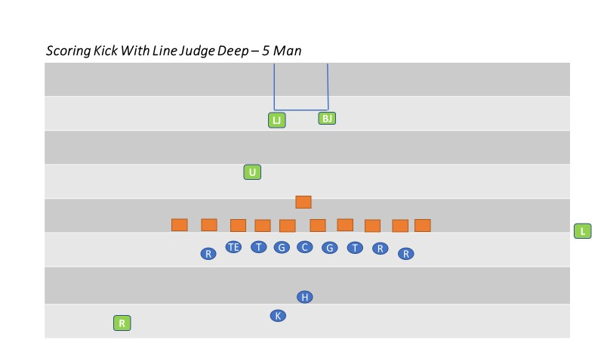
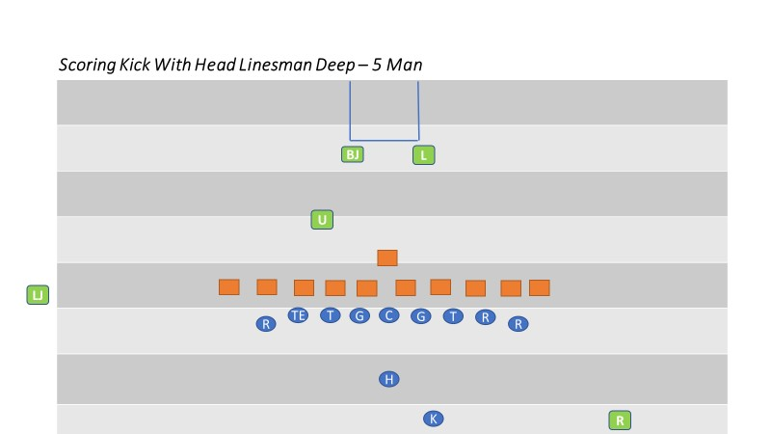

SECTION 20: TIME OUTS

PROCEDURES

I. Referee
a. Indicate a full length charged time out by facing the press box. Give time out signal then extend one arm in pointing fashion, horizontally, in direction of requesting team.
b. Check with Umpire as to the number of time outs charged to each team and the playing time remaining in the period. Notify the head coach when his team time outs are exhausted.

II. Flanks
a. Notify a coach from team on your sideline as to the number of time outs remaining for each team and of the time remaining in the period.

III. All Officials
a. When relaying the number of time outs, relay the number that the teams have remaining.

IV. Referee
a. Upon Back Judges’ signal that the time out interval has expired, or when both teams indicate readiness to resume before that time, direct teams indicate readiness to resume before that time, direct teams to prepare to resume play. Go to position, get ready signals from each captain and declare the ball ready for play within five seconds.

V. All Official
a. Record time left on the clock and number of requesting player when charged team timeout is requested. Do not huddle unless necessary.

VI. Flanks
a. Take a position halfway between your team and its team area. Direct teams to prepare to resume play upon signal from Back Judge.
b. Check number of players in your team’s huddle. Repeat this check after taking position
for the next down. Flanks are responsible for teams on their side.

VII. Umpire
a. Quickly take position over the ball. Remain over the ball until released by the Referee.

VIII. Back Judge
a. Time the one-minute time-out interval. When 20 seconds remain in the interval, sound your whistle three times, short but sharp. Move to your position and give a visual signal to the Referee when the interval expires. Be alert to assist the Referee if needed.

IX. Officials Time Out
a. Signal time out, then indicate Officials’ time out by tapping chest with hands.
b. Any Official may stop the clock for a coach’s conference. If the coach is not correct on their reason for requesting a coach’s conference, the coach’s team will be charged with a time out. After the time out has been charge, the procedure for a team time out will be carried out.
c. Signal time out when Team A is awarded a first down.
d. Declare ball ready for play as soon as needed when time out has ended.

X. All Officials
a. Signal time out and carry out usual duties.
b. When either team is in possession of the ball in advance of the line to gain, covering official indicates time out.
c. If game is disrupted for any reason, record down, team in possession, position of the ball and time remaining in the game.

XI. Injury Time Outs
a. Same as team time out, however permit as much time as is necessary. SAFETY OF INJURED PLAYERS IS MOST IMPORTANT. Use signal #3, followed with tapping hands on chest.
b. Do not allow players to assist teammates but direct that they wait for trained staff.
c. The Referee may permit water attendants to tend to their teams on the field during extended injury time outs.

SECTION 21: MEASUREMENTS

PROCEDURE

I. All Officials
a. When establishing forward progress or the end of the run, be sure there is no need for measurement before announcing the down. If close, announce the down and be alert for either captain’s request for measurement. If doubtful, call for measurement without captain’s request. In usual circumstances, the Line Judge will assist Referee with determining obvious first downs by stopping the clock. When a play ends close to the down marker, the Line Judge can assist the Referee by indicating “close”. The Referee can then move to the spot to determine if a measurement is needed or if a first down will be awarded.

II. Back Judge
a. Will ensure the ball is not moved after being spotted for measurement. If holding the ball is necessary, assume a position parallel to the ball’s axis and in advance of the line to gain, allowing room for chains, etc.
b. Clear the area of officials and players for press box view.

III. Referee
a. When the ball becomes dead in a side zone or out of bounds and measurement should be at the dead ball spot, have covering official place the ball at the proper spot. Indicate to the Head Linesman and to the press box that a measurement is needed.

IV. Head Linesman
a. Instruct the box operator to place the box at the position of the front stake, maintaining the previous down. Grasp the line-to-gain indicator and clip at back edge of back-yard line (don’t just grasp clip since clip could detach).
b. Bring the line-to-gain indicator behind ball and place clipped part of indicator at back edge of back-yard line.
c. Hold firmly and call “ready” to Umpire to stretch the indicator tight.

V. Line Judge
a. Go to yard line nearest rear stake. Mark a spot perpendicular to the ball to aide. b. Assist the Head Linesman in positioning the chain for an accurate measurement.

VI. Umpire
a. Take forward rod. Check for kinks in chain and be sure that chain is taut. Wait until Head Linesman calls “ready” then carefully tighten the chain only once. Don’t pull or jerk it. Have the rod perpendicular to the ground at the side of the ball until Referee announces his ruling, and then return rod to the chain crew.

VII. All Officials
a. If short of the line-to-gain, use the forward point established on the chain when spotting the ball at the inbounds line. If alternate game ball is available following the measurement, leave the ball in the side zone until an alternate ball is placed at the corresponding inbounds spot.

VIII. Head Linesman
a. If the end of the play was short of the line-to-gain, retain firm grasp of the chain and personally reset the chain at its original spot on the sideline. Check the point marked by your down box person and changes the down box indicator to the next down.

IX. Referee and Umpire
a. Umpire remains over the ball and the Referee announces down and distance. Get ready signals from the captains while Head Linesman is resetting chain. When Head Linesman is ready, declare the ball ready for play.

SECTION 22: CALLING FOULS AND ENFORCEMENT
Officials must study and master their individual responsibilities when it comes to penalty enforcement. It is the responsibility of the CREW assigned to each game to ensure that all penalties are enforced timely and correctly. This is an ongoing process that requires a thorough discussion, led by the assigned crew chief, to iron out any particular preferences and establish clear expectations for the crew. This is an on-going process for crews that work together throughout the year, starting with their pre-season meeting(s) and continues each week. Regardless of the level, all officials are responsible to their crew to communicate correctly and get it right.

PROCEDURE

The following is a collection of necessary penalty enforcement actions:
- Throw flag to the spot of the foul for fouls that will be enforced from that spot
- Throw flag high into the air for all other fouls
- Continue to officiate if live ball foul
- Kill clock immediately, using a staccato whistle, if dead ball foul
- Kill clock after the play, using a staccato whistle, if a live ball foul
- The staccato whistle alerts all other officials that we have a penalty
- Check the status of the clock to confirm it has indeed stopped
If the foul is a line of scrimmage/administrative foul or DPI or OPI foul:
- Hustle toward referee and give preliminary signal
- Verbally report the number of the offending player (use of radio to report the number of the player is permitted)
- Flank officials will assist their coaches with information and penalty options to assist the referee in obtaining the coach’s choice of penalty options (as necessary)
- Referee reports foul, yardage of penalty, and the direction the umpire is to go, to the umpire
- Umpire goes to previous spot and makes visual contact with HL and marches penalty off with the HEAD LINESMAN. LINE JUDGE holds enforcement spot until LJ and umpire visually confirms correct administration
- Referee gives penalty signal and correct down signal to the press box
- All crew members (especially the BACK JUDGE/LINE JUDGE ) provide the appropriate signal to the referee to either hack the ball ready for play or wind the clock
- Flank officials provide penalty information to their respective coaches
- Referee moves to his new pre-snap spot and checks crew and teams before giving the ready to play or winding the clock signal and whistle

If the foul is any other foul:
- Adjust your flag if it is a spot foul
- Communicate your foul to other official if there is more information available or to confirm you have the same or different fouls.
- If a foul is called by another official, the Back Judge or opposing flank should cover and hold the dead ball spot. Leave the ball
- Hustle to the referee and report:
  - Type of play;
  - Status of the ball when the foul occurred;
  - Foul;
  - Offending team;
  - Number; and position
  - The spot of the foul.
- The referee will ask clarifying questions if needed then immediately give the preliminary signal to the press box
- Flank officials will assist their coaches with information and penalty options to assist the referee in obtaining the coach’s choice of penalty options (as necessary)
- The umpire will listen to the report by the flank official
- Referee reports foul, yardage of penalty, enforcement spot, and the direction the umpire is to go, to the umpire
- Umpire goes to the correct enforcement spot and makes visual contact with HL and marches penalty off with the HL. LJ holds enforcement spot until LJ and umpire visually confirms correct administration.
- All crew members (especially the BJ) provide the appropriate signal to the referee to either hack the ball ready for play or wind the clock.
- Flank officials provide penalty information to their respective coaches.
- Referee moves to his new pre-snap spot and checks crew and teams before giving the ready to play or winding the clock signal and whistle.

PENALTY CODES / DOCUMENTING
It is recommended that all certified officials note each foul that they call during a game. It is highly recommended that a Foul Report is completed by the crew for each varsity game0 The recording of fouls helps in post-game discussions and improved 'video review' by the crew in all games that have video.

Foul notes can be taken quickly but should NOT interfere with your focus on the game or dead-ball officiating. Each official should develop his/her own technique for quickly noting their fouls and should include;
1) Quarter
2) Time Left
3) Team
4) Foul
5) Offense or Defense
6) Player number

Example
1/4:07/H/FST/O/88

Foul Codes have been developed to speed up the note taking and improve consistency between officials

FOUL CODES
5-YARD PENALTIES
DOG Delay of game
ENC Encroachment
FM Grabbing face mask
FST False start
IDP Ineligible downfield on pass
IFH Illegal forward handing
IFK Illegal fair catch signal
IFP Illegal forward pass
ILF Illegal formation
ILM Illegal motion
ING Intentional grounding
ISH Illegal shift
ISP Illegal snap
KOB Kick out of bounds
RNK Running into the kicker
SLI Sideline interference, 5 yards
SLW Sideline Warning (no yardage)
SUB Illegal substitution

10-YARD PENALTIES
DH Defensive holding
IBK Illegal block during kick
IBB Illegal block in the back
IUH Illegal use of hands
OH Offense holding

15-YARD PENALTIES
BAT Illegal batting
BBW Blocking below the waist
CHB Chop block
CLP Clipping
DPI Pass interference, defense
FMM Personal foul, face mask
HCT Horse collar tackle
HUR Hurdling
IKB Illegally kicking
ILP Illegal participation
KCI Kick catch interference
OPI Pass interference, offense
RTH Roughing the holder
RTK Roughing the kicker
RTP Roughing the passer
RTS Roughing the snapper
SLM Sideline interference, 15 yards
UNR Personal foul, unnecessary roughness
UNS Unsportsmanlike conduct

SECTION 23: END OF A PERIOD

PROCEDURES

I. All Officials
a. Near the end of a period, all officials should be aware of the time remaining before the start of each play.

II. Referee and Umpire
a. Referee and Umpire keep each other informed of remaining playing time. Indicate by an inconspicuous signal whether there is ample or scant time for next snap. Advise Referee at the end of the down if time expired while the ball was in play.
b. When time expires. Sound whistle only if ball is dead. The termination of a period is then indicated by the Referee holding a ball over his head with one hand. The Referee is primarily responsible for determining the end of any period.
c. At close of first and third periods, see that ball is not disturbed until exact position for transfer has been determined. Turn the ball over to the Back Judge at close of second period.

SECTION 24: ONE-MINUTE INTERMISSIONS

PROCEDURES

I. All Officials
a. Observe players as they move to the other end of the field.

II. Back Judge and Line Judge
a. Move downfield assuming responsibility of respective teams.

III. Back Judge
a. Time the one-minute intermission between periods and the one-minute intermission after a safety, try or successful field goal. When 20 seconds remain in the intermission, sound your whistle three times, short but sharp. Move to your position and give a visual signal to the Referee when the intermission expires.

IV. Referee
- Be aware of last minute of play. If the ball is not in play when the clock runs out, step in to prevent the snap
- Announce end of quarter by holding the ball over head, record the down and distance Record and announce yard line on which forward point of the ball rests and the down and distance loudly and clearly enough for other officials to hear.
- Carefully measure distance from nearest marked yard line to forward point of the ball. Distance from the inbounds line may be estimated.
- Check with the Head Linesman and Umpire on location, down and distance, and proceed to corresponding yard line beyond the 50-yard line and have Umpire spot the ball. Do not resume play until one minute has elapsed.

V. Umpire, Head Linesman, Line Judge and Back Judge
a. Record yard line, down and distance and check both before and after changing position of the ball.

VI. Head Linesman
a. Determine the yard line which intersects the chain between the rods. Record the down, distance and yard line upon which the ball rests. Grasp the chain at the back edge of the marked yard line, reverse the chain and the chain crew holding the rods, then move to the corresponding yardline at the opposite half of the field. Hold the point on the chain at the intersection of that line with the sideline while the chain crew tightens the chain.

VII. All Officials
a. During the intermission between periods, after other prescribed duties are completed, take positions to observe the teams, but away from the team areas. Upon the Back Judge’s 20-seconds remain and move to positions for the succeeding play.

VIII. Back Judge
a. Escort the down box to the spot corresponding to the dead ball spot at the end of the quarter on the other side of the 50 yd line
b.When the succeeding play will be a free kick, upon 20-seconds remaining, deliver the ball to the kicker between the inbounds lines, and quickly return to the sideline. Be on the sideline and ready when the intermission expires.

IX. Referee
a. Upon the Back Judge’s visual signal that the intermission has expired, ensure both
teams are ready to play, then immediately declare the ball ready for play.

SECTION 25: HALFTIME INTERMISSION
END OF SECOND PERIOD

I.Back Judge
a. From the end zone give the start the clock signal when field is clear of officials and
players.
b. Keep other officials informed as to time remaining in intermission. Make sure crew arrives on the field to start second half on time, at least 5 minutes before kickoff.

PRIOR TO KICKOFF

I. Line Judge or Head Linesman
a. Check with head coach on your sideline and secure the second half option.

II. Referee and Umpire
a. Check with other officials regarding second half choices.

III. Back Judge and Line Judge
a. Bring your team to the team area three minutes before kickoff.

IV. Head Linesman
a. Make certain your chain crew is ready and send them to the receiving team’s 20-yard line. Remind them to stay behind the restraining line during the kickoff.

V. All Officials
a. Arrive at your kickoff position no later than one minute prior to kickoff.

SECTION 26: OVERTIME PROCEDURE (RESOLVING TIED GAMES)

END OF REGULATION PLAY

I. Referee
a. Direct the teams to their respective team areas. Announce or otherwise notify press box that: “Regulation play has ended with a tie score and there will be a three-minute intermission followed by an extra period of play.”

II. All Officials
Gather at the center of the field and review extra period rules and procedures.
Overtime procedures should also be reviewed in the pre-game conference or during halftime if the game is close and there is a chance of the game ending tied. After the three-minute intermission, break to positions for coin toss.

III. Back Judge
Ensure field clock is turned off or displays 00:00. Ensure play clock is operational.

I. Referee and Umpire
After a two-minute intermission the Referee and Umpire move directly to the center of the field and call for captains and coaches from both teams. The referee will review the overtime rules prior to conducting the coin toss. Be sure to inform the coaches of the number of timeouts they have available. The game clock is not used in overtime.

II. Head Linesman, Line Judge, and Back Judge
Perform regular coin toss duties. Immediately move to scrimmage positions and begin play without delay after coin toss.

COIN TOSS

Referee
Remind captains that the winner of the toss may not defer choice. Conduct toss, obtain choices, and move captains with their backs to their respective goal lines. Place hand on shoulder of captain (nearest press box) of team winning toss. Stand adjacent to team (to press box side) that will be on offense first and give signal 8 (first down). Simultaneously, announce choices if equipped with field microphone.

All Officials
Immediately move to scrimmage positions and begin play without delay after coin toss.

ADDITIONAL EXTRA PERIOD

OVERTIME PROCEDURE
- Umpire
After the toss choices have been made, place the offensive team’s ball on the appropriate yard line.
- Head Linesman and Line Judge
Stay near your team’s sideline until you receive the signal from the back judge indicating the conclusion of the overtime intermission. At that time, promptly get your team on the field to begin the overtime period.
- Back Judge
You will keep the 25-second clock. Begin timing the three-minute overtime intermission at the conclusion of the fourth quarter. Ensure that the overtime period begins punctually. Signal the linesman and line judge with 30-seconds remaining in the intermission so they can get their teams on the field.

SECTION 27: OCFOA PHILOSOPHIES

QUALITIES OF AN EXCELLENT CREW MATE
It is within each of us to be an outstanding crew mate. All we need to do is be the best person and official possible, always striving to get even better. In addition, we must commit to our crew mates in a selfless manner. The following are a partial list of words that describe an excellent crew member:

Prepared | Team builder | Selfless | Patient
Confident | Giving | Inspiring | Compassionate
Trusted | Resourceful | Efficient | Innovative
Accountable | Flexible | Motivating | Responsible
Supportive | Understanding | Committed | Encouraging
Nurturing | Dedicated | Trusting | Positive
As a member and constant representative of the crew, and our association, we must always be pleasant, professional and respectful. Our professional conduct always makes a great first impression when we conduct our business.

When we communicate with coaches on the sidelines, we are focused, professional and helpful whenever possible or necessary. Helping coaches with penalty options, time outs or opponent’s time outs, the status of the clock, time remaining in the game, formation issues to resolve, or players who are having trouble with their emotions are just a few of the ways we can communicate in a positive manner with our coaches. Maintaining a clear and safe restricted area can be accomplished without emotion or aggression. Sideline warnings are used in a manner that is calm, yet purposeful. Safety, and the integrity of the game, is at the forefront of all communications.

When interacting with players we do our best to be positive and reinforcing of proper conduct. Our goal is to minimize illegal contact, demonstrate our presence, and strengthen our voice when it is necessary to get their attention or halt potentially illegal action. As George Schutte taught, “Find a friend”, meaning we should identify players who are willing to engage and serve as a leader and positive influence on their teammates. These players become our “friend” and we employ their help in maintaining order with their team.

An excellent crew member is a consistent communicator with fellow officials. We use strong, confident signals when we make rulings on the field and employ the full range of approved signals to communicate within our crew. We employ a thorough pre-snap routine and communicate dead ball, penalty, and pre-snap information via these signals. The use of the radios is limited to the approved protocols.

Great crew members concentrate on every down as if it were the final play of the Super Bowl. In this way we establish a consistent routine of concentration and communication. When we get to the critical plays of the game, we are prepared because we have been concentrating and preparing ourselves and our crew for every snap!

There may be times in a game where we “reset” or are reminded that concentration and focus are imperative. These times may include:
- The opening kickoff and the 2nd half kickoff;
- The opening scrimmage plays of the game or the 2nd half;
- After a turnover;
- 3rd down plays;
- Following an injury or other delay;
- New QB or center enters the game;
- Red zone plays;
- Plays inside of 2 minutes of each half

It is at these times when we “reset” our focus and concentration by engaging in a thorough pre-snap routine and employing the tenets of the “Make it be Big” philosophy thus avoiding the temptation to “over-officiate” at these times.
In summary, being an excellent crew member means bring your very best to the crew and participating enthusiastically in achieving all crew goals. Through your individual efforts, and the collective efforts of your crew, you demonstrate:
- Excellence in game timing
- Great dead ball officiating
- Accuracy and efficiency of penalty enforcements
- First class ball mechanics, and
- Outstanding game flow.

The following philosophies have been adopted for OCFOA games.

I. Ball Spotting
a. The ball can be placed on a yard line to begin a next series after a change of possession.
For example, if a punt return ends between the 33- and 34-yard lines, move the ball forward to the 34-yard line.

II. Line Of Scrimmage
a. Officials will work to keep offensive linemen legal and will call only when obvious or where repeated warnings are ignored. Don’t wait until the fourth quarter to enforce rule.
b. Don’t be technical on an offensive player who is a wide receiver or slot back in
determining if he is off the line of scrimmage. When in question, it is NOT a foul.
c. Wide receivers or slot backs lined up outside a tight end will be ruled on the line of scrimmage and covering the tight end if there is no stagger between their alignments. If in question, he is not covered up.
d. Formations during the execution of a trick or unusual play have the highest degree of scrutiny and should be completely legal.

III. Bean Bags
a. FUMBLES: Officials shall drop the bean bag only when they see the ball fumbled, not when they see the ball loose.
b. PUNTS: Officials shall drop the bean at the spot the kick ends or the spot of illegal touching.
c. Be accurate. You are marking a potential enforcement spot.
d. Do not drop your bean bag after an interception, except when inside the 5-yard line.

IV. Defensive Pass Interference
When judging for pass interference, we must keep in mind the football rule fundamental that both the offensive and defensive players have an equal opportunity to catch a forward pass. When reporting one of these fouls to the referee or a coach, it is critical that we are accurate in reporting the proper category of foul. If the action does not fit into one of these categories, then it is not a foul.

a. We must assume that both the offensive and defensive players have an equal opportunity to catch a forward or backward pass.
b. Actions that constitute defensive pass interference include but are not limited to the following six categories:
- Early contact by a defender who is not playing the ball is defensive pass interference provided the other requirements for DPI have been met, (make sure the receiver is not a potential blocker) regardless of how deep the pass is to the receiver.
- Playing through the back of a receiver in an attempt to make a play on the ball.
- Grabbing and restricting a receiver’s arm(s) or body in such a manner that restricts his opportunity to catch a pass.
- Extending an arm across the body (arm bar) of a receiver thus restricting his ability to catch a pass, regardless of the fact of whether or not the defender is looking for the ball.
- Cutting Off or riding the receiver out of the path to the ball by making contact with him without playing the ball.
- Hooking and restricting a receiver in an attempt to get to the ball in such a manner that is causing the receiver’s body to turn prior to the ball arriving.

Not Defensive Pass Interference
Actions that do not constitute defensive pass interference include but are not limited to:
- When there are tangled feet and both players are looking back at the ball or neither player is looking back at the ball.
- When either player is making a legitimate play on the ball or there is shoulder to shoulder contact-players coming from different angles.
- When the contact is so close to the touching of a pass that we refer to it as bang- bang pass interference it will not be called.
- When a defender places a hand on a receiver’s body but does not initiate a turn or twist, nor a pull or push

VI. Offensive Pass Interference
The 3 Categories of Offensive Pass Interference (OPI) include but are not limited to:
- Initiating contact with a defender by shoving or pushing off, thus creating Separation in an attempt to catch a pass.
- Driving Thru a defender who has established a position on the field.
- Blocking Downfield (Pick) to prevent a defender from making a play on another receiver.

VII. Not Offensive Pass Interference
Actions that do not constitute offensive pass interference include but are not limited to:
- A screen pass where the ball is overthrown behind the line of scrimmage but subsequently lands beyond the line of scrimmage and linemen are blocking downfield unless such blocking prevents a defensive player from catching the ball.
- A pick play if the defensive player is blocking the offensive player when the pick occurs.
- After the ball has been touched by B beyond the neutral zone or during any play in which B touches the ball in or behind the neutral zone. Actually, after any forward pass has been touched by either team, the conditions for Pass Interference expire.

Other Passing Situations
a. When in question on action against the passer, it is roughing the passer if the defender’s intent is to punish.
b. If an interception is near the goal line (inside the one-yard line) and there is a question as to whether possession is gained in the field of play or end zone, make the play a touchback.

IX. Backward Pass
a. When in question, the pass is forward, not backyard.
b. When the QB’s hand starts forward with the ball, rule the pass forward even if he is contacted and the ball goes backward.

X. Catch/No Catch (taken from the SDCFOA Manual)
Any tight judgment first requires proper mechanics and positioning to give an official a "clear window" to the action, followed by proper rules knowledge, and finally a thorough understanding of the philosophies that apply.

This manual provides the specifics for making sure you are in the best position possible for viewing tight plays. Ideally, an official should be no closer than 8-10 yards from the action if they are to get the absolute best view of the entire action. Being stationary at the time of the judgement is preferred to being on the move as our head and eyes tend to move slightly, possibly causing some distortion. For catches, it is preferred that the official be underneath the action (viewing upfield into the action) for the best unobstructed view of the ball and the ground (trap?) And finally, the sideline, endline and goal line are important, additional elements when judging a catch or recovery. Ideally, an official should keep the same 8-10 yard cushion from the action with a clear, unobstructed view of the line involved.

The SDCFOA has developed outstanding philosophies that must be applied whenever one is judging a tight play involving a possible catch or recovery of a loose ball:
• Feet then ball.
• When in question, the pass is incomplete.
• Never sacrifice accuracy for speed when making officiating decisions.
• Go Slow; do not be in a hurry to make an error.
• Never guess or assume as to what may have happened.
• Go slow and be positive when declaring possession of fumbles and loose balls.
• Let the play kill itself.
• Never blow the whistle unless you see the ball.

The key elements for getting these plays ruled correctly are:
• Vision – Are you looking at the right place at the right time?
• Go slow – Are you consciously slowing your decision-making down, so you can review in your mind what you just observed and allow for a possible late change in the action which would cause a change in your decision.

And finally, the following definitions from Rule 2 must be mastered:
Rule 2-4-1 A catch is the act of establishing player possession of a live ball which is in flight, and first contacting the ground inbounds while maintaining possession of the ball or having the forward progress of the player in possession stopped while the opponent is carrying the player who is in possession and inbounds.

Rule 2-4-2 Catching is always preceded by touching the ball; thus, if touching causes the ball to become dead, securing possession of the ball has no significance.

Rule 2-34-1 A ball in player possession is a live ball held or controlled by a player after it has been handed or snapped to him, or after he has caught or recovered it.

Rule 2-34-3 A change of possession occurs when the opponent gains player possession during the down.

The judgement portion of these rulings usually deals with the term “possession”. Debate can erupt when observing action where control is not clear, as control is key to determining possession. For this reason, it is the philosophy of the SDCFOA that a player must demonstrate “control” in order to be awarded possession and demonstrating “control” takes an additional act or additional time. The following situations have been adopted as SDCFOA philosophies on “control”:

Incomplete Pass or Catch/Fumble –
When a receiver is attempting to demonstrate control of the ball and is contacted by the defender and the ball falls to the ground before he is able to demonstrate control, we must judge it to be an incomplete pass. The covering official must judge that “adequate time has elapsed” to demonstrate control and/or that the receiver secured the ball (control) while making an additional football related moves such as turning/moving to avoid a defender. If the ball leaves the receiver’s hands quickly, it is never a catch. There must be an adequate length of time for control to be awarded. If the receiver does meet the standards for an awarded catch (control = time + additional football act) then subsequent loss of possession by the receiver would be accurately judged a fumble.

Attempted Catch While the Receiver is Upright –
When a receiver is upright (not falling to the ground as he attempts to make the catch) the receiver must first contact the ground in-bounds while demonstrating control of the ball… in that order, feet then ball. This judgment is the same for the upright receiver in the field of play, at the sideline, at the end line, or at the goal line.

Attempted Catch While the Receiver is Going to the Ground –
In this case the elements of the judgment are exactly the same as a catch while the receiver is upright except that the receiver must demonstrate control of the ball throughout the catch process (survive the ground). In other words, the receiver must have his feet in-bounds, demonstrated control of the ball, plus control of the ball before, during, and after going to the ground. Any movement of the ball during the catch process will invalidate “demonstrated control” and must be ruled an incomplete pass. This judgment is the same for the receiver going to the ground in the field of play, at the sideline, at the end line, or at the goal line.

Attempted Catch While the Receiver is Approaching the Goal Line –
If the receiver has demonstrated control and then breaks the goal line, it is a touchdown by rule. If the receiver has not demonstrated control, even though he has broken the plain of the goal line, it cannot be a touchdown until the control is demonstrated and the catch is completed. Only after demonstrating control can possession by awarded and only with possession of the football in the end zone can a touchdown be awarded.

Attempted Fumble Recovery –
The same elements of a catch apply to a recovery as the definition of possession. The player must demonstrate control of the ball and time is an element of control. Thus, instantaneous possession is impossible by definition as no control can be demonstrated. Thus, awarding a “quick recovery” must be avoided. Take your time. And quick recoveries at the sideline must also be avoided. Demonstrated control, prior to ever reaching the sideline, is a prerequisite for awarding a recovery. The exact same is true for attempted recoveries at the end line.

XI. Blocking and Holding
The 4 Categories of Offensive (or Defensive) Holding (OH/DH)
- Grab and Restrict
- Hook and Restrict
- Takedown
- Tackle

  - Takedowns at the point of attack, those in the open field, point of attack, within the tackle box, affecting the result of the play should be called.
  - If there is a potential offensive holding but the action occurs clearly away from the point of attack and has no (Or could have no) effect on the play, offensive holding should not be called.
  - If there is a potential for defensive holding but the action occurs clearly away from the point of attach and has no (or could have no) effect on the play, defensive holding should not be called.
  - For blocks in the back, if one hand is on the number and the other hand is on the side and the initial force is on the number, it is a block in the back. The force of the block could be slight and still a foul if the contact propels the player past the runner.
  - A grab of the receiver’s jersey that restricts the receiver and takes away his feet should be defensive holding if other criteria are met and could also be defensive pass interference.
  - Holding can be called even if the quarterback is subsequently sacked as it may be the other half of an offset foul.
  - Illegal block in the back can be called on fair catches only if point of attack is involved or personal foul.
  - Rarely should you have a hold on a double team block unless there is a takedown, or the defender breaks the double team and is pulled back.
  - When in question, if an illegal block occurs in the end zone or field of play, it occurs in the field of play.
Just because an arm is around a defender, or a shirt is grabbed, it does not automatically qualify as holding or pass interference. To be a foul there must be a visible restriction; an advantage gained and occurs at the point of attack. It must have a “MATERIAL EFFECT” on the play, and be at the point of attack, or it is not a foul. The quickest flags often result in the weakest or missed holding or pass interference calls. Look at the action and wait long enough to consider material effect and point of attack. If you think it’s a foul – it isn’t! If you know it’s a foul – IT IS!

XII. Free Blocking Zone
Blocking below the Waist is permitted in the Free Blocking Zone when:
  - All players involved in the blocking are on the line of scrimmage and in the zone at the snap.
  - The contact is in the zone.
  - The ball has not left the zone.
While in a shotgun or pistol formation, technically an offensive lineman may legally block below the waist. However, the CIF Rules Interpreter has stated that it is nearly impossible for a legal low block to be made before the ball has left the zone. A ball snapped while in a shotgun or pistol formation leaves the zone in as little as .3 seconds. Therefore, the contact with the defensive player being blocked would have to be initiated immediately to be legal. In addition, the offensive player (who is lined up in the Free Blocking Zone) must be in a 3 or 4 point stance, and the defensive opponent must be head up over the offensive lineman. Head up is defined as having both shoulders within the frame of the opponent’s body
It will be an illegal block below the waist if the offensive lineman is in a 2-point stance, or if there is any delay in the contact with the defensive player, or if the block is not against a head up defender, as the ball will be considered to have left the zone prior to the contact below the waist.
.

XIII. Kicking
a. The kicker’s restraining line for onside and short pooch kickoffs should be officiated as a plane and any player, other than the kicker or holder, breaking the plane with any part of the body before the ball is kicked should be called encroachment.
b. For deep kickoffs, the foot should be on the ground and beyond the line for encroachment to be called.
c. When in doubt as it relates to the receiver’s goal line, it is a touchback vs. allowing the runner to return the kick.

XIV. Plays At The Sideline
a. If legal contact occurs before the runner has a foot down out of bounds, consider it a legal hit.
b. If the whistle has blown and a runner continuing to advance down the sideline has eased up, contact by the opponent against the runner is a foul.

XV. When In Doubt
a. The runner fumbled the ball and was not down.
b. The pass is incomplete vs. the ball caught and then fumbled.
c. If legal contact occurs before the runner has a foot down out of bounds, it’s a legal hit.
d. Runner continuing down sideline: If whistle has blown and player has eased up, it is a foul. Be alert and be sure any action is not part of the initial play before calling a foul.
e. A non-airborne runner crossing the goal line inside the pylon with the ball crossing the goal line extended is a touchdown.
f. When in question, the runner did not step out of bounds.

XVI. End Of Game
a. If an offensive team goes into a victory formation, officials should use common sense officiating and make every attempt to not call fouls that have no bearing on the outcome of the game.
b. Personal Fouls and Player Safety Fouls should always be called regardless of time and score.
c. If the Referee stops play for any reason, the game is suspended and not over. d. The official’s jurisdiction ends when the officials leave the playing field.

XVII. Miscellaneous
a. When issuing a sideline warning, throw the flag. Make the call at the end of a down without causing an interruption but be sure the head coach has had a prior verbal warning.
b. Five-yard facemask fouls are rare, but if it is a “grasp and then let go,” it can be called.
When in question it is a 15-yard foul.
c. The ball can be placed on a yard line to begin the next possession. At all other times, the ball is placed where it is. (Exception: If the change of possession occurs on a fourth- down running or passing play, the ball will be left at the dead-ball spot to begin the next series.)
d. 5/5 axiom: In order to adjust the game clock when it has been running. There must be more than a five-second differential if there is more than five minutes remaining in either half. Any time loss due to the clock being started erroneously, such as when a dead ball foul is called, the clock must be adjusted.

SECTION 28 Crew-of-Seven Mechanics

Pregame Duties and Responsibilities

Referee
- Go with the Umpire to meet with the Head Coaches.
- Ask the Head Coach to certify player compliance to mandatory equipment rules.
- Inspect the entire field with the SJ. Note unusual markings or irregularities. Work with home management to correct any hazardous conditions within or near the boundary lines.
- Observe Quarterbacks and Kickers during their warm-ups and note hand/foot used to throw/kick ball.
- Spot check equipment and report any irregularities to the Umpire who will work with the trainer to correct.

Umpire
- Go with the Referee to meet with the Head Coaches.
- Verify Head Coach certification of player compliance to mandatory equipment rules.
- See trainer regarding bandages, wraps, and other possible equipment questions.
- Discuss with the flanks how to communicate position of the ball.
- Spot-check equipment.
- Observe offensive linemen as they warm up.

Head Linesman
- Discuss signals & communications with LJ.
- Check chain crew equipment. Tape in middle of chain.
- Have pregame conference with the chain crew.
- Notify the visiting coach 5 minutes prior to kickoff and bring the visiting team onto the field.

Line Judge
- Discuss signals & communications with HL.
- Notify the home coach 5 minutes prior to kickoff and bring the home team onto the field.

Back Judge
- Have a watch capable of timing the 25-second play clock.
- Discuss signals & communication with FJ and SJ.
- Instruct the play clock operator.

Field Judge
- Discuss signals & communication with SJ and BJ.
- Introduce yourself to the Head Coach on your sideline and determine who is to receive foul reports during the game. Will handle most communication for the game.
- Who is the Get Back Coach?
- Instruct the ball boys. SJ will assist.
- Have the Home captains at the sideline 5 minutes before kickoff.

Side Judge
- Give crew the official time.
- Have a watch capable of timing the game if the field clock malfunctions. Keep the game time during the game.
- Leave the dressing room together at the pre-determined time.
- Discuss signals & communication with FJ and BJ.
- Instruct the game clock operator.
- Go with the R and inspect the entire field.
- Introduce yourself to the Head Coach on your sideline and determine who is to receive foul reports during the game. Will handle most communication for the game.
- Who is the Get Back Coach?
- Assist the FJ with instruction of the ball boys.
- Have the Visiting captains at the sideline 5 minutes before kickoff.

Coin Toss Procedures and Responsibilities

Referee
- 5 minutes before kickoff, go with the U to the middle of the field, R faces the clock.
- 5 minutes before kickoff, FJ and SJ send captains for the coin toss.
- Once the choices have been made by both teams, move the captains so their backs are to the goal they’re defending. The REFEREE will indicate winning captains and choice or option deferred. If the captain’s choice is to defer, the REFEREE will give the proper signal (signal #10) then move to the other captains and give the signal for the appropriate choice.
- All officials meet and review toss results. Then jog to kickoff positions.

Umpire
- 5 minutes before kickoff, go with the R to the middle of the field, R faces the clock.
- 5 minutes before kickoff, FJ and SJ send captains for the coin toss.
- Listen and verify captain's choices and R's options.
- All officials meet and review toss results. Then jog to kickoff positions

Head Linesman
- Stay on your sideline at the 50-yard line with a game ball (SJ will be at the numbers).
- Meet with other officials at the center of the field, provide game ball to BJ if your team will be kicking, and then jog to kickoff positions.

Line Judge
- Stay on your sideline at the 50-yard line with a game ball (FJ will be at the numbers).
- Meet with other officials at the center of the field, provide game ball to BJ if your team will be kicking, and then jog to kickoff positions.

Back Judge
- Stay on your sideline at the 50-yard line (SJ will be at the numbers).
- Meet with other officials at the center of the field and then jog to kickoff positions.

Field Judge
- On a signal from the R, escort the captains to the numbers and send them to the R.
- Meet with other officials at the center of the field, then jog to kickoff positions.

Side Judge
- On a signal from the R, escort the captains to the numbers and send them to the R.
- Meet with other officials at the center of the field, then jog to kickoff positions.

Free Kicks-Deep (click here to go to diagram)

Referee
- Assume a starting position in the middle of the field on the goal line.
- Count R and confirm with the H and L.
- Once the BJ indicates the other officials and players are ready, sound your whistle and give the ready for play signal.
- You are responsible for the end line. Be alert for a touchback or a kick beyond the end line.
- You are responsible for play clock and for knowing if K has at least four players on both sides of the kicker when the ball is kicked.
- Move laterally to be in position to see action at the point of attack. Be alert to a handoff or reverse.

Umpire
- Starting position is on the sideline opposite the press box on K’s restraining line.
- Count K and confirm with the B.
- You are responsible for clearing your sideline to K’s end line.
- Umpire keys on K’s players #4 and #5 from his sideline and observes action on the kicker (see diagram).
- Ensure K’s players are within 5 yards of their restraining line. Watch illegal action on the kicker.
- Once the ball is kicked, move between the numbers and the hash marks moving down field no more than 8-10 yards.
- Observe action mainly toward the center of the field, observing off-ball action.
- If kick is to opposite side, move to the hash marks and observe action mainly toward the center of the field, observing off-ball action.

Note: K’s players #1 are not accounted for in the keys as he normally is not threatened until he reaches the Head Linesman or Line Judge’s zone (see diagram).

Head Linesman
- Starting position is on the sideline opposite the press box at R’s goal line. You have goal line and pylon responsibility. Stay at the goal line until it is no longer threatened.
- Count the receiving team and confirm with R. Signal accordingly for less than/greater than/or equal to 11 players.
- Wind the clock when the ball is legally touched in the field of play, unless the ball is caught or recovered by a player who is legally down.
- When the runner is on your side of the field, you are responsible for blocks at the point of attack and the runner.
- When you do not have the ball, take a position to observe blocks on the backside of the runner.

Line Judge
- Starting position is on the sideline on the press box side at R’s goal line. You have goal line and pylon responsibility. Stay at the goal line until it is no longer threatened.
- Count the receiving team and confirm with R. Signal accordingly for less than/greater than/or equal to 11 players.
- Wind the clock when the ball is legally touched in the field of play, unless the ball is caught or recovered by a player who is legally down.
- When the runner is on your side of the field, you are responsible for blocks at the point of attack and the runner.
- When you do not have the ball, take a position to observe blocks on the backside of the runner.

Back Judge
- Count K and confirm with the U. Hand the ball to the kicker and move to your starting position at the sideline on the press box side on K’s restraining line. Raise your arm to signal the R you are ready.
- You are responsible for clearing your sideline to K’s end line.
- Back Judge keys on K’s players #4 and #5 from his sideline and observes action on the kicker (see diagram).
- Ensure K’s players are within 5 yards of their restraining line. Watch illegal action on the kicker.
- Once the ball is kicked, move between the numbers and the hash marks moving down field no more than 8-10 yards.
- Observe action mainly toward the center of the field, observing off-ball action.
- If kick is to opposite side, move to the hash marks and observe action mainly toward the center of the field, observing off-ball action.

Note: K’s players #1 are not accounted for in the keys as he normally is not threatened until he reaches the Head Linesman or Line Judge’s zone (see diagram).

Field Judge
- Starting position is on the sideline on the press box side on R’s restraining line. Assist in clearing your sideline.
- Field Judge keys on K’s players #2 and #3 on his side of the field (see diagram).
- You must know if the ball was kicked into the ground.
- After the members of the kicking team have passed by, move no more than 10 yards toward R's goal line to provide better coverage in the critical area where contact occurs between the kicking and the receiving team.
- You have sideline coverage to K's goal line on a runback.

Note: K’s players #1 are not accounted for in the keys as he normally is not threatened until he reaches the Head Linesman or Line Judge’s zone (see diagram).

Side Judge
- Starting position is on the sideline opposite the press box on R’s restraining line. Assist in clearing your sideline.
- Side Judge keys on K’s players #2 and #3 on his side of the field (see diagram).
- You must know if the ball was kicked into the ground.
- After the members of the kicking team have passed by, move no more than 10 yards toward R's goal line to provide better coverage in the critical area where contact occurs between the kicking and the receiving team.
- You have sideline coverage to K's goal line on a runback.

Note: K’s players #1 are not accounted for in the keys as he normally is not threatened until he reaches the Head Linesman or Line Judge’s zone (see diagram).

Free Kicks-Onside (click here to go to diagram)

Referee
- Assume a starting position in the middle of the field behind the deepest receiver. You have goal line and pylon responsibility.
- Once the BJ indicates the other officials and players are ready, sound your whistle and give the ready for play signal.
- Be prepared if K kicks deep instead of onside.

Umpire
- Starting position is on the sideline opposite the press box on K’s restraining line. Have bean bag in hand.
- Treat K’s restraining line as a plane. Any player (other than the kicker or holder) breaking the plane before the ball is kicked should be called for encroachment.
- If the kick is to your side, you have secondary responsibility for touching by either team.
- If the kick is to the opposite side, you are responsible for blocking.
- Be alert for a fair-catch signal by K and be prepared to cover the play if a K player recovers the kick and attempts to advance the ball.

Head Linesman
- Starting position is on the sideline opposite the press box, midway between the two restraining lines.
- Observe blocking by both teams. Know if the ball was kicked into the ground.
Be alert for a fair-catch signal by R and be prepared to cover the play if a R player recovers the kick and attempts to advance the ball

Line Judge
- Starting position is on the sideline on the press box side, midway between the two restraining lines. Have bean bag in hand.
- Observe blocking by both teams. Know if the ball was kicked into the ground.
- Be alert for a fair-catch signal by R and be prepared to cover the play if a R player recovers the kick and attempts to advance the ball.

Back Judge
- Count K and confirm with the U and F. Hand the ball to the kicker and move to your starting position on the sideline on the press box side at K’s restraining line. Once you are in position, raise your arm to signal the R you are ready. Have beanbag in hand.
- Treat K’s restraining line as a plane. Any player (other than the kicker or holder) breaking the plane before the ball is kicked should be called for encroachment.
- If the kick is to your side, you have secondary responsibility for touching by either team.
- If the kick is to the opposite side, you are responsible for blocking.
- Be alert for a fair-catch signal by K and be prepared to cover the play if a K player recovers the kick and attempts to advance the ball.

Field Judge
- Starting position is on the sideline on the press box side at R’s restraining line. Have bean bag in hand.
- You must know if the kick broke the plane of R’s restraining line. You are primarily responsible for touching by either team.
- Be alert for a fair-catch signal by R and be prepared to cover the play if a R player recovers the kick and attempts to advance the ball.

Side Judge
- Starting position is on the sideline opposite the press box at R’s retraining line. Have bean bag in hand.
- You must know if the kick broke the plane of R’s restraining line. You are primarily responsible for touching by either team.
- Be alert for a fair-catch signal by R and be prepared to cover the play if a R player recovers the kick and attempts to advance the ball.

Plays from Scrimmage (click here to go to diagram)

Referee
- Assume a basic position, always on the QB’s throwing arm side, outside the normal tight end position and at least five yards deeper than the deepest back (12-14 yards off the line of scrimmage).
- Count the offensive team in the huddle and observe their substitution process. Use visual signal to confirm count with Umpire and alert HL/LJ as to number of players on offense.
- Check the offensive formation and observe the QB and other backs for possible false start, illegal motion, illegal shift, etc.

Umpire
- Line up five to seven yards off the ball, between the linebackers, inside tackles and always able to see the snap clearly.
- Count offense. Signal to Referee (hand closed, extended toward offense) only when sure.
- Key on guard-center-guard.
- Watch the snapper for illegal movements. Be alert to possible illegal snap and false start by the offense. HL and LJ will call neutral zone infractions.
- Be alert to the sound and cadence of the defensive captain’s signals.

Back Judge
- Basic position is in the middle of the field 25 yards from the LOS.
- When the snap is from on or inside the 25-yard line, your position is on the end line.
- Count the defense and confirm with FJ and SJ.
- Identify the receiver you will be responsible for based on a snap-shot at the snap.
- If a balanced formation, your key is the second receiver on the LJ side.
- If an unbalanced formation, your key is the second receiver on the strong side.
- If trips, your key is the third receiver on the trips side.
- If quads, your keys are the third and fourth receivers on the quads side at the snap, then let them declare if they are bunched or stacked.

Field Judge
- Basic position is on the sideline on the press box side, 20-22 yards beyond the LOS.
- Count the defense and verify count with BJ and SJ.
- Identify the receiver you will be responsible for at the snap. This will be the widest receiver on your side of the formation based on a snap-shot at the snap.

Side Judge
- Basic position is on the sideline opposite the press box side, 20-22 yards beyond the LOS.
- Count the defense and verify count with BJ and FJ.
- Observe the start of the game clock with the R's wind or ready signal.
- Identify the receiver you will be responsible for at the snap. This will be the widest receiver on your side of the formation based on a snap-shot at the snap.

Running Plays

Referee
- After the snap, observe action behind the line and the runner to the neutral zone, as well as action on the ball and the quarterback on handoffs and backward passes.
- Once you read run, focus on the blocks on the front side of the point of attack.
- On option plays, if the QB keeps the ball and turns upfield, assume responsibility for the trailing back until there is no longer a threat of a foul. If the QB pitches the ball, stay with the QB.
- Stay with the runner behind the line. Trail but don’t chase the runner into the side zone, covering behind the play.
- If the QB goes out of bounds, coordinate sideline coverage with the HL or LJ to ensure the spot is maintained and players return to the field.
- Assist in spotting the ball on runs that end in the side zone and out of bounds.
- On change of possession, be alert for action on the QB.
- After the snap, observe action behind the line and the runner to the neutral zone, as well as action on the ball and the quarterback on handoffs and backward passes.
- Once you read run, focus on the blocks on the front side of the point of attack.
- On option plays, if the QB keeps the ball and turns upfield, assume responsibility for the trailing back until there is no longer a threat of a foul. If the QB pitches the ball, stay with the QB.
- Stay with the runner behind the line. Trail but don’t chase the runner into the side zone, covering behind the play.
- If the QB goes out of bounds, coordinate sideline coverage with the HL or LJ to ensure the spot is maintained and players return to the field.
- Assist in spotting the ball on runs that end in the side zone and out of bounds.
- On change of possession, be alert for action on the QB.

Umpire
- Up the middle
- Watch lead blocks. Get out of the way.
- Take progress from wing officials.
- Into either side zone
- Read keys. Watch lead blocks.
- Watch dead ball and action behind the play.
- Hustle to the number to receive and spot the new ball.

Head Linesman
- Up the middle focus on blocks and the ball carrier.
- Toward your side of the field focus on blocks in front of the ball carrier, how did he turn the corner, forward progress. Close at a 90-degree angle.
- Away from your side of the field focus on back-side blocks (protect behind the R and U) and cross field spot for LJ.
- You have progress to B’s 2-yard line.

Line Judge
- Up the middle focus on blocks and the ball carrier.
- Toward your side of the field focus on blocks in front of the ball carrier, how did he turn the corner, forward progress. Close at a 90-degree angle.
- Away from your side of field focus on back-side blocks (protect behind the R and U) and crossfield spot for HL.

Back Judge
- You are responsible for action on or by your receiver. Be alert to crack-back blocks, blocks below the waist and holding.
- Maintain a 10-15 yard cushion. Be at the goal line when the runner crosses.
- You are responsible for ruling on action in advance of the runner.
- If the runs ends between the numbers, hold your position and observe dead ball action.
- If the run ends near a sideline, move towards the play and observe dead ball action.
- Be alert to live ball fouls and dead ball personal fouls.

Field Judge
- You are responsible for action on or by the widest receiver on your side of the field. Be alert to crackback blocks, blocks below the waist and holding.
- You have progress inside the 2 yard line.
- Toward your side of field
- Maintain a 10-15 yard cushion. Be at the goal line when the runner crosses.
- You are responsible for ruling on action in advance of the runner.
- When the runner goes out of bounds, the LJ will mark the spot of forward progress; you are responsible for cleaning up the action around the play and out of bounds.
- Away from your side of field
- Clean up behind the U.
- Be alert to live ball personal fouls, and dead ball fouls.
- Cover action between you and the area of the runner once the play crosses the line of scrimmage.

Side Judge
- You are responsible for action on or by the widest receiver on your side of the field. Be alert to crackback blocks, blocks below the waist and holding.
- You have progress inside the 2 yard line.
- Toward your side of field
- Maintain a 10-15 yard cushion. Be at the goal line when the runner crosses.
- You are responsible for ruling on action in advance of the runner.
- When the runner goes out of bounds, the LJ will mark the spot of forward progress; you are responsible for cleaning up the action around the play and out of bounds.
- Away from your side of field
- Clean up behind the U.
- Be alert to live ball personal fouls, and dead ball fouls.
- Cover action between you and the area of the runner once the play crosses the line of scrimmage.

Passing Plays

Referee
- If pass is indicated drop at a 45-degree angle getting deeper and wider as the QB drops back into the pocket. Maintain a 12-14-yard cushion.
- As the QB drops back, observe action behind the line. Observe blockers and the QB (your primary responsibility) until there is no threat of a foul.
- Insure that the QB is not roughed or thrown to the ground. Verbally alert the defenders when the passer has released the ball.
- Rule on intentional grounding; may consult with other officials regards positions of eligible receivers in the area of the pass.

Umpire
- Move up to line when reading pass.
- Focus attention on action involving the center and guards. Watch for potential chop blocks, illegal blocks, clips and holds.
- Be aware of B touching the pass in or behind the neutral zone.
- Pivot and turn on passes. Help out when possible on catch-no catch.

Head Linesman
- Identify the receiver you will be responsible for based on a snap-shot at the snap of the ball.
  - If balanced formation (2 rec on each side), your key is the 2nd receiver in.
  - If balanced formation (1 rec on each side), your key is a back.
  - If un-balanced formation and your side is weak side, your key is the back or 2nd receiver in.
  - If un-balanced formation and your side is strong side with 2 receivers, your key is the back.
  - If un-balanced formation and your side is strong side with 3-4 receivers, your key is the 2nd receiver in.
  - If quads to your side, let them declare after the snap.
- SNAP-TACKLE-BACK.
- Is the pass behind the line of scrimmage thrown forward or backward?
- Must know if the pass is thrown from beyond the neutral zone.
- Must know if the pass crosses the line of scrimmage.
- Stay at line of scrimmage until the ball crosses, then move to get progress.
- Stay with your receiver as long as possible; until another receiver enters your area or the pass is thrown. Know where the ball is. Never guard air.
- You have progress to B’s 2-yard line.
- Reverse fade on interception. Back pedal and give up progress to the SJ. Observe blocks in front of the runner. Get to the goal line if necessary. You have progress inside the 2 yard line. Clean up around the dead ball spot and out-of-bounds. Watch dead ball action.

Line Judge
- Identify the receiver you will be responsible for based on a snap-shot at the snap of the ball.
  - If balanced formation, your key is the back.
  - If un-balanced formation and your side is weak side, your key is the back or 2nd receiver in.
  - If un-balanced formation and your side is strong side with 2 receivers, your key is the back.
  - If un-balanced formation and your side is strong side with 3-4 receivers, your key is the 2nd receiver in.
  - If quads to your side, let them declare after the snap.
- SNAP-TACKLE-BACK.
- Is the pass behind the line of scrimmage thrown forward or backward?
- Must know if the pass is thrown from beyond the neutral zone.
- Must know if the pass crosses the line of scrimmage.
- Stay at line of scrimmage until the ball crosses, then move to get progress.
- Stay with your receiver as long as possible; until another receiver enters your area or the pass is thrown. Know where the ball is. Never guard air.
- You have progress to B’s 2-yard line.
- Reverse fade on interception. Back pedal and give up progress to FJ. Observe blocks in front of the runner. Get to the goal line if necessary. You have progress inside the 2 yard line. Clean up around the dead ball spot and out-of-bounds. Watch dead ball action.

Back Judge
- Identify the receiver you will be responsible for at the snap based on a snap-shot at the snap.
- If a balanced formation, your key is the second receiver on the LJ side.
- If an unbalanced formation, your key is the second receiver on the strong side.
- If trips, your key is the third receiver on the trips side.
- If quads, your keys are the third and fourth receivers on the quads side at the snap, then let them declare if they are bunched or stacked.
- Hold your basic position at the snap and observe the type of play as it unfolds. Begin to fade only when your 10-15 yard cushion is threatened.
- You are responsible for action on or by your receiver. Be alert to crackback blocks, blocks below the waist and holding.
- Watch for holding or illegal checking of eligible receivers and all contact beyond the neutral zone both before and after the pass is thrown.
- Stay with your receiver as long as possible; until another receiver enters your area or the pass is thrown. Know where the ball is. Never guard air.
- Once the pass is thrown, all eyes go to the ball.
- When ruling on a pass reception involving the end line, watch foot and then ball. Ensure receiver/defender controls the ball throughout the process, even if out of bounds.
- Coordinate with S, F on plays that involve the side line/end line and plays snapped from 5 yard line and in.
‘Fade Mechanics’

At the snap the FJ / BJ / SJ are to read their keys and the play and react accordingly.

If the receiver’s action at the snap indicates a run or short pass pattern
- Maintain initial position until cushion (at least 7 to 10 yards from the receiver) is threatened. At that time, begin to fade remaining at least 7 to 10 yards in front of their receiver and, if necessary, be at the goal line when the receiver/runner crosses the goal.

If their receiver’s action at the snap indicates a deep pass pattern
- Begin to fade immediately in order to maintain cushion of at least 7 to 10 yards from the receiver and, if necessary, be at the goal line when the receiver/runner crosses the goal.
- The key is to read the receivers initial action at the snap and work to be in the best position to cover the play that is indicated.

Field Judge
- You are responsible for action on and by the widest receiver on your side of the formation based on a snap-shot at the snap.
- Hold your basic position at the snap and observe the type of play as it unfolds. Begin to fade when you read pass and maintain your 10-15 yard cushion at all times.
- Be alert to the wide receiver voluntarily going out of bounds. Throw your hat to signify the receiver is voluntarily (or involuntarily) OB.
- Cover sideline from your original position to the end line.
- Use Modified Fade Mechanics and maintain a 10-15 yard cushion.
- Watch for holding and illegal checking of eligible receivers and all contact beyond the neutral zone both before and after the pass is thrown.
- Stay with your receiver as long as possible; until another receiver enters your area or the pass is thrown. Know where the ball is. Never guard air.
- Once the pass is thrown, all eyes go to the ball.
- When ruling on a pass reception involving the sideline, watch foot and then ball. Give only incomplete signal if incomplete, timeout signal if complete.
- Coordinate close sideline plays with L.
- Reverse fade on interceptions
- On interception run backs, switch responsibilities with the LJ.
- You are responsible for the runner’s forward progress to the opponent’s 2 yard line, the LJ will rule on action in advance of the runner.
- When the runner goes out of bounds, you will mark the spot of forward progress; the LJ is responsible for cleaning up the action around the play and in the team area.

‘Fade Mechanics’

At the snap the FJ / BJ / SJ are to read their keys and the play and react accordingly.

If the receiver’s action at the snap indicates a run or short pass pattern
- Maintain initial position until cushion (at least 7 to 10 yards from the receiver) is threatened. At that time, begin to fade remaining at least 7 to 10 yards in front of their receiver and, if necessary, be at the goal line when the receiver/runner crosses the goal.

If their receiver’s action at the snap indicates a deep pass pattern
- Begin to fade immediately in order to maintain cushion of at least 7 to 10 yards from the receiver and, if necessary, be at the goal line when the receiver/runner crosses the goal.
- The key is to read the receivers initial action at the snap and work to be in the best position to cover the play that is indicated.

Side Judge
- You are responsible for action on and by the widest receiver on your side of the formation based on a snap-shot at the snap.
- Hold your basic position at the snap and observe the type of play as it unfolds. Begin to fade when you read pass and maintain your 10-15 yard cushion at all times.
- Be alert to the wide receiver voluntarily going out of bounds. Throw your hat to signify the receiver is voluntarily (or involuntarily) OB.
- Cover sideline from your original position to the end line.
- Use Modified Fade Mechanics and maintain a 10-15 yard cushion.
- Watch for holding and illegal checking of eligible receivers and all contact beyond the neutral zone both before and after the pass is thrown.
- Stay with your receiver as long as possible; until another receiver enters your area or the pass is thrown. Know where the ball is. Never guard air.
- Once the pass is thrown, all eyes go to the ball.
- When ruling on a pass reception involving the sideline, watch foot and then ball. Give only incomplete signal if incomplete, timeout signal if complete.
- Coordinate close sideline plays with H.
- Reverse fade on interceptions.
- On interception run backs, switch responsibilities with the HL.
- You are responsible for the runner’s forward progress to the opponent’s 2 yard line, the HL will rule on action in advance of the runner.
- When the runner goes out of bounds, you will mark the spot of forward progress; the HL is responsible for cleaning up the action around the play and in the team area.

‘Fade Mechanics’

At the snap the FJ / BJ / SJ are to read their keys and the play and react accordingly.

If the receiver’s action at the snap indicates a run or short pass pattern
- Maintain initial position until cushion (at least 7 to 10 yards from the receiver) is threatened. At that time, begin to fade remaining at least 7 to 10 yards in front of their receiver and, if necessary, be at the goal line when the receiver/runner crosses the goal.

If their receiver’s action at the snap indicates a deep pass pattern
- Begin to fade immediately in order to maintain cushion of at least 7 to 10 yards from the receiver and, if necessary, be at the goal line when the receiver/runner crosses the goal.
- The key is to read the receivers initial action at the snap and work to be in the best position to cover the play that is indicated.

Punts (click here to go to diagram)

Referee
- Take position 3 to 5 yards behind the kicker and wider than the normal tight end position on the kicking leg side. See the ball from snap to kick. Be in position to see blockers, rushers, and kicker at the same time.
- Count the kicking team.
- Be alert to the kicking team’s substitution process and timing.
- Warn the kicker if he is near the end line prior to the snap.
- Watch blocking and action by players behind the line of scrimmage.
- Observe action by and against the kicker. Give signal #11 if ball is tipped.
- If the kick goes toward the sideline, move to the spot of the kick, observe the flight of the ball and use arm signals to assist covering official (FJ / SJ) in determining the out of bounds spot. Protecting the kicker is your first responsibility.
- If the kick remains in bounds, observe players (especially the kicker) while proceeding down field.
- If the kick is caught or recovered inbounds, be ready to use reverse fade on the return and be at the goal line when the runner crosses.

Umpire
- Line up a little deeper (7-9 yards) than normal position.
- Always able to see the snapper’s hands.
- Stay over ball a little longer while teams change personnel.
- Count kickers and signal to R and flanks.
- Get numbers of interior lineman. Know exception rules.
- Remind defense to avoid the snapper.
- Watch for illegal blocks and holding by both teams.
- Pay particular attention to the team B player over the snapper.
- Pivot once the ball passes overhead and watch action ahead of the runner.
- On a fake or broken play, move to the line of scrimmage and cover play.

Head Linesman
- Same position as any scrimmage play.
- Stay at the line of scrimmage until the ball crosses, move downfield, watch the fair catch signaler for blocking if he does not touch the ball.
- Reverse fade on punt returns. Back pedal and give up progress to the SJ. Observe blocks in front of the runner. Get to the goal line if necessary. You have progress inside the 2 yard line. Clean up around the dead ball spot and out-of-bounds. Watch dead ball action.
- Look for legal and illegal blocks into the kicker.
- On a bad snap/ blocked kick behind LOS, bracket the ball with the R if you are facing him. LJ has the LOS.
- On fakes, know eligible receivers.

Line Judge
- Same position as any scrimmage play.
- Stay at the line of scrimmage until the ball crosses, then move slowly downfield.
- Reverse fade on punt returns. Back pedal and give up progress to the SJ. Observe blocks in front of the runner. Get to the goal line if necessary. You have progress inside the 2 yard line. Clean up around the dead ball spot and out-of-bounds. Watch dead ball action.
- Look for legal and illegal blocks into the kicker.
- On a bad snap/ blocked kick behind LOS, bracket the ball with the R if you are facing him. HL has the LOS.
- On fakes, know eligible receivers.

Back Judge
- Basic position is 7-10 yards behind and just outside shoulder of the deepest punt receiver, always inside the hash marks. Have a bean bag in your hand.
- Count defense and confirm with FJ and SJ.
- You are responsible for the receiver and the ball from sideline to sideline with help from the FJ and SJ when the ball comes down outside the numbers.
- Find the path of the ball and move with the receiver to maintain a 45° viewing angle when ball is caught.
- Rule touchback if the kick crosses R's goal line.
- Rule on legality of a fair catch signal, validity of the catch, kick catch interference, first touching and batting by the kicking team.
- Follow the ball if it is not caught.
- Bean bag the spot of first touching or the spot where the kick ends.
- After the catch, cover the runner until he takes the first step and then observe blocks around the runner.
- On the return, observe action around the runner while remaining between the hash marks. FJ and SJ have coverage of the runner and forward progress.
- Coordinate with FJ, SJ on fakes and blocked punts.

Field Judge
- Take a position on the sideline on your side of field no less than 5 yards behind the deepest receiver.
- When the ball is snapped at approximately Team A’s 45 yardline, take an initial position at the goal line pylon.
- You have responsibility for contact on or by your flyer(s).
- Have a beanbag in your hand.
- Count Team B players and verify count with BJ and SJ.
- Be alert for blocked or fake kick. You have the widest receiver.
- Be alert to kicker's ‘flyers’ voluntarily going out of bounds. Be ready to throw your flag at the spot of the player’s return to the field and participation in the play.
- You must see any illegal blocks on or by your flyer, especially blocks into the receiver.
- Be alert for fair catch signals and the actions of players when a signal is given. The offside official is responsible for blocking by the fair catch signaler.
- Be prepared to rule on interference with the catch opportunity by your gunner.
- When it is obvious that the kicked ball will not land in your area of responsibility:
- Hold fast in your original position while the ball is in the air.
- Cover action in front of the receiver and then cover action around the runner if the play is away from you. Use cross field mechanics to assist the SJ with progress.
- Be ready to clean up and be alert for dead ball fouls.
- If the return is to your side, take over the runner when he takes a step after catching the ball. You are responsible for his forward progress to the opponent’s 2 yard line.
- The LJ will cover action in front of the runner and is responsible for cleaning up the action around the play and in the team area.
- When the ball comes down near your sideline, be prepared to rule on the receiver's position when he first touches the ball; inbounds or out of bounds.
- Be in position to rule on the legality of hand-offs on the kick return.
On a kick out of bounds in flight, look to the R hacking you in position to the out of bounds spot. You are responsible for the out of bounds spot on kicks that come down inbounds and then roll out of bounds on your sideline

Side Judge
- Take a position on the sideline on your side of field no less than 5 yards behind the deepest receiver.
- When the ball is snapped at approximately Team A’s 45 yardline, take an initial position at the goal line pylon.
- You have responsibility for contact on or by your flyer(s).
- Have a beanbag in your hand.
- Count Team B players and verify count with BJ and FJ.
- Be alert for blocked or fake kick. You have the widest receiver.
- Be alert to kicker's ‘flyers’ voluntarily going out of bounds. Be ready to throw your flag at the spot of the player’s return to the field and participation in the play.
- You must see any illegal blocks on or by your flyer, especially blocks into the receiver.
- Be alert for fair catch signals and the actions of players when a signal is given. The offside official is responsible for blocking by the fair catch signaler.
- Be prepared to rule on interference with the catch opportunity by your gunner.
- When it is obvious that the kicked ball will not land in your area of responsibility:
- Hold fast in your original position while the ball is in the air.
- Cover action in front of the receiver and then cover action around the runner if the play is away from you. Use crossfield mechanics to assist the FJ with progress.
- Be ready to clean up and be alert for dead ball fouls.
- If the return is to your side, take over the runner when he takes a step after catching the ball. You are responsible for his forward progress to the opponent’s 2 yard line.
- The HL will cover action in front of the runner and is responsible for cleaning up the action around the play and in the team area.
- When the ball comes down near your sideline, be prepared to rule on the receiver's position when he first touches the ball; inbounds or out of bounds.
- Be in position to rule on the legality of hand-offs on the kick return.
- On a kick out of bounds in flight, look to the R hacking you in position to the out of bounds spot. You are responsible for the out of bounds spot on kicks that come down inbounds and then roll out of bounds on your sideline.

Field Goals and Trys (click here to go to diagram)

Referee
- Take position mid-way between the holder and kicker outside the normal tight end position and facing the holder. See the ball from snap to kick. Be in position to see blockers, rushers, and kicker at the same time.
- Referee is responsible for action by and on the kicker and holder.
- Be alert to possible fakes and/or bad snaps. Holder must rise to hand, pitch or pass.
- On broken plays and fakes, observe action behind the line of scrimmage and the runner while he is behind the neutral zone.
- Cover passer if runner throws a legal forward pass.
- If the kick is caught or recovered inbounds, be ready to use reverse fade on the return and be at the goal line when runner crosses.

Umpire
- Line up behind the defense, always able to see the snapper’s hands.
- Focus is on the snapper.
- Count kickers.
- Get numbers of interior lineman. Know exception rules.
- Watch for holding, pull-and-shoot, and personal fouls.
- Watch for the defense using a teammate or opponent to gain leverage to block the kick.
- Hustle to the end of the kick and clean up action.
- On a fake or broken play, move to the line of scrimmage and cover play.

Head Linesman
- Same position as any scrimmage play.
- Know down & distance, count offense, signal with LJ, identify formation, identify eligible receivers, ensure legal snap, watch wing back, think kick rules, who’s facing R to help with blocked kick?
- Watch action of widest blocker on LOS.
- Help Referee if rusher is illegally blocked into the kicker.
- You have the goal line and must be at the pylon and ready to rule on a possible touchdown.
- If you are facing the referee, you will retreat on blocked kicks and snaps over the kicker/holder’s head and bracket the play with the referee to the opposite goal line. If you are not facing the referee, you will remain on line of scrimmage.
- You have sideline responsibility to the goal line on a runback.

Line Judge
- Same position as any scrimmage play.
- Know down & distance, count offense, signal with LJ, identify formation, identify eligible receivers, ensure legal snap, watch wing back, think kick rules, who’s facing R to help with blocked kick?
- Watch action of widest blocker on LOS.
- Help Referee if rusher is illegally blocked into the kicker.
- You have the goal line and must be at the pylon and ready to rule on a possible touchdown.
- If you are facing the referee, you will retreat on blocked kicks and snaps over the kicker/holder’s head and bracket the play with the referee to the opposite goal line. If you are not facing the referee, you will remain on line of scrimmage.
- You have sideline responsibility to the goal line on a runback.

Back Judge
- Take a position just behind the upright of the goal post on the HL side opposite the FJ.
- Make sure FJ is under the goal post with you.
- Give the illegal procedure signal to remind you and other officials that the ball is live during kick on a “field goal” attempt.
- Count Team B players and confirm with FJ and SJ.
- Read the offensive formation and determine your player responsibility/eligibility.
- Be ready to rule on success or failure of field goal/try attempt. Whistle at the end of play when appropriate.
- Be alert for fake field goal or try attempts; be ready to cover runs or passes. You are responsible for the end line
- Be alert for the ball striking an upright or crossbar. If the ball strikes the crossbar or upright, you are responsible for the ruling.
- If a long field goal attempt is short, you may need to move to the goal line and rule on possible touch back.
- Coordinate with F on fakes and blocked kicks.

Field Judge
- Take a position just behind the upright of the goal on your side of the field.
- Count Team B players and verify count with the BJ and SJ.
- Read the offensive formation and determine your player responsibility/eligibility.
- Be ready to rule on success or failure of field goal/try attempt.
- Be alert for fake field goal attempts; be ready to cover runs or passes.
- Be alert for the ball striking an upright or crossbar. If the ball strikes your upright, you are responsible for the ruling.
- Coordinate with BJ on fakes and blocked kicks
- When the ball is snapped outside the 20-yard line:
  - Move at a 45-degree angle to the intersection of the goal line and sideline on your side of the field. Be at the pylon. You have goal line responsibility.
- When the ball is snapped on or inside the 20-yard line:
  - Move to the intersection of the end line and sideline on your side of the field. Be at the pylon. LJ has goal line responsibility.
  - If the return is to your side of the field, you are responsible for forward progress to the opponent’s goal line. The LJ will cover action in front of the runner and is responsible for cleaning up the action around the play and in the team area.

Side Judge
- Take a position as a “double umpire” behind the defensive line.
- The SJ should be on the strong side of the kicking team formation. Communicate your position with the U.
- Count Team B players and verify count with FJ and BJ.
- Observe line play on your side of the center.
- Be alert for fake field goal attempts; be ready to cover runs or passes.
- If there is a Swinging Gate Formation, start in your normal scrimmage play position then shift to the double umpire position if the offense shifts.

Goal Line Plays

Referee
- Positioning is the same as for any other scrimmage play.
- COMMUNICATE AND THINK GOAL LINE.
- Reverse Goal Line Mechanics - Be prepared to rule on the ball and the goal line (safety).
- Start on a position on or near the end line.
- From the 7-yard line and in, you are responsible for knowing if a pass is forward or backward.

Umpire
- Use basic scrimmage play mechanics.
- In the pregame, discuss with the flanks how to communicate position of the ball.
- Never signal touchdown.
- From the 7-yard line and in, be prepared to assist in determining if the passer is beyond the LOS and if the pass is beyond the LOS.

Head Linesman
- Goal line responsibility when the ball is snapped from the 7 yard-line and in.
- Same position as any scrimmage play.
- Get to the goal line immediately and officiate the play-rule on progress from there.
- Stay wide & know the location of the ball when it crosses the goal line.
Reverse Goal Line Mechanics
- Goal line responsibility when the ball is snapped from the 3 yard-line back.
- Same position as any scrimmage play.
- Get to the goal line immediately and officiate the play, rule on progress from there.

Line Judge
- Goal line responsibility when the ball is snapped from the 7 yard-line and in.
- Same position as any scrimmage play.
- Get to the goal line immediately and officiate the play-rule on progress from there.
- Stay wide & know the location of the ball when it crosses the goal line.
Reverse Goal Line Mechanics
- Goal line responsibility when the ball is snapped from the 5 yard-line back.
- Same position as any scrimmage play.
- Get to the goal line immediately and officiate the play, rule on progress from there.
- When the ball is snapped between Team A’s 5 and 10 yard lines, be prepared to move to the goal line if the play dictates.

Back Judge
- Start on the end line near the middle of the field.
- Same coverage of receivers as for normal plays.

Field Judge
- When the ball is snapped outside the 25, assume your normal position. You are responsible for being at the goal line when the runner crosses.
- When the ball is snapped from the 25 to the 7-yard line, your position is on the goal line at the pylon. WHEN THE PLAY TERMINATES ON OR NEAR THE GOAL LINE, YOU MUST BE ON THE GOAL LINE TO RULE ON PLAY. You are responsible for progress inside the last two yards.
- When the ball is snapped from the 7-yard line in, take a position at the pylon at the intersection of your sideline and the end line.
- Count Team B players and verify count with BJ and SJ.
- Read the offensive formation and determine your player responsibility.
- Concentrate your attention on the sideline in the end zone and the end line in your area.
- Coordinate with BJ on plays that involve the end line.

Side Judge
- When the ball is snapped outside the 25, assume your normal position. You are responsible for being at the goal line when the runner crosses.
- When the ball is snapped from the 25 to the 7-yard line, your position is on the goal line at the pylon. WHEN THE PLAY TERMINATES ON OR NEAR THE GOAL LINE, YOU MUST BE ON THE GOAL LINE TO RULE ON PLAY. You are responsible for progress inside the last two yards.
- When the ball is snapped from the 7-yard line in, take a position at the pylon at the intersection of your sideline and the end line.
- Count Team B players and verify count with BJ and FJ.
- Read the offensive formation and determine your player responsibility.
- Concentrate your attention on the sideline in the end zone and the end line in your area.
- Coordinate with BJ on plays that involve the end line.

Penalty Enforcement

Umpire
- Mark off all penalties with the HL. Verify accuracy.
- All officials are responsible to verify that the penalty has been properly enforced.

Head Linesman
- Mark off all penalties with the U. Verify accuracy.
- All officials are responsible to verify that the penalty has been properly enforced.

Line Judge
- Stay at the enforcement spot until the march-off is complete, then verify accuracy.
- All officials are responsible to verify that the penalty has been properly enforced.

Back Judge
- Cover the dead ball spot and/or flags thrown by other officials if you are not involved.
- All officials are responsible to verify that the penalty has been properly enforced.

Field Judge
- You are responsible for reporting the type of foul, number of player who fouled and a brief description of ‘what he did’ to the Head Coach on your sideline.
- All officials are responsible to verify that the penalty has been properly enforced.

Side Judge
- You are responsible for reporting the type of foul, number of player who fouled and a brief description of ‘what he did’ to the Head Coach on your sideline.
- All officials are responsible to verify that the penalty has been properly enforced.

General Game Duties

Referee
- Substitutions and counting players
- R (and U) is primarily responsible for counting offense and kickers. Count offense while in their huddle; observe their substitution process.
- Give visual signal to confirm count with Umpire and notify HL/LJ.
- Must know down, distance and clock status every play.
- At the end of the down, communicate with and signal HL the next down.
- R may spot the ball on 2nd and 3rd downs if it helps the flow of the game.

Umpire
- Substitutions and counting players
- Always count offense or kickers.
- Use wristbands for lateral position of the ball on the field.
- Spot the ball on runs up the middle, on change of possession, fourth down, hurry-up or no-huddle offense.
- R may help spot the ball on normal 2nd and 3rd downs.
- Know ball location and be ready to advise R of the position when he spots the ball.

Head Linesman
- Be particularly aware of player and/or substitutes entering or leaving on your sideline.
- Be aware of substitutions to deceive.
- Must know down, distance and clock status every play.

Line Judge
- Be particularly aware of player and/or substitutes entering or leaving on your sideline.
- Be aware of substitutions to deceive.
- Must know down, distance and clock status every play.

Back Judge
- You are responsible for the 25-second play clock. Call delay of game penalty if the ball is still on the ground after observing the play clock reading “00”.
- Know status of the game clock before and after every play.
- Be aware of substitutions to deceive.
- Must know down, distance and clock status every play.

Field Judge
- Be particularly aware of player and/or substitutes entering or leaving on your sideline.
- Be aware of substitutions to deceive.
- Must know down, distance and clock status every play.
- Count B players before every down and confirm with BJ and SJ.

Side Judge
- You have primary responsibility for the game clock. Know status of the clock before and after every play. Keep the game clock during the game.
- You are responsible for all other timing except for the 25-second play clock.
- Be particularly aware of player and/or substitutes entering or leaving on your sideline.
- Be aware of substitutions to deceive.
- Must know down, distance and clock status every play.
- Count B players before every down and confirm with BJ and FJ.

Measurements

Referee
- When spotting the ball after each play, be alert to the possible need for a measurement.
- Avoid unnecessary measurements; however, if in doubt, measure.
- When the ball becomes dead in the side zone or out of bounds, the measurement should be from at the dead ball spot.
- Rule whether or not the ball is beyond the front stake. Signal appropriately (1st down, or uses hands or fingers to indicate the distance that the ball is short of the 1st down).
- If the ball is short and in the side zone, grasp the chain with the link that will be used to place the ball, and bring the ball with you to re-set the ball at the proper inbounds location, or have the SJ or FJ provide you with a new ball if considered necessary.

Umpire
- Pull the forward stake.

Head Linesman
- Box is at the forward stake with the old down.
- Take the clip into the field.
- If not a first down, personally reset the chains.

Line Judge
- Provide the spot on the appropriate line to place the clip.

Back Judge
- Hold the ball. Your back should be to the defensive side of the field.

Field Judge
- Ensure that players and/or officials do not block a view of the ball from the press box.

Side Judge
- Ensure that players and/or officials do not block a view of the ball from the press box.

7 Man Diagrams

Free Kick Position and Coverage
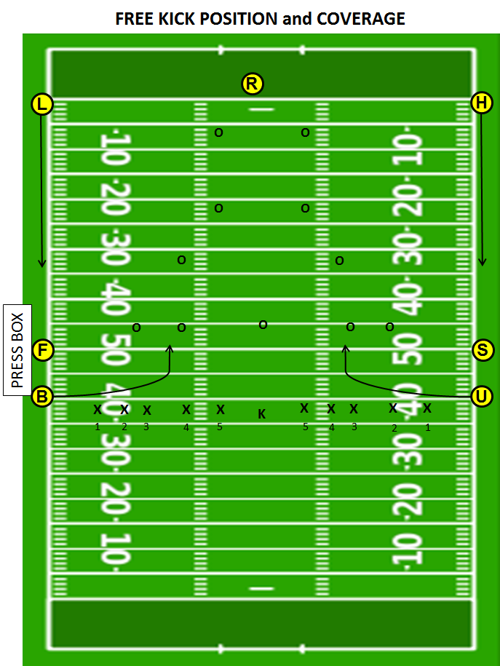

Short Free Kick Position
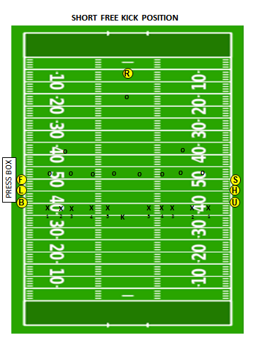

Basic Scrimmage Position
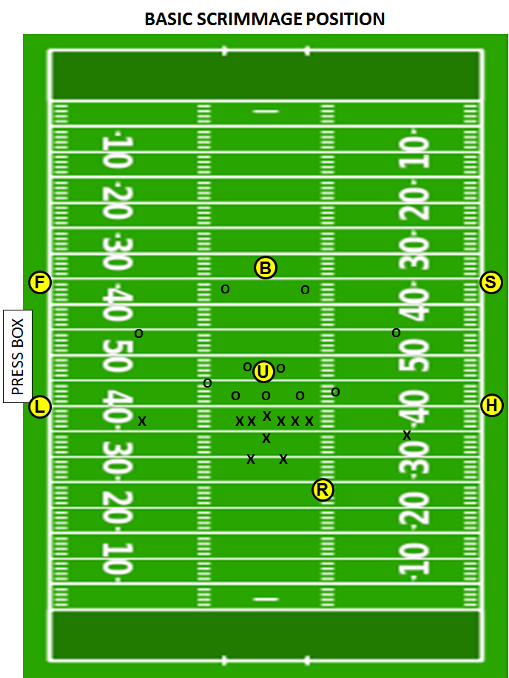

Basic Scrimmage Kick Position (FG and Try)
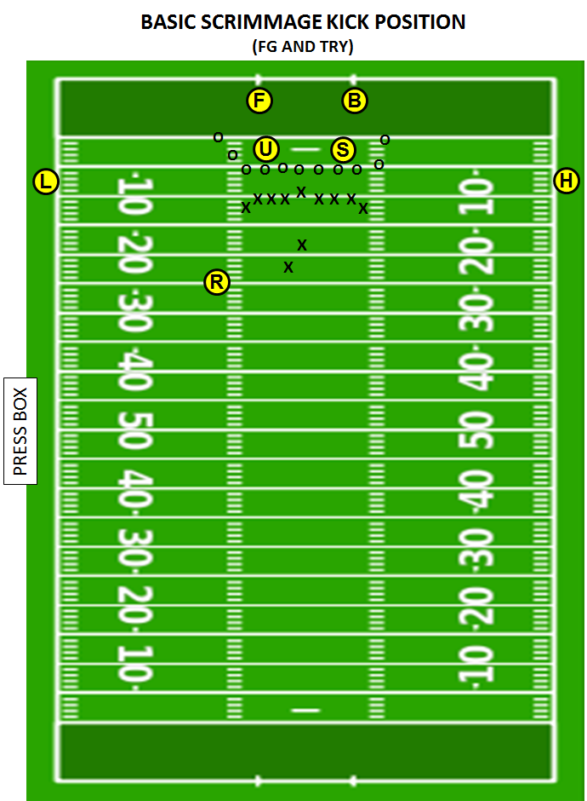

Basic Scrimmage Kick Position (Punt)
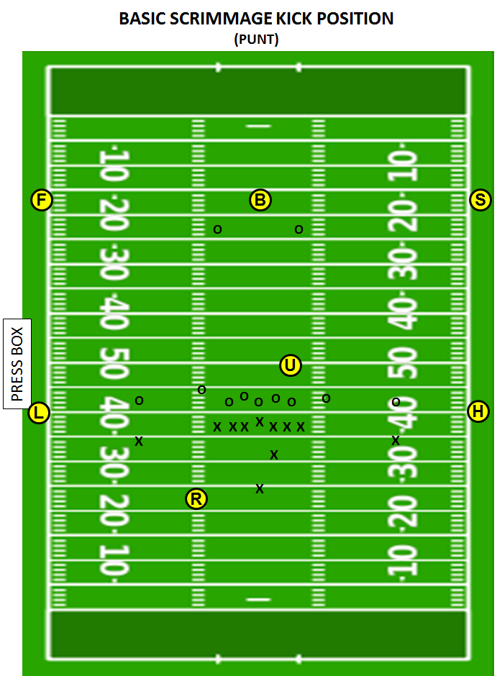

SECTION 29 4 PERSON MECHANICS SUPPLEMENT MANUAL

The 5-Person Mechanics Manual contains the mechanics and philosophies for officiating football in CFOA and provides the foundational information necessary to officiate a 4-Person game. The mechanics contained in this supplement are intended to assist with the transition from 5-Person mechanics to 4-Person mechanics without a significant amount of change. Officials must read and understand the 5-Person Mechanics Manual prior to utilizing this supplemental information.

NOTABLE DIFFERENCES BETWEEN THE 5-PERSON AND 4-PERSON MECHANICS:

1. Referee will time and communicate the 25-second play clock to the quarterback and coach
2. Wings will count Team B players and the Referee & Umpire will count Team A players
3. Pregame communication with clock operator in press box is done by the Line Judge
4. Line Judge will hold the ball during a measurement.
5. Keys
6. Positioning and Coverage of Free Kicks, Scrimmage Kicks and Scoring Kicks
7. Scrimmage Play Coverage

KEYS

I. BALANCED FORMATION
a. In a balanced formation, there are two receivers outside of the tackles on either side of the formation. The wing officials’ main key is the widest receiver; the flankers are secondary keys.
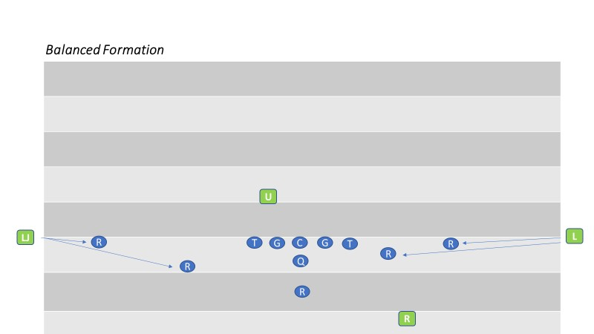

II. TRIPS FORMATION
a. In a trips formation, the wing official on the strong side keys on the widest receiver on the end of the line and the two flankers are secondary keys. The other wing official keys on the tight end, the only receiver on the line on his side of the formation.
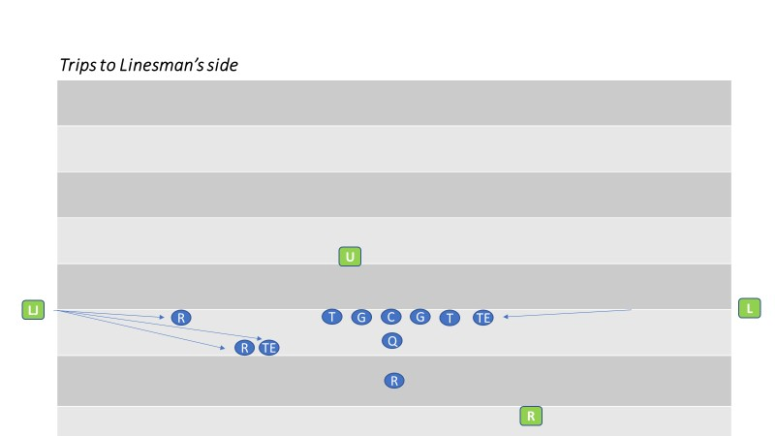

III. MOTION CHANGES FORMATION FROM UNBALANCED TO BALANCED
a. Strength was to the Line Judge’s side, but motion changed the strength of the formation to the Linesman’s side. However, the Line Judge observes the action of the motion man. Legality of motion is always the responsibility of the official away from whom the player is moving. The split end is the Line Judge’s key. The flanker and the split end are the linesman’s keys
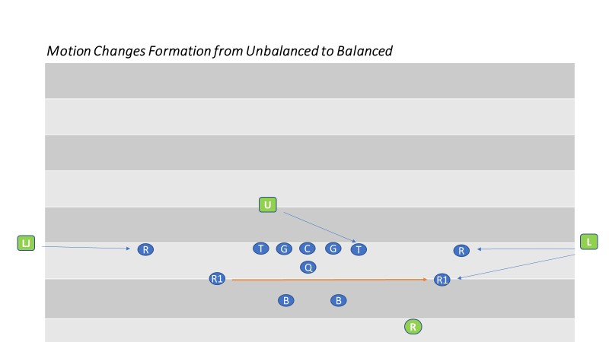

IV. REFEREE AND UMPIRE KEYS
a. Regardless of the formation, the Referee and Umpire key on the opposite-side tackle. It the quarterback is right handed, the Referee keys on the left tackle and the Umpire keys on the right tackle, guards and center.

POSITIONING AND COVERAGE

I. FREE KICK
a. Referee
i. Starting position is near the top of the numbers near team R’s five or 10 yard line on the Line Judge’s side of the field. He counts Team R players and confirms his count with the Umpire. Once he sees a ready signal from each official, the Referee blows his whistle and gives the ready-for-play signal. Because the goal line is solely the Referee’s responsibility, he must be prepared to cover the goal line to rule on momentum. Adjustments in starting position may be necessary based on kicker’s leg strength.
b. Umpire
i. Starting position is on the sideline at R’s 20 yard line. The Umpire counts the receivers and signals the Referee by raising an arm overhead when he is ready for the kickoff.
c. Linesman and Line Judge
i. The Linesman is on team K’s restraining line; the Line judge on team R’s restraining line. They each count Team K players. The Linesman should not give the ball to the kicker until team K has 11 players on the field and should remind the kicker not to kick the ball until the Referee has sounded his whistle. When they are in position and ready for the kick, they should raise an arm as a ready signal for the Referee.
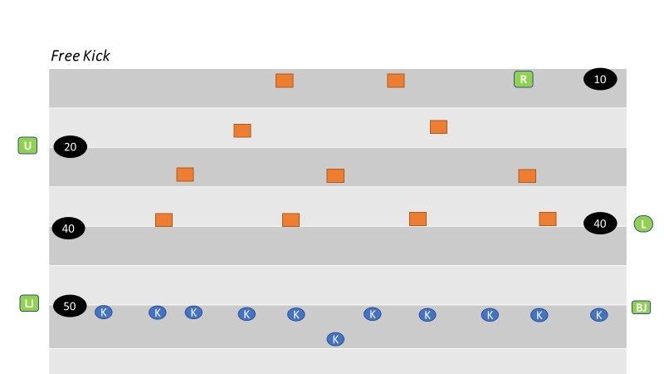

d. Onside Kick
i. The Linesman and Line Judge assume their regular positions while the Referee establishes his position based on the deepest receiver maintaining a view of all players. The Umpire moves to share team R’s restraining line with the Line Judge.
ii. The Umpire, Linesman and Line Judge should have their bean bags in hand to mark the spot if team K first touches the kick and should be prepared to blow the ball dead if a prone player from either team recovers the kick regardless of whether it has traveled 10 yards.
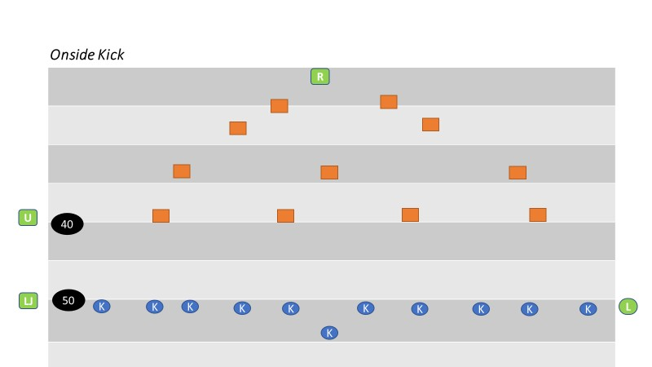

SCRIMMAGE PLAY

I. Referee
a. Starting position is on the passing-arm side of the quarterback, approximately 12 to 15 yards deep and about 4-5 yards outside the tight end on the quarterback’s throwing arm side. The Referee should be in an upright stature with a balanced and athletic posture. The Referee is responsible for Team A’s player count and knows how many players are in the huddle. He signals the player count when the huddle breaks, holding it until the offense reaches the line of scrimmage. The Referee will keep the 25 second clock. He must develop a consistent tempo for marking the ball ready for play.
II. Umpire
a. Starting position is 4-7 yards behind Team B’s line and between the defensive ends in a hands-on-thighs position. The Umpire must be able to see the snapper hands whenever they are on the ball. Until the Referee blows the ready for play whistle, the Umpire must maintain control of the ball by voice or position. He must know which players are on the line of scrimmage in the free blocking zone. He shall note the position of ball

between hash marks. He will count Team A and confirm count with Referee (Crew
Signal A).
III. Linesman and Line Judge
a. Starting position is straddling the line of scrimmage on the sideline, They will use an upright stance while working off the field of play. They each count Team B but no confirmation signal is required.
b. Before the snap, the wing officials identify the eligible receivers on their side of the field and determine legality of the offensive formation. As the widest receiver approaches his position near the wing official, the Wing will indicate the location of the line of scrimmage by placing his up field foot on the line of scrimmage and patting his hand on his thigh. After the receiver has established his position, the Wing official will signal and declare the receiver’s position. If the receiver is in the back field the wing will extend his arm toward the offensive backfield (Crew Signal I). If he is on the line of scrimmage the wing official shall point with the up field arm to the ground (Crew Signal J).

GOAL LINE GOING IN

A touchdown signal is given only by an official who actually rules on the play. Never mirror a touchdown signal if you do not see the action. The crew will find it difficult to overcome two officials making an incorrect ruling.
I. Referee
a. Standard starting position and coverage.
II. Umpire
a. Standard starting position; however, do not stand on the goal line as this will interfere
with the wing’s goal line coverage.
b. On running play between the tackle that results in the ball ending in a pile near the goal line, point to the ball to assist the crashing wings in determining if result is a touchdown.
III. Linesman and Line Judge
a. When the ball is snapped inside the 15 yard line, the wing officials should begin coverage movement toward the goal line at the snap. When the ball is snapped on or inside the 5 yard line, the Wings must move immediately to the goal line pylon. If the play moves toward you, back away from the sideline keeping the goal line in view. When the ball breaks the goal line plane in player possession, use a slow confident touchdown signal while continuing to dead ball officiate. There is no reason to rush this signal.
b. On close plays in the middle of the field do not stay on sideline. Move rapidly in toward
ball after the play is over. When you determine the progress has resulted in a touchdown, stop your feet prior to signaling a confident touchdown signal. Sell your call! If not sure, move in ‘inside’ the field of play using your feet to mark the progress spot. If you come in on the goal line or in the end zone, everyone will think the ball has crossed the goal line. Avoid pointing to the ground and verbalizing that “he is short” until you have confirmed that the opposite wing does not have a touchdown.

GOAL LINE COMING OUT

When the ball is snapped between the goal line and Team A’s 10 yard line, proper positioning and coverage is necessary to ensure the goal line is covered. When the ball is snapped inside the 5 yard line, attention to the goal line is even more important. This coverage is called Reverse Goal Line Mechanics. The priority is determining if a safety is scored. Covering officials must be alert for the ball becoming dead in the end zone in the possession of the offensive team. A safety signal is given only by an official who actually rules on the play. Mirroring the signal is unnecessary and dangerous.
WHEN THE BALL IS SNAPPED INSIDE THE 5 YARD LINE I. Referee
a. The Referee starts near the end line and wider than normal to provide a better view of
forward progress if the quarterback scrambles out of the pocket on a pass play and is stopped near the goal line. The Referee is responsible for the goal line on passing plays along with the facing wing official. The Referee is responsible for the end line.
II. Linesman and Line Judge
a. At the snap the wings must move immediately to the goal line and about two yards outside the pylon and then read a tackle for run/pass.
b. On a running play they must determine if the ball gets completely out of the end zone before it becomes dead and stay on the goal line until it is no longer threatened. They must pinch in on the field of play to mark progress or look for the ball near the goal line and pinch in when in the end zone to signal safety. They must work back toward the line of scrimmage if the runner takes them there and square off to identify the forward progress spot. (REMEMBER: The ball must get completely out of the end zone.) If the progress spot is very close to the goal line, the ball is placed at least a foot into the field of play.
c. On a passing play the wing official that is NOT facing the Referee shall retreat towards the goal line at the snap while reading the tackle’s block for run/pass. If pass is read, he changes direction and observes the receivers. The wing official that is facing the Referee remains on the goal line to assist the Referee with goal line coverage and rotates his focus to pass coverage after the quarterback releases the ball.
WHEN THE BALL IS SNAPPED BETWEEN THE 5 YARD LINE AND 10 YARD LINE I. Referee
a. The Referee shall start 10 yards deep and wider than normal. Starting wider and closer
to the line of scrimmage will allow the Referee to get a better look at the quarterback who drops back to pass near the goal line and is in danger of being sacked there. This position also provides the Referee a better chance to rule on the quarterback’s forward progress. The Referee is responsible for the end line and the goal line.
II. Umpire, Linesman and Line Judge
a. There are no differences from regular scrimmage downs.

SCRIMMAGE KICK POSITIONING
I. Referee
a. The Referee’s position is about five yards outside and five yards behind the kicker and opposite side of the kicker from the Linesman. The Referee should be able to view the snap and the initial block back and the tackle then the action around the kicker before, during and after the kick. The Referee must be ready to move in the appropriate direction if an errant snap leads to a loose ball in the offensive backfield and must have an awareness of the goal line.
II. Umpire
a. Deeper is better on scrimmage kicks. The Umpire should start at least 10 yards off the line of scrimmage.
III. Linesman
a. The starting position is the same as for other plays from scrimmage.

IV. Line Judge
a. The Line Judge begins the play three to five yards behind the deepest receiver and wide enough to observe the receiver’s hands. The Line Judge must be prepared to move up field if the kick is short or downfield if the receiver has to retreat. If the deep receiver is near or behind Team R’s 15 Yard Line, the Line Judge must start on the goal line and not move off the goal line unless it is certain it will not be threatened.
COVERAGE

Once the kick is away and the kicker is safe, the Referee takes a quick look to see the flight of the ball. If the kick is toward a sideline, he must be prepared to determine the spot the ball went out of bounds. If the kick is very short, the Referee can identify the out-of-bounds spot by verbalizing the yard line; if the kick is long and goes out of bounds the Referee will take note of the location that the ball landed, the covering official moves past where he thinks it flew out before walking toward the Referee with his hand up — along the sideline — until the Referee chops downward, telling him to halt. The wing officials should always spot the ball on a whole yard line. The wing official should not always expect the Referee to help line up a scrimmage kick that has gone out-of-bounds in the air. If the Referee has a hand up, that means he can help. You may have to create a spot, but once you choose a spot, sell it!
On blocked kicks, the Linesman will determine if the ball crosses the Line of Scrimmage. The Referee and Linesman should be ready to rule on the recovery and observe the advance of any player who runs with a recovered ball.
If the kick is short, officials must know who touched a loose ball; if the kicking team is first to touch the
kick, a bean bag should be dropped at the yardline of the touching.
During a return, the Line Judge is responsible for covering the runner until he is transferred another official. If the runner breaks into the opposite side zone, coverage transfers to the Linesman and the Line Judge cleans up behind the play. The Referee may take over coverage of the runner if the runner breaks off a long return.

I. Referee
a. As the ball travels from the snapper to the punter, the Referee should observe the initial block by the near backfield protectors and then shift his focus to any player who becomes a threat to contact the ball or the kicker. If the snap is errant or mishandled, the Referee must be prepared to rule on the legality of any contact with the kicker. He must stay focused on the kicker until all threat of harm has passed. He should alert the defenders when the ball is kicked: “Ball’s away, ball’s away.” Do not move too quickly downfield after the scrimmage kick and keep all players in your view.
b. The Referee must be ready to move in the appropriate direction in case of a blocked kick. On blocked kicks, the Referee should be ready to rule on the recovery and observe the advance of any player who runs with a recovered ball. If the kicker runs with the intent to kick rugby style, the Referee must move with him and note the nearest defenders to rule on the legality of any contact.
c. The Referee must strive for a position where he can watch both the kicker and the flight of the ball. Once it is clear the ball will not go out of bounds in flight, the Referee should no longer be concerned about the ball.
d. If the kick goes out-of-bounds in flight, the Referee will raise his hand to line up the kick for the covering official. If there is continuing action on the kicker, the Referee must disregard the preceding and let the covering official get the out-of-bounds spot by himself.
e. If the receivers begin a return, the Referee should move slowly downfield; if the runner breaks a long return, the Referee may ultimately assume responsibility for the runner. The Referee has responsibility of the goal line.
II. Umpire
a. For the goal line and the sideline opposite from the Linesman. Referee will get an inside- out look regardless of which sideline is involved since the appropriate wing official has sideline responsibility from end line to end line.
b. The Umpire is responsible for the initial action on the snapper and for blocks by all interior linemen and the widest players (gunners) opposite the Linesman. After the ball is kicked and all linemen/backs have cleared his position, he should move slowly downfield along the hash opposite of the Referee keeping as many players in view as possible. The Umpire should be aware of a short kick or a partially blocked kick. The Umpire must observe the action around the ball and help determine if the ball is touched first by Team R beyond the neutral zone and prepare to drop a beanbag if first touching occurs by K. On a return, the Umpire has responsibility for blocks between his position and the runner.
III. Linesman
a. The Linesman observes the initial line charge and is responsible for encroachment/false start. The Linesman is primarily responsible for determining if the ball crossed the neutral zone and doesn’t move downfield until the ball crosses it. The Linesman’s focus should include blocking/restraint by Team R on his side of the ball including the
‘gunners’ followed by coverage around and in front of the kick receiver. The Linesman is responsible for his sideline from end line to end line and for covering the runner when the return is to his area. If the run is to the opposite sideline, he should clean up behind the play.

b. If the ball is punted near the end zone, the wing officials must be alert for a blocked punt or a broken play and may have to cover action involving the goal line.
c. If the kick is blocked, the Linesman has primary responsibility for determining if the ball
is touched first by Team R beyond the line and whether the spot of a recovery is beyond or behind the line. The Linesman must also be cognizant of a fake punt. If the kicker initially starts to run before deciding to kick, the Linesman may have to rule whether the punter was beyond the line when the ball was kicked.
d. The distance the Linesman moves after the kick is dependent on the length of the kick, but each should strive for covering approximately half the distance between the line and the end of the kick.
e. If a scrimmage kick goes over the receivers head the Line Judge shall cover the ball and
the Linesman will observe the receiver for any blocking after a fair catch signal (valid or invalid).
IV. Line Judge
a. All deep receivers are the responsibility of the Line Judge. Once the ball is kicked, he judges the validity of any fair catch signal, moves with the receiver and maintains a position to rule on catch vs. muff. He should observe the receivers and the players around them rather than the ball as it flies downfield. Remaining far enough away from the receiver to retain a wide-angle view and moving in at a controlled pace, with eyes searching, once the receiver has completed the fair catch helps the Linesman look for illegal action around the receiver. In such cases, it is also a good idea not to have the whistle in the mouth; it is possible for a fair catch to be muffed and a whistle blown before the ball dribbles loose from the receiver’s grasp.
b. Once the receiver catches the kick, he must watch the players who approach the runner and should track the ball with his peripheral vision. The Line Judge is responsible for his sideline from end zone to end zone and for covering the runner until he is transferred another official.
c. If the ball is kicked over the head of the deepest receiver, the Line Judge must retreat and not allow any player to get behind him. He will release the receiver to the Linesman and proceed to cover the ball.
d. The Line Judge has sole responsibility for determining if a touchback occurs or the momentum exception applies.
e. The Line Judge must bean bag the spot where the kick ends unless that spot is also the dead-ball spot in which case the Line Judge will stop the clock and hold the spot. That spot may be used for post- scrimmage kick penalty enforcement.

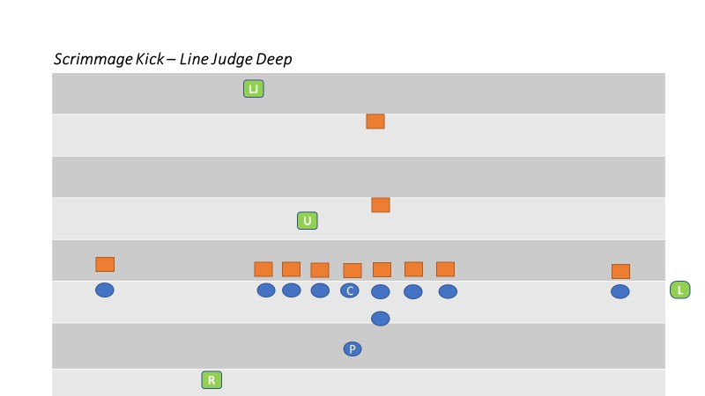

SCORING KICK PAT/FIELD GOAL

POSITIONING

I. Referee
a. The Referee’s starting position is even with and facing the front of the holder. It is permissible for the Referee to line up 1-2 yards behind the yard line of the holder to get a better view the snap and the initial block by the end and back on his side and then the action around the kicker before the kick. The distance from the holder may vary depending on personal preference, keeping the mind that the Referee is responsible for the sideline and the pylon behind him if there is a run or pass to that side.
b. The Referee rules on roughing the holder and kicker.
c. The Referee must be ready to move in the appropriate direction if an errant snap leads to a loose ball in the offensive backfield and must have an awareness of legality of the holder’s position and actions during a fake.
d. The Referee signals the score to the press box after confirmed the signal from the officials under the upright.
II. Umpire
a. The starting position is under the upright opposite the Referee. The Umpire is responsible for counting the offense; checking the numbers of the players on the offensive line and reminding Team R players about illegal contact on the snapper.
III. Linesman or Line Judge
a. The wing official that the Referee faces remains in his normal position straddling the line of scrimmage and off the field. The opposite wing official (from behind the Referee) joins the Umpire at the upright nearest his sideline and rules on his upright and the cross bar. The wing official that remains on the line of scrimmage must be prepared to rule on the entire goal line if the try turns into a run or pass play.
b. In order to avoid confusion during a last-second field goal attempt, the positioning of the wings must be a point of emphasis during the pregame.
c. Umpire and Wing under upright: After ruling determining successful or unsuccessful, take two steps straight forward announcing “yes yes” or “no no” then signal. Officials shall hold their signal until the Referee has made eye contact.

SCORING KICK COVERAGE
I. Referee
a. The Referee must watch the holder receive the ball and the action of the holder’s knee as the rules distinguish between the lifting of the knee during a muff and after possession of the ball has been obtained. The position of the knee is also critical if the ball is subsequently passed or handed off.
b. After the kick, the Referee is responsible for ruling on contact on both the kicker and holder. Once he is confident the kicker and holder are no longer in danger of being contacted, the Referee should dead-ball officiate for two-three seconds and then look to

the deep officials to learn the result of the kick. The signal should be relayed to the press box once players have separated.
c. If a kick Try is blocked, the Referee should blow his whistle immediately as the play is
over and the ball is dead; however, a blocked field goal remains live. Communication with the crew prior to the kick regarding the live ball/dead ball status of a blocked kick or a kick that fails to reach the goal line is essential.
d. In cases of a fake or a broken play, if a run or pass develops to his side, the Referee is responsible for sideline coverage including the pylon (acts as the wing). If Team R recovers the ball and runs for a score, the Referee is responsible for his sideline all the way to the goal line.

II. Umpire
a. Initially, the Umpire rules on the legality of the snap. His primary responsibility then is action on the snapper. He must also watch the blocks by the snapper and guards. The Umpire should step towards the snapper after the try kick with a vocal presence to reduce the chance of unnecessary acts.
b. If a blocked kick or fake results in a play toward the goal line, the Umpire has the inside- out look at blocks near the point of attack and can help with goal line coverage on the open side of the field.
III. Linesman and Line Judge
a. The wing official on the line of scrimmage has sole responsibility for encroachment/false starts.
b. If the Try or FG becomes a run or pass play this wing has sole responsibility for the goal line and the line to gain. He can also help rule on ineligibles downfield on fake kicks that result in a pass that crosses the neutral zone. When a runner approaches the goal line, the wing official will move to the goal line to rule on the potential score.
c. After the kick, the wing official must pinch-in toward the offensive and defensive linemen to dead-ball officiate and use his voice to encourage players to unpile and return to the sideline. If the ball falls short of the goal line, the wing official must rule on touchback, momentum and a kick return by Team R.
IV. Wing Under Upright
a. This wing official is responsible for ruling whether the ball passed inside or outside the upright. When a successful kick passes the upright or when the ball breaks the goal line plain and it is obvious it will not score, the Wing sounds his whistle. The Wing official should pronounce his ruling verbally using “yes, yes” or “no, no, no.” The Wing official shall then take two steps straight forward into the end zone and signal. Hold the signal until the Referee makes eye contact and repeats the signal to the press box.

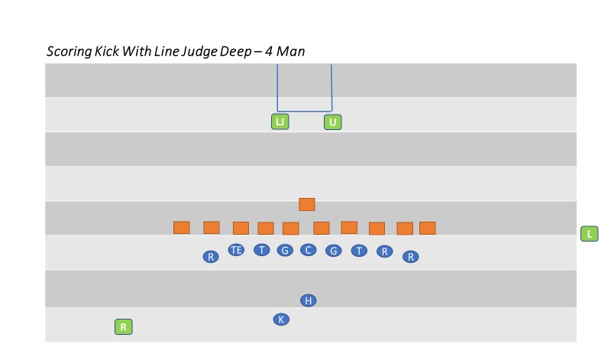

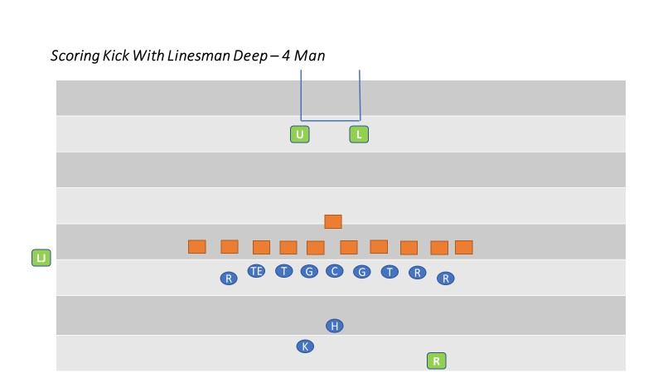

SWINGING GATE FORMATION

The Swinging Gate formation is occasionally used during a Try. The Referee is encouraged to ask during the pregame discussion with the head coach if he has any trick plays including the use of the Swinging Gate. If so, the crew should subsequently discuss the use of this mechanic in detail.

Some plays that are typically run out of this formation include:

An angled long snap (not between the snapper’s legs) to a running back behind the linemen
with a subsequent bull rush to the goal line.
The holder receives the snap and passes to an eligible receiver (by position and number) which can include the snapper.
The holder pitches the ball to the kicker and becomes a blocker.
I. Referee
a. The Referee faces the holder from a position about three yards behind and five yards to the side of the kicker. The Referee should be able to view the snap and the action around the kicker before the kick. The Referee rules if the ball passed inside the upright to his side and signals the score to the press box if confirmed by the signal from the Umpire under the post.
b. The Referee must watch the holder receive the ball and the action of the holder’s knee as the rules distinguish between the lifting of the knee during a muff and after possession of the ball has been obtained. The position of the knee is also critical if the ball is subsequently passed or handed off.
II. Umpire
a. The Umpire’s initial position is seven yards deep in the end zone, favoring the side opposite of the Referee. If Team A shifts into a normal kick try formation, the Umpire will take a position behind the upright. He should vocalize to the Team B players to avoid illegal action against the snapper. The Umpire is responsible for ruling whether the ball passed inside or outside the upright on his side as well as whether the ball cleared the crossbar.
III. Linesman and Line Judge
a. The wing’s starting position and coverage is the same as normal scrimmage plays. Each moves to the goal line at the snap as for any other goal line coverage situation. If Team A shifts into scrimmage kick formation, the wings shall shift to the goal post.

SECTION 30 3-MAN MECHANICS

BELOW VARSITY PRE-GAME
REFEREE
Confirm positions assigned and officiating experience if unknown, On-field duties prior to kickoff, kickoffs, penalty philosophy, communication with coaches, FG/PAT, crew communication. Running plays – progress, cross-field mechanics, communication with flanks, goal line mechanics (going in and out), ball mechanics, counts A/B, communication with referee, penalty mechanics.

HEAD LINESMAN
Chains, communication with referee, whistle control, dead ball officiating, line of scrimmage fouls.

LINE JUDGE
Passing plays, forward/backward, quick over the middle, intentional grounding, DPI/OPI, scrimmage kicks, muff vs fumble, 25 second clock, game clock awareness.

COIN TOSS PROCEDURES
- LINE JUDGE and REFEREE escort captains from press box side to center. HEAD LINESMAN escort captains from chains side to center.
- LINE JUDGE introduces captains to REFEREE on sidelines, HEAD LINESMAN introduces captains to REFEREE in center of field.
- LINE JUDGE and HEAD LINESMAN, make certain your team is either in their respective team box or in their end zone during the coin toss.
- After meeting in center of the field, LINE JUDGE and HEAD LINESMAN will move to 45-yard line (in order from left to right). REFEREE will face the clock.
- REFEREE will introduce the crew.
- REFEREE instructs captains. Visiting captains will call coin toss. The visiting captain is required to indicate heads or tails prior the toss of the coin.
- Once the choices have been made by both teams, move the captains so their backs are to the goal they’re defending. The REFEREE will indicate winning captains and choice or option deferred. If the captain’s choice is to defer, the REFEREE will give the proper signal (signal #10) then move to the other captains and give the signal for the appropriate choice.
- After the toss, all meet and record results, then jog to kickoff positions

QUARTER
REFEREE
- Be aware of last minute of play. If the ball is not in play when the clock runs out, step in to prevent the snap
- Announce end of quarter, record the down and distance and release the HEAD LINESMAN
- Check to make certain the down, distance and yard line is correct
- When officials are ready and the LINE JUDGE indicates the intermission is over, declare the ball ready for play

HEAD LINESMAN
- Prepare the chains to move to the new location on the REFEREE’S signal. Make certain the clip is located appropriately on the nearest yard line and take note. Grab the clip and chain at the same time, reverse the chain crew, jog to the new position and place the chain on the new spot
- Place your heel at the front of the ball for the down box

LINE JUDGE
- Prepare to go to the spot where the ball should be put into play at the start of the next quarter
- Time the one-minute intermission and notify REFEREE when 55 seconds have elapsed
- Jog to the new spot on the opposite side of the field and spot the ball
- Stay between the teams to show presence as you move to the new spot
- Confirm that the REFEREE and HEAD LINESMAN have the ball and chains at the right spot

HALFTIME
- As soon as teams leave field, the REFEREE will look at the timer and wind to start the half-time clock
- All officials meet and review first half
- Flank officials will extend a 5-minute courtesy call to each team
- HEAD LINESMAN or LINE JUDGE will confer with the coach who has the second half decision on which way they would like to kick the ball. Do this as they either leave the field or when you provide the 5-minute courtesy call. Provide the information to fellow officials during mandatory three-minute warm-up period or before the crew leaves for the appropriate kick-off positions

FREE KICK MECHANICS – 3-MAN
PRE-KICK MECHANICS
ALL OFFICIALS
HUSTLE TO POSITION!

REFEREE
- Take position at the goal line (or as appropriate behind the deepest receivers) in the middle of the field
- Count the receiving team (use eyes not fingers). Signal accordingly for less than/greater than/equal to 11 players
- Signal HEAD LINESMAN to confirm count by extending your arm with a closed fist
- Upon ready signal from LINE JUDGE, if the receiving team is in position, blow the ready for play whistle
- On anticipated short free kicks may cheat-up if possible
- On a free kick following a safety, take position five-yards deeper than the receiver(s) and not further from the goal line than the 20-yard line

HEAD LINESMAN
- Go to your position on the receiving team’s restraining line at the sideline. Have your team on the field within one minute following a score
- Count the receiving team (use eyes not fingers). Signal accordingly for less than/greater than/or equal to 11 players. Confirm with REFEREE
- Hold bean bag in hand. Anticipate first touching
- Provide ready signal only when count is correct, receiving team is in position, sideline is clear, you are ready, and the LINE JUDGE signals he is ready

LINE JUDGE
- Time the one-minute intermission following a score. Alert HEAD LINESMAN after 45 seconds. Have your team on the field within one minute following a score. Make certain the ball is inflated properly, has “pebble grain” and white stripes
- Count the kicking team (use eyes not fingers). Signal accordingly for less than/greater than/or equal to 11 players
- Give kicker the ball and tell him not to kick until the REFEREE blows his whistle.
- Go to your position on the kicking team’s restraining line at the sideline
- Signal ready to the HEAD LINESMAN who will then raise arm for ready signal
- Upon ready signal from HEAD LINESMAN, provide ready signal to REFEREE (K may be in the huddle when you signal)
- Hold bean bag in hand. Anticipate first touching
- Provide ready signal only when count is correct, kicking team is in position, sideline is clear, you are ready, and the HEAD LINESMAN signals he is ready

FREE KICK FOLLOWING A FAIR CATCH
REFEREE, position with the kicker.

HEAD LINESMAN, position on the kicking team’s restraining line.

LINE JUDGE, position under the goal post.

DURING THE FREE-KICK MECHANICS
REFEREE
- Identify your keys, the nearest receivers
- Consider your areas of protection; goal line
- Quickly check the direction of the ball (short, long, left, or right). If it is a short kick, move up and provide dead-ball support. On a kick out of bounds, move toward the out of bounds spot and throw your flag if in your zone
- When the ball is touched, start the clock (two winds)
- When the kick breaks the goal line plane (touched or untouched), signal touchback.
- Observe action around the receivers and watch the middle players of the receiving team moving down the field. Cover blocking and other action on and by your keys
- As the runner moves further downfield, assume coverage in behind the ball carrier
- Maintain an inside-out view of the action around the field

HEAD LINESMAN
- Identify your keys, the nearest six players of the kicking team
- Watch the receiver’s restraining line for encroachment by receiving team
- Quickly check the direction of the ball (short, long, left, or right). If it is a short kick, look for first touching by kicking team and use your bean bag as needed. On a kick out of bounds, throw flag to the out of Bounds spot. If the team on your sideline is the offended team, get the enforcement choice from the coach and advise the REFEREE
- Observe action on the kicker. Cover blocking and other action on and by your keys.
- As the runner nears, assume coverage in front of the ball carrier. Be on the goal line before the runner. Maintain an inside-out view of the action around the ball carrier.
- Drift down the field to assume coverage of the runner and take all the way to the goal line. You have progress
- On plays to the opposite side, mirror LINE JUDGE movement downfield. With wide vision, watch blocking and look for illegal acts. Use cross-field mechanics where appropriate
- When the runner is downed in your coverage zone, stop the clock. Place the ball at your feet until the incoming ball is spotted. Duplicate other official’s signals if play does not end in your coverage zone

LINE JUDGE
- Identify your keys, the nearest five players of the kicking team
- Watch the kicker’s restraining line for encroachment by the kicking team
- Quickly check the direction of the ball (short, long, left, or right). If it is a short kick, look for first touching by kicking team and use your bean bag as needed. On a kick out of bounds, throw flag to the out of bounds spot. If the team on your sideline is the offended team, get the enforcement choice from the coach and advise the REFEREE
- Drift down the field to assume coverage of the runner and take all the way to the goal line. You have progress
- On plays to the opposite side, mirror HEAD LINESMAN movement down field. With wide vision, watch blocking and look for illegal acts. Use cross-field mechanics where appropriate
- When the runner is down in your coverage zone, stop the clock. Place the ball at your feet until the incoming ball is spotted. Duplicate other official’s signals if play does not end in your coverage zone

FREE KICK COVERAGE MECHANICS
ALL OFFICIALS
Keep play and runner boxed in and sidelines covered at all times.

RETURNS DOWN THE CENTER OF THE FIELD
REFEREE
Cover the secondary areas and view blocking and other illegal activity.

HEAD LINESMAN and LINE JUDGE
Keep the runner boxed in between you. View the action immediately around the runner.

RETURNS INTO THE HEAD LINESMAN SIDE ZONE
- HEAD LINESMAN is responsible for the runner and action immediately surrounding the runner
- HEAD LINESMAN will cover the action in front of the runner, viewing blocking and other illegal activity
- REFEREE will cover behind and to the side of the runner, keeping a distance to view activity by other players not around the play

RETURNS INTO THE LINE JUDGE SIDE ZONE
- LINE JUDGE is responsible for the runner and action immediately surrounding the runner
- LINE JUDGE will cover the action in front of the runner, viewing blocking and other illegal activity
- REFEREE will cover behind and to the side of the runner, keeping a distance to view activity by other players not around the play

POINTS OF EMPHASIS
- There should always be two officials covering the secondary areas away from the ball carrier
- All officials should dead ball officiate after the play
- All officials will hustle and efficiently prepare for the start of the next series

SCRIMMAGE PLAY MECHANICS – 3-MAN
PRE-SNAP MECHANICS
REFEREE
- Signal upcoming down to HEAD LINESMAN and then to rest of the crew
- Retrieve the ball from the runner or obtain a new ball from another official or ball boy. Hustle outside the inbounds marks as needed to assist in retrieving the ball and spotting it. Make visual contact with all officials to determine if they are ready, verify the LINE JUDGE is ready to start the 25 second play clock
- Indicate “Ready for Play” with short whistle and hack or long whistle and wind (two times)
- Count Team A players
- Count Team A players numbered 50-79. Know ineligibles
- Assume a position about 12-yards behind the neutral zone and outside the tackle on the quarterback’s throwing arm side
- Count Team A players (in huddle, if possible) and signal
- Identify formation and observe initial keys: snap, quarterback, false start, QB hard count and head bob, tackle on opposite side

HEAD LINESMAN
- Signal upcoming down and confirm with REFEREE and LINE JUDGE.
- Move box/chains as necessary for the correct down and distance
- Assume a position straddling the neutral zone, outside the sideline opposite the LINE JUDGE
- Be prepared to indicate Team A line to Team A wide receiver with your foot
- Identify formation and signal status of eligible receivers on your side of snapper
- Use the prescribed Line of Scrimmage signals on all scrimmage plays.
- Know eligible receivers on your side of snapper and identify your initial keys. Know your eligible receivers
- Motion – if motion man is going away from you, have primary responsibility for knowing if motion is legal or illegal. If motion man is coming to your side and motion is forward, call it if you see it

LINE JUDGE
- Signal upcoming down and confirm with HEAD LINESMAN and REFEREE
- Communicate with the REFEREE if necessary to indicate the status of the game clock (on the ready with wind signal at waste or, on the snap with arms crossed at the chest). Time 25 second play clock from REFEREE’s ready for play
- Assume a position straddling the neutral zone, outside the sideline opposite the HEAD LINESMAN.
- Count team B players, signal when Team A breaks huddle
- Be prepared to indicate Team A line to Team A wide receiver with your foot
- Identify formation and signal status of eligible receivers on your side of snapper
- Use the prescribed Line of Scrimmage signals on all scrimmage plays
- Know eligible receivers on your side of snapper and identify our initial keys. Know your eligible receivers
- Motion – if motion man is going away from you, have primary responsibility for knowing if motion is legal or illegal. If motion man is coming to your side and motion is forward, call it if you see it

RUN MECHANICS – 3-MAN

RESPONSIBILITIES AT THE SNAP
REFEREE
- Observe the snap, then momentarily read the action of the quarterback to determine the type of play
- Allow your reads to take your focus to the point of attack, while maintaining primary responsibility for action on and by the quarterback

HEAD LINESMAN
- Observe the snap then momentarily read read/pass by observing the block by the near tackle (block toward, pass block, pull, etc.)
- Locate the ball and the point of attack but do not focus on it
- On plays beginning at or within the five-yard line, going into the end zone, move to the goal line and officiate back to the line of scrimmage
- On plays beginning at or within the three-yard line, going out of the end zone, move back to the goal line and officiate forward to the line of scrimmage

LINE JUDGE
- Observe the snap then momentarily read run/pass by observing the block by the near tackle (block toward, pass block, pull, etc.)
- Locate the ball and the point of attack but do not focus on it
- On plays beginning at or within the five-yard line, going into the end zone, move to the goal line and officiate back to the line of scrimmage
- On plays beginning at or within the three-yard line, going out of the end zone, move back to the goal line and officiate forward to the line of scrimmage

RESPONSIBILITIES AFTER THE SNAP
REFEREE
- After reading the quarterback, shift your focus to the Team A blockers and action behind the point of attack. Know where the runner is, but he should not be your primary focus once he is beyond the line of scrimmage
- If the point of attack is outside the inbounds marks, move to that side while maintaining your view of the action behind and around the runner
- If the point of attack is between the inbounds marks, box in from the rear, again focusing on blocks behind at the point of attack and around the runner
- After the runner is down, maintain a wide view of the dead ball action. If the play ends out of bounds, hustle to the sideline and ensure players separate and return inbounds. Get the ball to the inbounds line
- You are responsible for maintaining control around the pile. Talk to players as they un-pile, encouraging them to do so in a sportsmanlike manner
- If the ball is dead between the inbounds marks, hustle to that spot while keeping your head up to observe the action around the pile

POINTS OF EMPHASIS
- False starts
- Illegal shifts
- Motion
- Free Blocking Zone
- Blocking around runner and by team A backs
- Illegal acts around runner
- Reverses and trick plays
- Free blocking zone

LINE JUDGE AND HEAD LINESMAN
- After reading the block of the near tackle, momentarily locate the point of attack and the runner
- You always have the progress spot all the way until the runner crosses the goal line. This includes an accurate spot when the runner goes out of bounds
- On plays within the 10-yard line, if a play threatens the goal line, be prepared to be at the goal line to make the appropriate call
- If the play is away or between the inbounds marks, maintain a wide view of the action while paralleling the progress spot, observing player conduct away from the play
- If the play is toward your side, observe blocks in front of the runner until you take over responsibility for the runner. If the runner is headed toward your sideline, allow the play to go past you (move into the offensive backfield, if necessary), then trail the play. If the runner crosses the sideline, hustle to the spot and mark progress. Signal timeout while observing the out of bounds dead ball action. Do not look at the ground. If the runner crosses the goal line and continues out of bounds, signal touchdown while observing all dead ball action
- After the ball is dead, close to the dead ball spot. Do not pass players and do not close beyond the near inbounds mark unless:
- The line to gain is threatened
- The goal line is threatened
- The ball is loose then recovered
- In these three cases, hustle to the dead ball spot.

POINTS OF EMPHASIS
- Encroachment
- False Starts
- Illegal motion, shifts, formations
- Clipping, blocks in back and use of hands

PASS MECHANICS – 3-MAN

COVERAGE MECHANICS (In addition to Running Play)
REFEREE
- As QB drops to pass, drop back at 45 angle maintaining position behind QB on passing arm side
- Observe initial blocks by offensive backs
- Look through QB to observe blocking by the tackle opposite you
- As QB is threatened and attempts to pass, determine if arm is moving forward
- Determine initial direction on all passes when QB takes at least a 3-step drop
- On QB scrambles toward LOS, determine forward point where ball is released
- Signal if the pass is tipped/touched
- viii. Announce “BALL IS AWAY” and protect QB until immediate action is complete or QB moves to participate. You have all calls on QB behind the line of scrimmage
- Dead ball officiate
- Spot the ball on plays
- Anticipate
  - Forward or backward pass
  - Pass attempt vs. fumble
  - Roughing passer
  - Illegal pass (beyond LOS or intentional grounding)

LINE JUDGE & HEAD LINESMAN
- Read through key receiver to nearest offensive lineman to read play
- Rule on action by and on key receiver during initial action. Following initial action, shift to zone coverage- focus on short receiver
- Remain near LOS until pass is thrown unless all receivers are deep, stay underneath the shortest receiver (EXCEPTION: Snap from inside 5-yard line, move immediately to goal line)
- On QB drops of less than 3 steps, determine initial direction of pass to your side
- Maintain Outside-in coverage, move parallel to sideline, responsible for sideline from end line to end line
- On catch attempts near end line or near sideline, focus on feet then hands
- If pass is caught in bounds and then player goes out of bounds, blow whistle, stop clock, mark spot, continue to officiate – Do NOT give catch signal
- Do not mark spot of passes caught out of bounds
- Responsible for progress up to the goal line
- Off-ball officiate on plays away. Come into the hash mark on plays into the opposite side zone
- Dead ball officiate
- Anticipate
  - Holding
  - Pass interference
  - Catch/No-catch
  - Unnecessary contact / Personal fouls
  - Forward/backward pass
  - Illegal participation

PASS RECEIVER COVERAGE KEYS
Definitions
Receiver –
End or back lined up outside of offensive tackles.
Strength of the formation –
Determined by the number of eligible receivers on a particular side of the offensive formation. The strong side is the side with the most eligible receivers outside the tackles.
Tight end –
The end man on the line of scrimmage lined up no more than 4 yards from the nearest offensive lineman. If he is lined up wider, then he is a split end.
Back in the backfield –
A player in the backfield between the tackles at the snap.
Trips –
Three or more receivers on one side of the offensive formation outside the tackles.
Widest receiver –
If players are stacked one behind another, the one nearest the line of scrimmage is considered to be the widest.

The HEAD LINESMAN and LINE JUDGE key on the eligible players of the offensive formation on their side of the field.

SCRIMMAGE KICK MECHANICS – 3-MAN

PRE-KICK MECHANICS
REFEREE
- Position to the LINE JUDGE side of the field and slightly behind the kicker (approximately 7 yards to the side and 5 yards deeper than the kicker)
- Count the kicking team and confirm with the HEAD LINESMAN
- View the lineman and know numbering exceptions
- Tell the receiving team lineman “DO NOT HIT THE SNAPPER”. Look quickly to see if the snapper was hit at the start of the play

HEAD LINESMAN
- Position on the line of scrimmage in front of the down marker
- Count the kicking team and look for confirmation from REFEREE that he has eleven players
- View formation to see that they have at least seven (7) players on the line of scrimmage
- View the position of the outside kicking team players. Know who is eligible to catch a pass or go down field prior to the kick

LINE JUDGE
- Position slightly behind and to the side of the deepest receiver on your side of the field (approximately 5-7 yards to the side and 3-5 yards behind the receiver). If two receivers, field position may require you to take a position between the receivers
- On kicks from inside the receiving team’s 40-yard line, take a position on the goal line
- Count the receiving team and confirm
- View the position of the outside kicking team players. Know who is eligible to catch a pass or go down field prior to the kick
- Provide fair catch instructions to the receiver(s) if possible
- Hold a beanbag in your hand

DURING THE SCRIMMAGE KICK MECHANICS
ALL OFFICIALS
Strange things happen on kicks. Be mentally prepared for various scenarios based on your position.

REFEREE
- Watch action on the SNAPPER and watch for ineligible players downfield
- Normal Kick –Watch blocking by the Team A backs and protect the kicker. Stay with the kicker until all is clear. Be the last official down the field and box in all players from behind with wide vision. If the return breaks through defense, be prepared to take the runner all the way to the goal line
- Bad Snap - When there is a bad snap on a scrimmage kick and the play goes deep into the backfield, you will follow the ball back
- Kick Out of Bounds – If the kick goes out of bounds in flight, line up the out of bounds spot with covering official by signaling with a hack
- After the Play - Indicate to HEAD LINESMAN when to move chains, hustle to the new spot and indicate first down and direction of ball
- At the end of the play DEAD BALL OFFICIATE. Spot the incoming ball to be ready for play

POINTS OF EMPHASIS
- Fake kicks
- Bad Snaps
- Blocked Punt
- Roughing or Running Into the Kicker; Incidental Contact
- Illegal Blocks
- Illegal Use of Hands
- Clock Status before and after the play

HEAD LINESMAN
- Look to see that the ball has been kicked and quickly see where the ball is headed (i.e. short, long, right, left). DID THE BALL CROSS THE LINE OF SCRIMMAGE, HIT THE GROUND OR A PLAYER?
- Normal Kick – View the blocking and action around the kicking team’s eligible players and view line action until the ball clears. After the ball has crossed the line of scrimmage, quickly release down the field and parallel the play from the outside with wide vision. Continue to watch the action as the players and ball move toward the receiver. Observe blocking down the field and in front of the runner
- Mark first touching with a bean bag
- Bad Snap – When there is a bad snap on a scrimmage kick and the play goes deep into the backfield, (the HEAD LINESMAN will then have kick crossing or not crossing line)
- Kick Out of Bounds – On kicks out of bounds, you are responsible for your sideline. Line-up deeper than where the ball went out of bounds on the sideline (no deeper than the goal line) with outside arm straight above your head. Make eye contact with REFEREE and begin to walk toward the original line of scrimmage. The REFEREE will hack when you have reached the out of bounds spot
- You are one of the covering officials, at the end of the play, spot progress and square-up with the LINE JUDGE, stop the clock and signal direction of the team in possession. DEAD-BALL OFFICIATE. If you are holding the spot, cover the ball until you are relieved by another official
- Look to the REFEREE for confirmation to move the chains

POINTS OF EMPHASIS
- Blocking
- Touching of ball; beyond line of scrimmage
- Illegal Kicking
- Interference
- Muff and First Touching Violations
- Ineligible players downfield

LINE JUDGE
- Look to see that the ball has been kicked and quickly look to see where the ball is headed (i.e. short, long, right, left).
- Normal Kick – View the receiver and run up to be even with the receiver as he prepares to catch the ball. Your only view is the receiver and stay to the side of him by 5-7 yards. Look to see that the receiver catches the ball cleanly and that there was no kick catch interference or to rule on fair catch.
- Drop your beanbag where the kick ends. Remember that the kick ends when any player gains possession or when the ball becomes dead. If the kick crosses the goal line, blow your whistle and signal touchback.
- Keep the runner between you and the HEAD LINESMAN. You are responsible for coverage of runner from an inside-out view your side of the field. Your distance should be about 10-15 yards from the runner. You have progress.
- Fair Catch - View the receiver and run up to be even with the receiver as he prepares to catch the ball. View the fair catch signal (valid or invalid?). Make certain the receiver catches the ball cleanly and it does not go through his hands. With a confirmed catch, stop the clock and blow your whistle.
- First Touch Violation – Use a beanbag if there is a first touching violation by the kicking team. Note: there may be more than one spot of the first touching violation.
- At the end of the play, stop the clock and signal direction of the team in possession.
- DEAD-BALL OFFICIATE.
- Kick Out of Bounds – On kicks out of bounds, you are responsible for your sideline. Line-up deeper than where the ball went out of bounds on the sideline (no deeper than the goalline) with outside arm straight above your head. Make eye contact with REFEREE and begin to walk toward the original line of scrimmage. The REFEREE will hack when you have reached the out of bounds spot.
- Communicate possession and direction to the REFEREE.

POINTS OF EMPHASIS
- Fair Catch Signals
- Blocking
- Goal Line
- Illegal Batting or Forward Handing
- Muff and First Touching Violations
- Fair Catch or Kick Catch Interference
- Ball Out of Bounds in Flight

FIELD GOAL & PAT MECHANICS – 3-MAN

PRE-SNAP MECHANICS
ALL OFFICIALS
Prior to all field goals attempts, all officials should remind themselves of live ball by using the illegal procedure signal (#S19).

REFEREE
- Take a position behind the potential kicker and 2–3 yards deeper than the kicker holder
- Beware of a fake field goal or PAT. Be ready to assist in covering to the sideline.
- Before the snap, observe any linebackers that may be attempting to shoot the gap to block the kick
- You have responsibility for the uprights and whistle
- Before the snap, check for any illegal locking of legs by offensive linemen

HEAD LINESMAN
Take a position on the sideline (on PAT, move in to numbers) and observe neutral zone.

LINE JUDGE
- At the goal post opposite the chains
- Count defense.
- You have sole responsibility for protection of the snapper.
- Check for use of numbering exception by Team A.
- You solely have cross bar.
- Callout the jersey numbers of eligible receivers

ALL OFFICIALS – SWINGING GATE
All officials will be in their regular positions for a scrimmage down. If team A shifts to a formation normally used for a PAT or attempted field goal, then all officials will assume their appropriate position.

